Log in to Microsoft Azure. Download one of these versions:
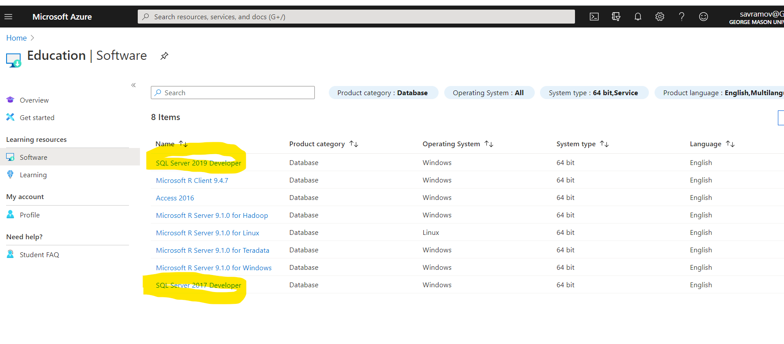
In the next steps I will show you how to install SQL Server 2017.
Click the first link to launch a wizard to install SQL Server 2017.
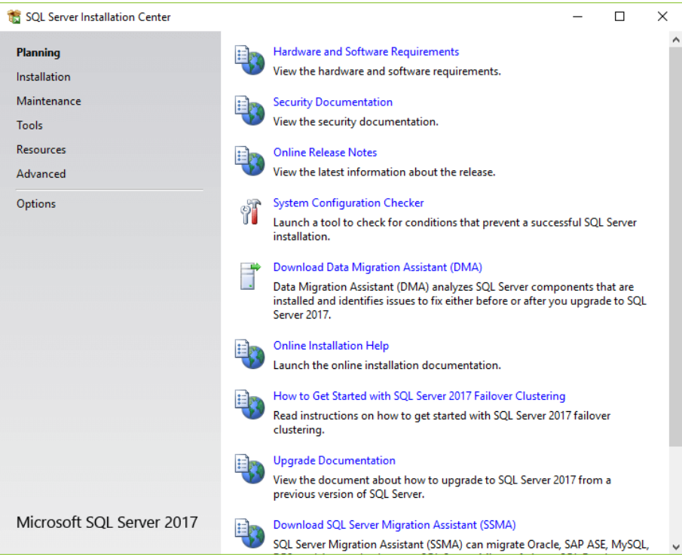
Specify the edition that you want to install, select Developer edition and click the Next button. Enter the product key.
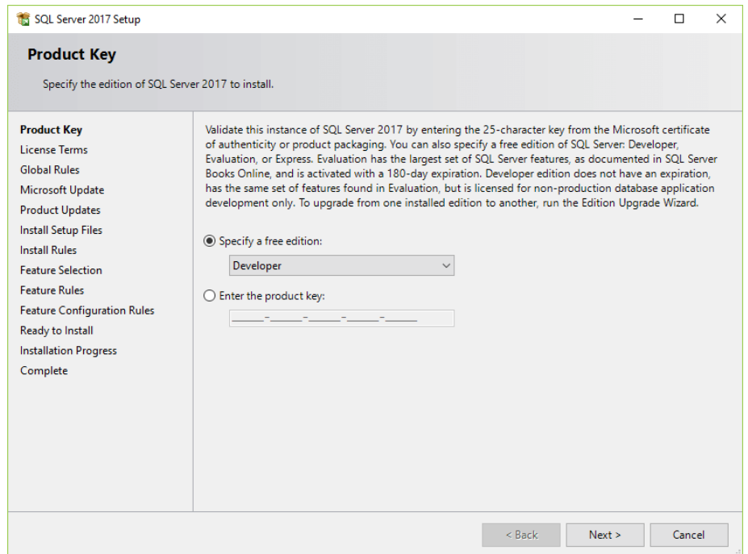

Select the “I accept the license terms.” Click Next.
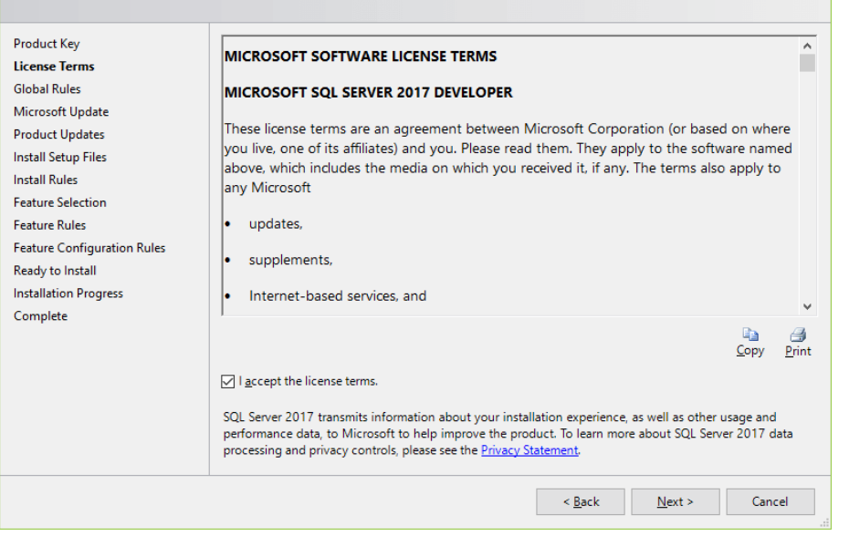

Check the “Use Microsoft Update to check for updates (recommended.
Click Next.
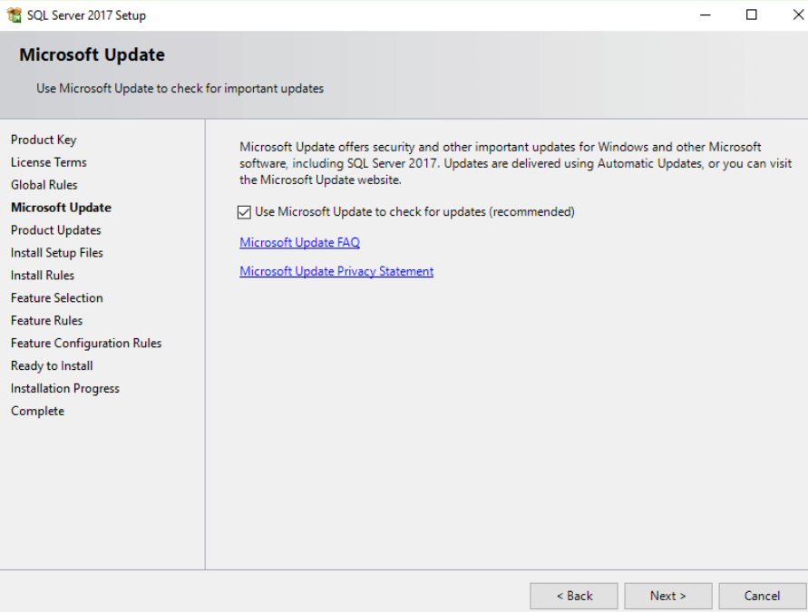

The installation checks for the prerequisites before installation. If no error found, click the Next button.
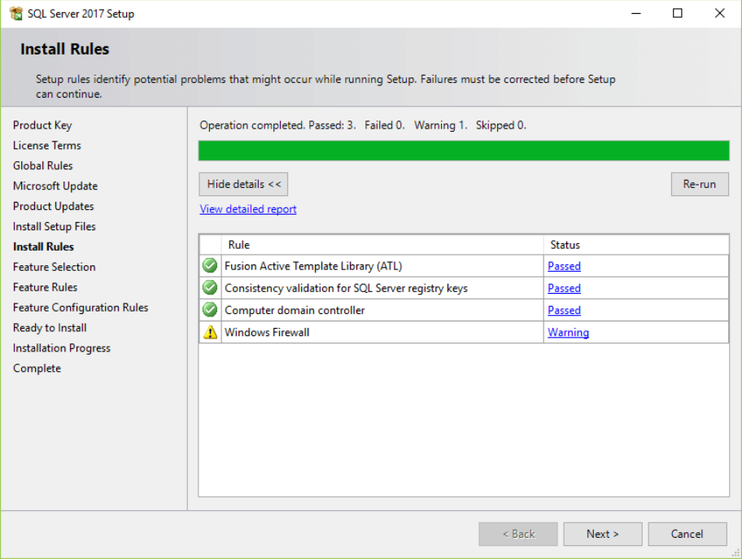

Select the features that you want to install. For now, you just need the Database Engine Services, just check the checkbox and click the Next button to continue
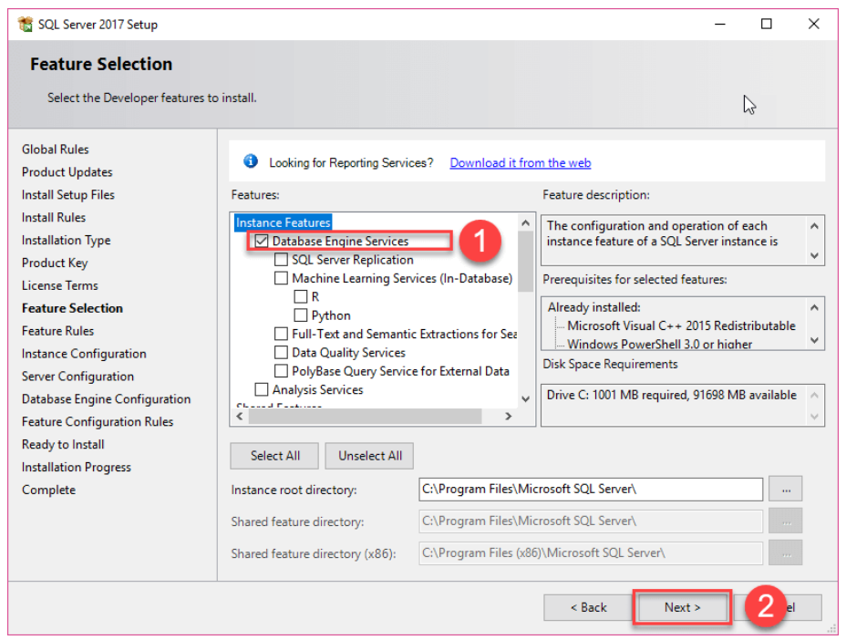
Click “Default instance” and click next.
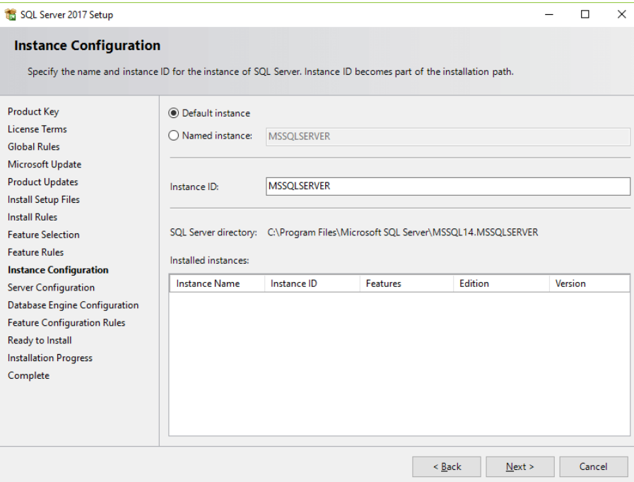

Specify the service account and collation configuration. Just use the default configuration and click the Next button.
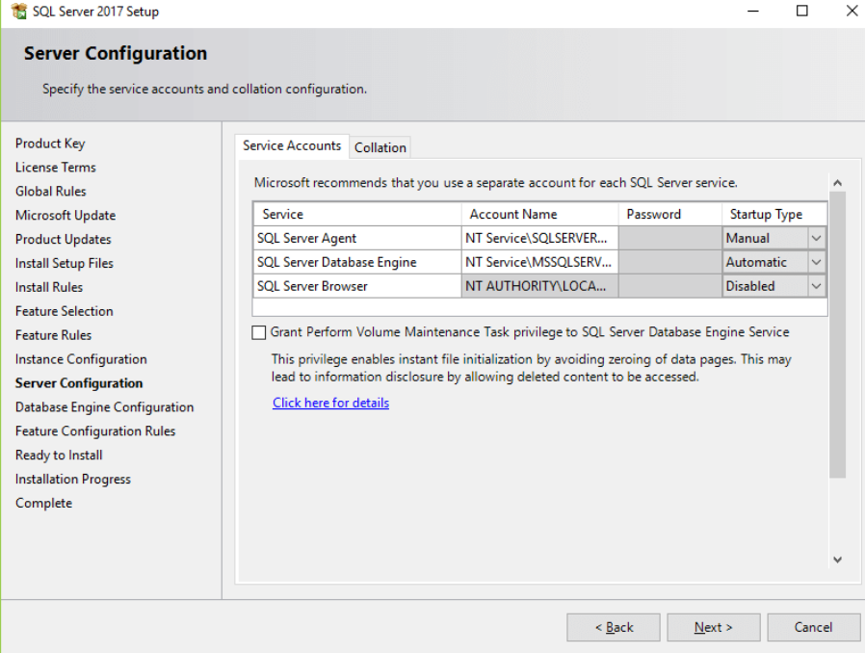

Specify the database engine security mode.Choose Windows Mode.
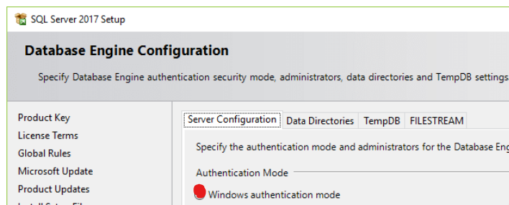
Add current user on the next 2 steps.
Verify the SQL Server 2017 features to be installed and click INSTALL:
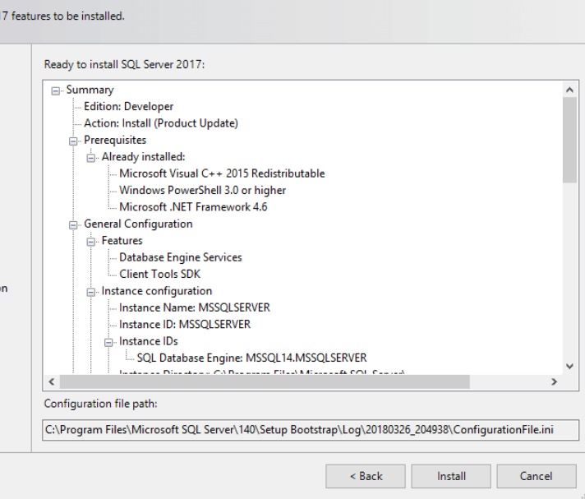

Once it completes click the OK button and CLOSE
You will also Install Microsoft SQL Server Management Studio
Download the SSMS from the Microsoft website via the following link:
https://docs.microsoft.com/en-us/sql/ssms/download-sql-server-management-studio-ssms?view=sql-server-ver15
Download SQL Server Management Studio
Double-click the installation file SSMS-Setup-ENU.exe to starting installing. The installation process of SMSS is straightforward which you just need to follow the screen sequence.
Click the Install button
Wait for few minutes while the installer sets up the software.
Once setup is completed, click the Close button

