### **Antidepressant Recommendation System**

This documentation provides a comprehensive overview of the antidepressant recommendation system, detailing each component, the data flow, and specific processes involved in feature selection and predictive modeling. The system is designed to deliver actionable AI recommendations, continuously learning from real-world patient data to refine antidepressant suggestions.

### **Table of Contents**

1. **Introduction**
   * System Overview
   * Objectives
   * Key Components
2. **System Architecture**
   * Data Collection and Ingestion
   * Data Processing and Preparation
   * Feature Selection
   * Predictive Modeling
   * Scoring and Recommendation
   * Feedback and Continuous Learning
3. **Data Flow and Logic**
   * End-to-End Data Flow
   * Key Processes and Decisions
4. **Detailed Process Flow**
   * Data Collection and Ingestion
   * Data Cleaning and Preparation
   * Feature Selection with Lasso Regularization
   * Model Training with Logistic Regression
   * Scoring Antidepressants
   * Feedback Loop and Model Retraining
5. **Integration with Course Projects**
   * Common AI Challenge
   * Analyze Missing Values
   * Remove Algorithm Bias
   * Actionable AI Advice
   * Follow-up
6. **Technical Details**
   * Data Structure and Variables
   * Algorithmic Approaches
   * Performance Metrics
7. **Error Handling and Decision Points**
8. **Conclusion and Future Enhancements**

### **1. Introduction**

#### **System Overview**

The antidepressant recommendation system is a data-driven tool designed to support clinicians in selecting the most effective antidepressant for a patient based on individual characteristics and historical data. This system aligns with actionable AI principles, aiming to provide specific, practical recommendations that can be directly implemented in clinical workflows.

#### **Objectives**

* To deliver personalized antidepressant recommendations that can be directly applied to patient care.
* To enhance decision-making in managing depression through actionable AI insights.
* To continuously refine recommendations through integrated feedback and ongoing model updates.

#### **Key Components**

* **AI Chatbot**: Collects patient data, including demographics, symptoms, and treatment history.
* **Data Processing Layer**: Cleans, transforms, and prepares data for analysis.
* **Feature Selection**: Uses Lasso Regularization to identify the most impactful predictors.
* **Predictive Modeling**: Applies logistic regression to predict the likelihood of treatment success.
* **Scoring Engine**: Ranks antidepressants based on their predicted effectiveness.
* **Feedback Loop**: Collects data on treatment outcomes to refine and retrain the model.

### **2. System Architecture**

#### **Data Collection and Ingestion**

* **AI Chatbot**: Engages patients in data collection through structured interactions, aligning with the **Common AI Challenge** project, where data-driven AI systems are used to enhance clinical decision-making.
* **APIs**: Facilitate secure data transmission from the Chatbot to the processing system.
* **Validation**: Ensures data completeness and integrity before ingestion, reflecting the importance of handling missing values as emphasized in the **Analyze Missing Values** project.

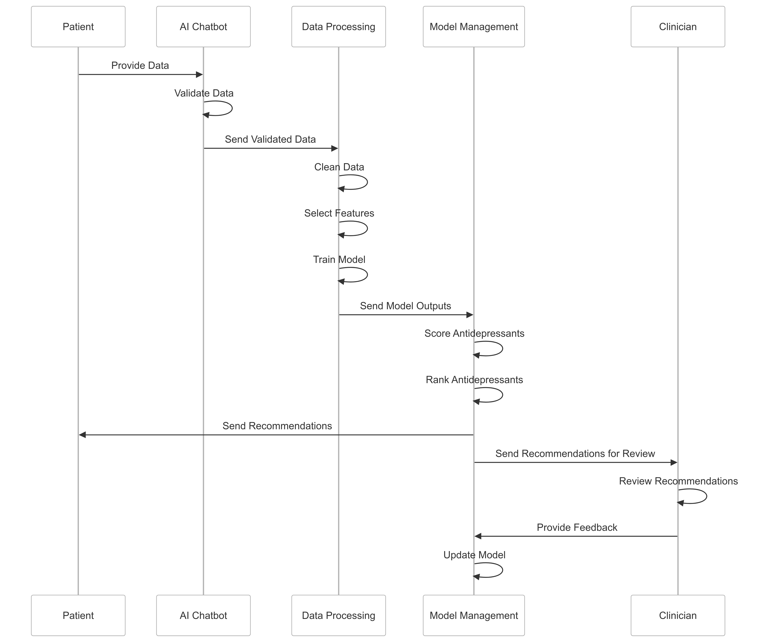

#### **Data Processing and Preparation**

* **Data Cleaning**: Handles missing data, removes duplicates, and adjusts outliers, directly addressing course content on analyzing and imputing missing values【Course: Analyze Missing Values】.
* **Data Transformation**: Standardizes data formats, preparing it for modeling by normalizing continuous variables and encoding categorical data.
* **Feature Engineering**: Enhances the dataset by creating new variables that capture complex interactions, supporting the actionable insights needed in clinical settings.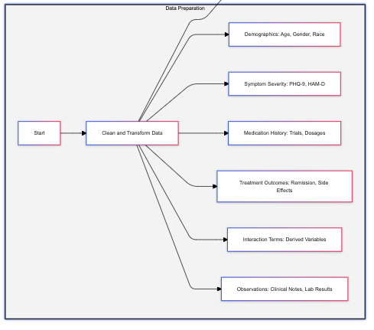

#### **Feature Selection**

* **Lasso Regularization**: Implements a penalty to less significant features, ensuring that only impactful predictors are retained for modeling. This process directly addresses biases by focusing on statistically significant features, as highlighted in the **Remove Algorithm Bias** project【Course: Remove Algorithm Bias】.
* **Retained Features**: Only features with non-zero coefficients are passed on to the modeling stage, simplifying the model and enhancing interpretability.

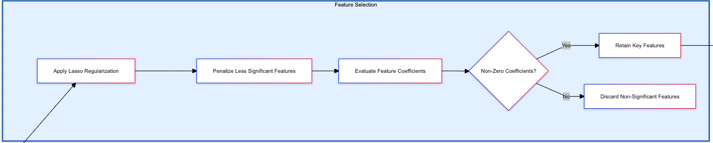

#### **Predictive Modeling**

* **Logistic Regression**: Trains a predictive model using the selected features to estimate remission probabilities. The logistic regression approach aligns with the **Actionable AI Advice** project, where AI systems provide specific, evidence-based recommendations【Course: Actionable AI Advice】.
* **Model Validation**: The model’s performance is validated using separate datasets, ensuring that it generalizes well to new patient data.

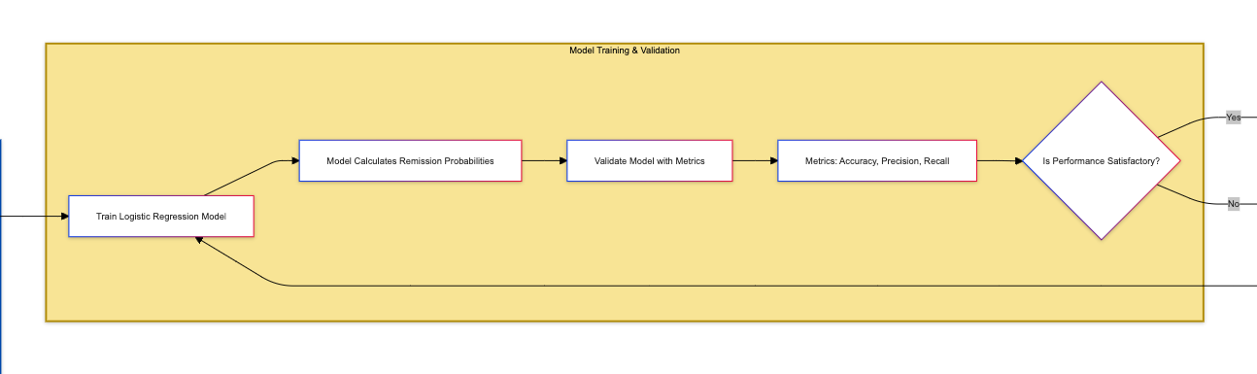

#### **Scoring and Recommendation**

* **Scoring Engine**: Applies the logistic regression model to calculate remission probabilities for each antidepressant based on patient data.
* **Ranking System**: Antidepressants are ranked by their predicted effectiveness, translating the model’s insights into clear, actionable recommendations.

#### **Feedback and Continuous Learning**

* **Feedback Collection**: Gathers data on treatment outcomes from follow-up surveys, ensuring the system continuously learns and adapts to new information.
* **Model Retraining**: Regularly updates the predictive model with feedback data, reflecting the continuous learning principles covered in the **Follow-up** project【Course: Follow-up】.

### **3. Data Flow and Logic**

**End-to-End Data Flow**

1. **Data Collection**: Patient data is gathered via the AI Chatbot.
2. **Data Validation**: The system checks data for completeness and accuracy.
3. **Data Cleaning**: Processes such as imputation and outlier management ensure data quality.
4. **Feature Selection**: Lasso Regularization filters features based on their statistical significance, aligning with bias reduction principles【Course: Remove Algorithm Bias】.
5. **Model Training**: Logistic regression is trained on the refined dataset to predict remission likelihood.
6. **Scoring**: The model scores various antidepressants, ranking them based on predicted effectiveness.
7. **Recommendation**: Clinicians receive a ranked list of antidepressants, ready for application in treatment decisions.
8. **Feedback Integration**: The system updates its model based on real-world outcomes, continuously refining its recommendations.

#### **Key Processes and Decisions**

* **Feature Selection**: Filters out irrelevant data, enhancing model accuracy and reducing biases.
* **Model Validation**: Ensures reliability before applying predictions in clinical contexts.
* **Feedback Loop**: Incorporates patient outcomes to refine and improve future recommendations.

### **4. Detailed Process Flow**

#### **Data Collection and Ingestion**

* **Actionable Insight**: The system directly collects data relevant to antidepressant selection, aligning with the **Common AI Challenge** goal of using AI to address clinical challenges【Course: Common AI Challenge】.

#### **Data Cleaning and Preparation**

* **Actionable Insight**: Missing values are addressed systematically, supporting the **Analyze Missing Values** focus on robust data handling【Course: Analyze Missing Values】.

#### **Feature Selection with Lasso Regularization**

* **Actionable Insight**: The system reduces algorithm bias by selecting features with non-zero coefficients, directly reflecting the objectives of the **Remove Algorithm Bias** project【Course: Remove Algorithm Bias】.

#### **Model Training with Logistic Regression**

* **Actionable Insight**: The model’s predictions provide specific treatment recommendations, fulfilling the **Actionable AI Advice** project’s emphasis on practical AI outputs【Course: Actionable AI Advice】.

#### **Scoring Antidepressants**

* **Actionable Insight**: The ranked antidepressants list represents a direct, implementable recommendation that clinicians can use to improve patient care.

#### **Feedback Loop and Model Retraining**

* **Actionable Insight**: Continuous learning from patient feedback aligns with the **Follow-up** project’s goals, enhancing the system’s adaptability and ongoing accuracy【Course: Follow-up】.

### **5. Integration with Course Projects**

* **Common AI Challenge**: The system addresses common challenges in AI-driven clinical decision-making by leveraging patient-specific data to provide tailored recommendations【Course: Common AI Challenge】.
* **Analyze Missing Values**: The system includes robust methods for handling missing data, ensuring that the AI model remains reliable and interpretable【Course: Analyze Missing Values】.
* **Remove Algorithm Bias**: By using Lasso Regularization, the system actively reduces biases by selecting only statistically significant predictors【Course: Remove Algorithm Bias】.
* **Actionable AI Advice**: The system’s predictions translate directly into specific, actionable treatment recommendations, enhancing clinical decision-making【Course: Actionable AI Advice】.
* **Follow-up**: The integration of patient feedback into model retraining supports continuous improvement, ensuring the AI remains aligned with real-world outcomes【Course: Follow-up】.

### **6. Technical Details**

#### **Data Structure and Variables**

* **Core Variables**: Age, Gender, PHQ-9 Score, Previous Antidepressant Trials, Adherence Rate, etc.
* **Algorithmic Approaches**: Lasso Regularization for feature selection, Logistic Regression for predictive modeling.
* **Performance Metrics**: Accuracy, Precision, Recall, McFadden’s R-squared.

### **7. Error Handling and Decision Points**

* **Validation Errors**: Alerts and corrective actions for missing or incorrect data.
* **Low Confidence Predictions**: Flagged for clinician review or alternative recommendation generation.
* **Feedback Issues**: Mechanisms for addressing incomplete or inconsistent patient feedback.

### **8. Conclusion and Future Enhancements**

The antidepressant recommendation system is a comprehensive, data-driven approach to personalized depression management, integrating key actionable AI principles from your course projects. By continuously learning from patient feedback, the system refines its predictive models to provide clinically relevant recommendations that improve patient outcomes. Future enhancements could include expanding the dataset to include genetic or biomarker data, further personalizing treatment recommendations.