- Title and contact information:
Eating Healthy
Class ID 290
Student ID 84
I give permission to display my work.
- Comprehensive list of causes and constraints:

Date Added | Cause or Constraint | Description | Is an event? | In next 2 weeks, is always present? | Precedes effect? | If causes absent, then no effect? | Mechanism  clear? | Modifiable by the person?
July 2 | Cause | Ask my aunt to remind me to eat more fiber | Yes | No | Yes, plans always precede eating food. | Yes: “I will not remember to eat fiber” | Yes: A reminder will triggers my mind to eat fiber | Yes: I can ask my aunt to stop
July 4 | Cause | Make more time available to prepare food | Yes | No | Yes, without plan no food to eat | Yes: “I do not have any food to eat” | Yes: Make more time to cook means more chances to eat healthy | Yes: I can arrange my time around
July 5 | Cause | Plan to take supplements | Yes | No | Yes, will have vitamins after taken the supplements | Yes: “No supplements means no vitamins” | Yes: More vitamins will help the body | Yes: I can stop and take anytime
July 7 | Constraint | Work or school | Yes | No | Yes, always busy | N/A | Yes, No eating healthy | Partially
Table1: A list of causes and constraints as of July 22, 2008
The first cause is a cause because this not always happen because I do not eat at home a lot anyways. Perhaps two or three times a week. If she does not remind me or make the food that healthy then I will not remember to eat healthy food, however, if she reminds me to eat fiber than I will remember to eat fiber in my diets. A reminder from her will remind me to eat fiber and healthy food.
The second cause is a cause because it not always happens due to the time I have to go to work and school. This cause is definitely precedes effect because if I did not make time to cook for myself then I will not eat healthy food. Sometimes I eat at home with my aunts then I do not have to cook for myself. When I cook for myself I always eat with vegetables.
The third cause is a cause because it allows me to stay healthy. The only difficulty that I will run into is that will I remember to take these supplements.
The constraint that I listed will inhibit me from eating healthy food. Since I go to school full-time I do not have time to eat and pack healthy lunch and snacks. I eat whatever is available to me. I try to make time available when I can to prepare my own food. The hours of work and time attending classes can be changed by me. I can make more time from classes by skipping them or take sick hours. But those are not permanent solutions.
3. Casual Model
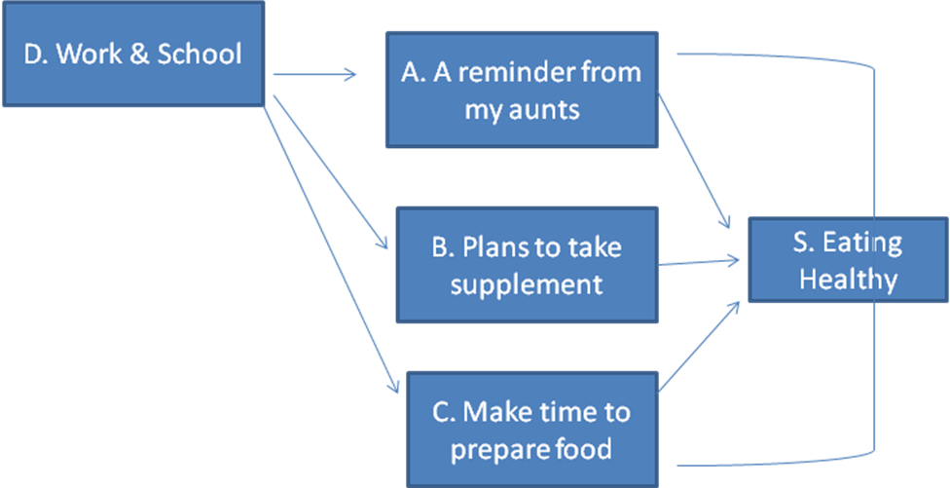
p(Exercise l A reminder from my aunts, Plans to take supplements, and Make time to prepare food) = High
P(Exercise l A reminder from my aunts, Plans to take supplements, and Do not make time to prepare food) = Between low and high
P(Exercise l A reminder from my aunts, No plans to take supplements, and Make time to prepare food) = Between low and high
P(Exercise l No reminder from my aunts, Plans to take supplements, and Make time to prepare food) = Between low and high
P(Exercise l No reminder from my aunts, No plans to take supplements, and Do not make time to prepare food) = Low
If A, B & C work together then the success will be eating healthy. There are some constraints that I encountered. These constraints essentially affect all the causes. Constraint D will cause Cause A, B & C will not occur. Because of Constraint D I will not be able to eat at home, cannot make time available, and plan to take supplements. The two causes that I think have association together are A & C. If Cause A occurs then Cause C does not need to occur.
4. Though Experiments

Type of Test | Relationships observed  in the causal model | True statements that support  the assumptions in my model
Root causes are irrelevant in predicting exercise given direct causes | p(Exercise l A reminder from my aunts) ≠ p(Exercise l A reminder from my aunts, Work & School) | If I know that I would be eating with my aunts then there are no constraints.
 | Work and school can prevent me from eating healthy every day. | If I had the opportunity to eat with my aunts than the constraints would not be a problem
Common causes make independent effects conditionally dependent on each other | Work and school are said to affect three causes. | If work and school affecting ABC than ABC are dependent.
 | Work and school are the common causes of these affects. The ability to eat with aunties, plan to take supplements, and make time to prepare food. | If this common cause occurs then ABC will not occur.
Multiple causes are dependent on each other when the effect is given | Cause A and C are conditionally dependent | When C occurs then I also have some times to eat then I can use
 | When C happens so can A | The time to eat with my aunts.
Counterfactual | I could have eaten healthy food if my aunts did not remind me. | I could just make a habit of eating healthy food rather depend on other
Counterfactual | I could have take supplements every day without making plans. | I could take it when I drink water before bed
Counterfactual | I could have made more time to prepare food without causing troubles. | I could cut down social interactions and make more time available to prepare my own food.
Table 2: Summary of Thought Experiments for Causal Model

5. Casual Diary
Day | Eat Healthy | Aunts Reminder | Not eating with aunts | More time available | Work & School
1 | Yes | Yes | No | Yes | No
2 | No | No | Yes | No | Yes
3 | Yes | Yes | No | No | No
4 | Yes | Yes | No | Yes | No
5 | No | No | Yes | No | Yes
6 | Yes | Yes | No | No | Yes
7 | Yes | Yes | No | No | No
8 | Yes | No | Yes | Yes | No
9 | No | No | Yes | No | Yes
10 | No | No | Yes | No | Yes
11 | Yes | Yes | No | Yes | No
12 | Yes | No | Yes | No | Yes
13 | Yes | No | Yes | No | Yes
14 | Yes | Yes | No | Yes | No
Table 3: Data from My Causal Diary

6. Analysis of the diary

Causes | Probability of Success  Given the Cause
Causes | Minimum | Maximum
A Reminder for aunts | 1 | 1
Plan to take supplements | .76 | .84
Make more time to prepare food | .55 | .80
Table 4: Probability of Success Associated with Different Causes

7. Report of action taken
* Precision is not needed- since we only have a short period of time to conduct this experiment therefore we do not need precision. The number on the impacts of causes helps us to produce insights. These numbers are helpful for us to understand if it is working or not.
* Focus on improvement – I must keep focus on the main goal to achieve it.
* No blame – The data I collected should not be blamed on anything. The purpose of collecting data is to understand how you are doing. If blaming or changing it will not help us to solve or understand the main achievement.
Using data to analysis all situation will show result of what we are looking for. However, since we cannot look at all causes but we can look at some. Some causes will not permanent, some will change. Keep collecting data to understand the constraints and causes that you encountered. When you have all the causes and constraints rule out the constraints and implement the causes.
8. Intropsection
The procedures of making a causal model and testing it are a little difficult. Since I was new to this type of procedures I was lost and confused for several times. The slide shows were helpful in a way that it explains what we are doing. It was helpful when the list of causes was made because I can easily see what I must do to change my eating habits. After following for two weeks I have improved my habits and glad I did.

