**Question 8:** The following graph was used to simulate data on bundling payment for total hip fracture treatment:

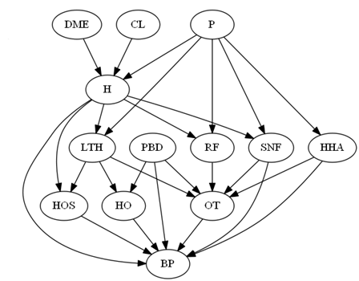

Recover the original network using LASSO regression and calculate the causal impact of H on BP using Netica.

## Install glmnet from CRAN & Load

> install.packages("glmnet", repos = "http://cran.us.r-project.org")

> library(glmnet)

> SBD<-read.csv("simulated bundled data.csv")

> colnames(SBD)



> x<-as.matrix(SBD[-12])

> y<-SBD[,12] ## BP as y

> fit=glmnet(x,y)

> plot(fit)

> print(fit)

> coef(fit,s=0.01)

> cvfit=cv.glmnet(x,y)

> plot(cvfit)

> cvfit$lambda.min

> coef(cvfit, s="lambda.min")

## H as y

> x<-as.matrix(SBD[,(1:3)])

> y<-SBD[,4]

> fit=glmnet(x,y)

> cvfit=cv.glmnet(x,y)

> plot(cvfit)

> cvfit$lambda.min

> coef(cvfit, s="lambda.min")

## LTH as y

> x<-as.matrix(SBD[,(1:4)])

> y<-SBD[,13]

> fit=glmnet(x,y)

> cvfit=cv.glmnet(x,y)

> plot(cvfit)

> cvfit$lambda.min

> coef(cvfit, s="lambda.min")

## PBD as y

> x<-as.matrix(SBD[,(1:4)])

> y<-SBD[,8]

> fit=glmnet(x,y)

> cvfit=cv.glmnet(x,y)

> plot(cvfit)

> cvfit$lambda.min

> coef(cvfit, s="lambda.min")

## RF as y

> x<-as.matrix(SBD[,(1:4)])

> y<-SBD[,7]

> fit=glmnet(x,y)

> cvfit=cv.glmnet(x,y)

> plot(cvfit)

> cvfit$lambda.min

> coef(cvfit, s="lambda.min")

## SNF as y

> x<-as.matrix(SBD[,(1:4)])

> y<-SBD[,6]

> fit=glmnet(x,y)

> cvfit=cv.glmnet(x,y)

> plot(cvfit)

> cvfit$lambda.min

> coef(cvfit, s="lambda.min")

## HHA as y

> x<-as.matrix(SBD[,(1:4)])

> y<-SBD[,5]

> fit=glmnet(x,y)

> cvfit=cv.glmnet(x,y)

> plot(cvfit)

> cvfit$lambda.min

> coef(cvfit, s="lambda.min")

## To quickly change the column order

> SBD<- SBD[c(1,2,3,4,5,6,7,8,13,9,10,11,12)]

## HOS as y

> x<-as.matrix(SBD[,(1:9)])

> y<-SBD[,11]

> fit=glmnet(x,y)

> cvfit=cv.glmnet(x,y)

> plot(cvfit)

> cvfit$lambda.min

> coef(cvfit, s="lambda.min")

## HO as y

> x<-as.matrix(SBD[,(1:9)])

> y<-SBD[,10]

> fit=glmnet(x,y)

> cvfit=cv.glmnet(x,y)

> plot(cvfit)

> cvfit$lambda.min

> coef(cvfit, s="lambda.min")

## OT as y

> x<-as.matrix(SBD[,(1:9)])

> y<-SBD[,12]

> fit=glmnet(x,y)

> cvfit=cv.glmnet(x,y)

> plot(cvfit)

> cvfit$lambda.min

> coef(cvfit, s="lambda.min")

## Result Table



## Result Table without β < 0.01



## Network Model drawn using NETICA

## NETICA Table for BP

## When H is “Yes,” the probability for BP increased to 97.3%

