Question 1: The following simulated data show the survival of patients in two tertiary medical centers and 3 community hospitals. Should ambulances take trauma victims to tertiary medical centers, by passing community hospitals?
1.1: Predict patient survival rates using patient-level variables: (a) Presence of severe burns, (b) Head injury, (c) More than 65+ years old, (d) Male gender. Identify the intercept for each hospital
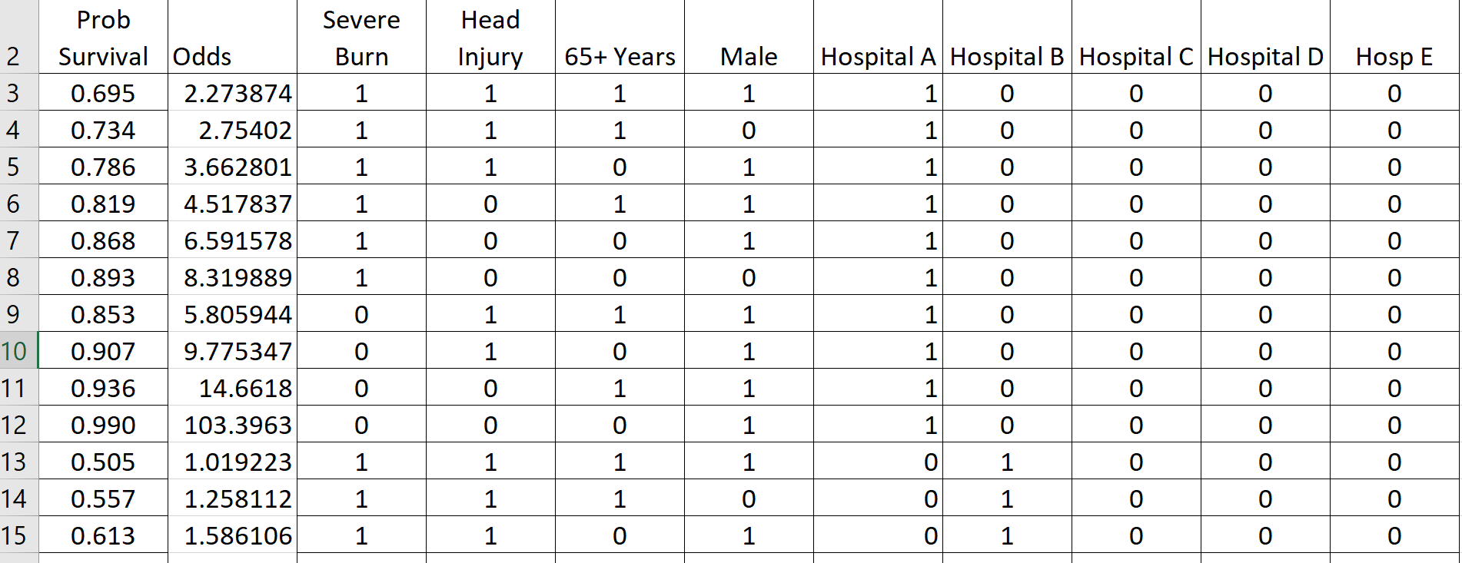
Odds ratio were calculated using the probability of survival. Also, Hospitals A- E were binarized before running a regression. The intercept is set to 0 so each intercept of the hospitals can be calculated. Below is the regression model for the data using all the patient-level variables.
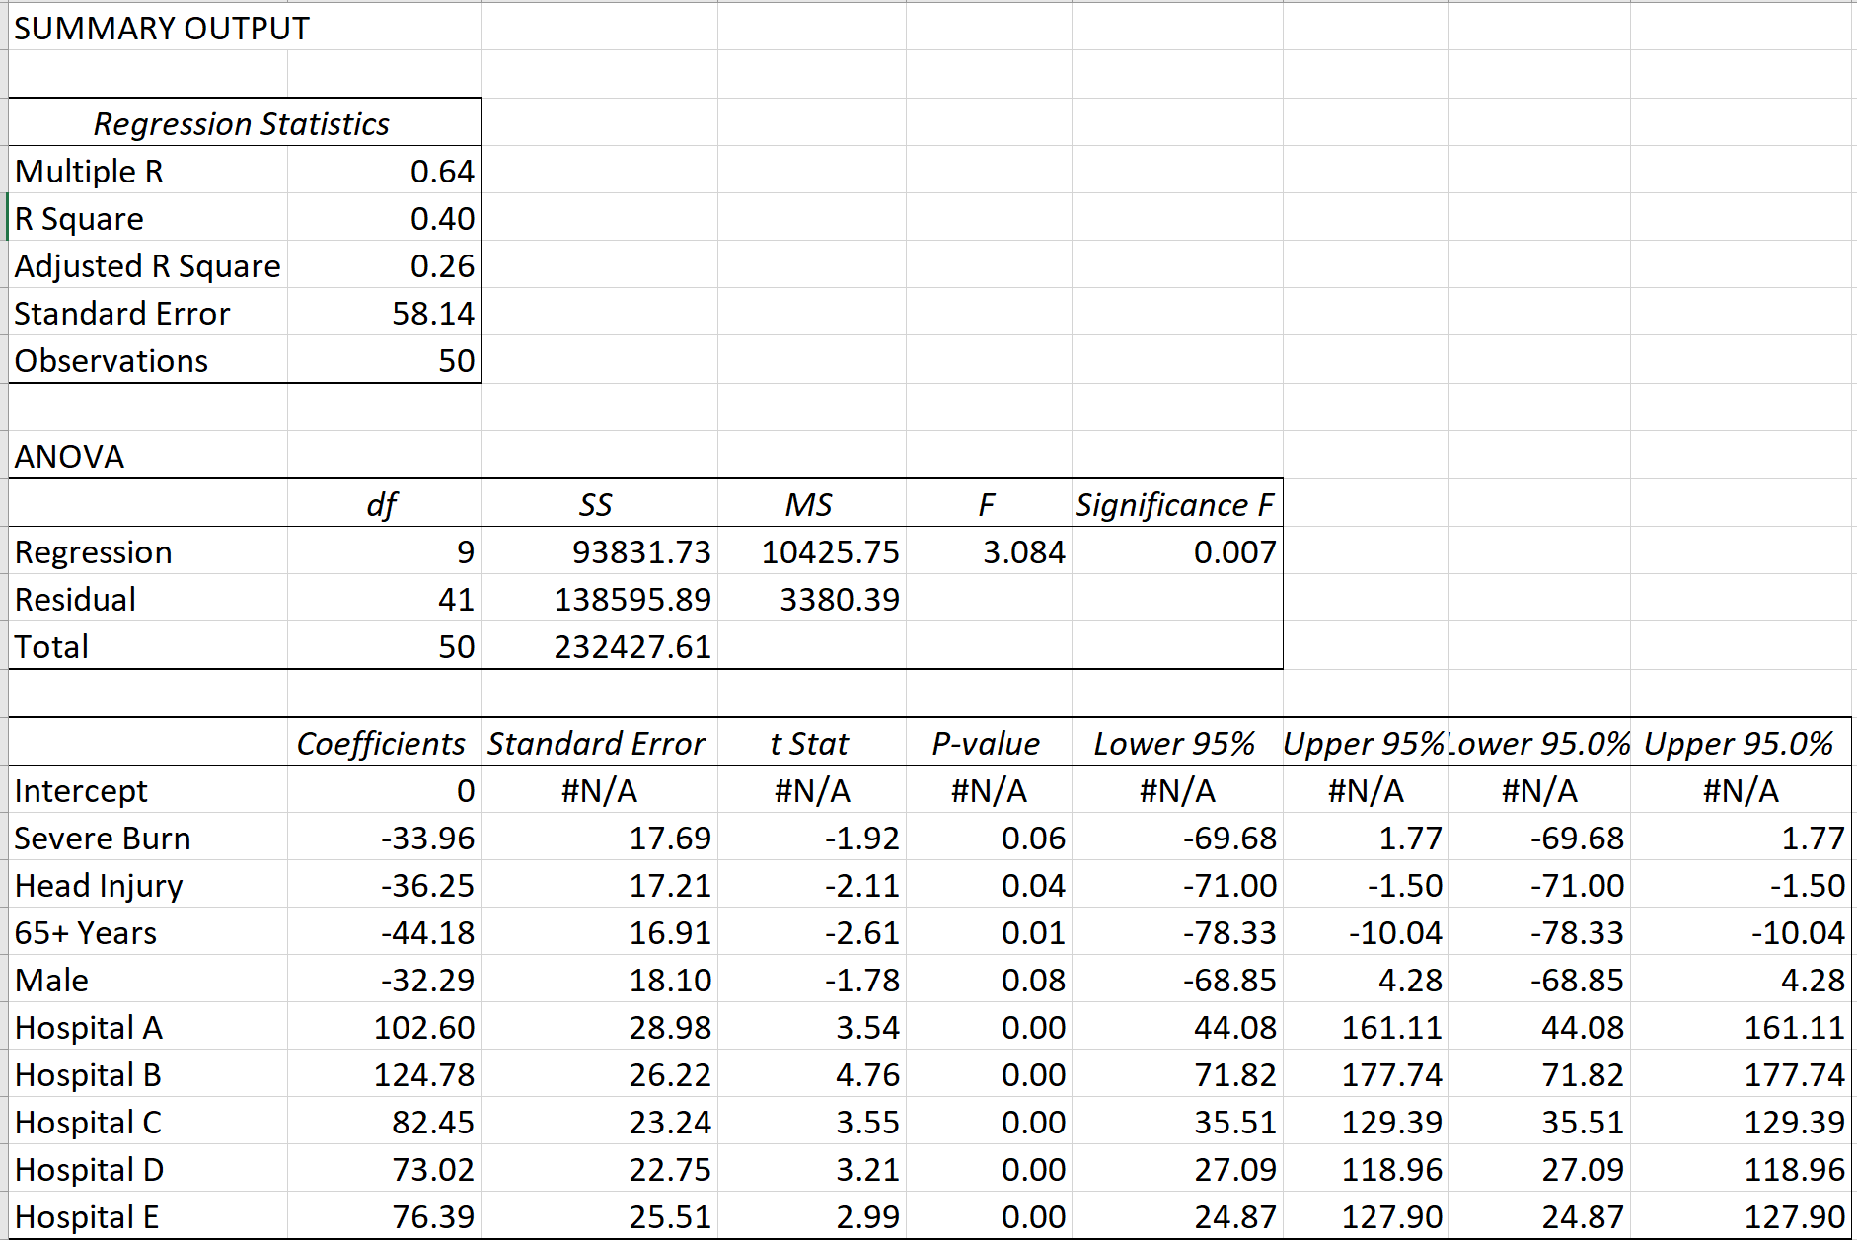

Results
This model explains 26% of variation in the survival odds using the patient’s characteristics of burn severity, head injury, age of 65 and gender being male. One can see that those characteristic decrease odds of survival as observed by the intercepts above. Conversely, the intercepts observed in all the hospitals increased odds of survival.

1.2: Regress unexplained variation in survival probability on features of the hospital, including whether it is a tertiary medical center (Yes=1, No=0), or has a dedicated burn unit (Yes=1, No=0).
Hospital | Calculated Odds of Survival | Tertiary Center | Has Burn Unit
A | 102.6 | 1 | 0
B | 124.78 | 1 | 1
C | 82.45 | 0 | 0
D | 73.02 | 0 | 0
E | 76.39 | 0 | 0

A regression model is built on the odds of survival and features of hospitals. Below is the result:
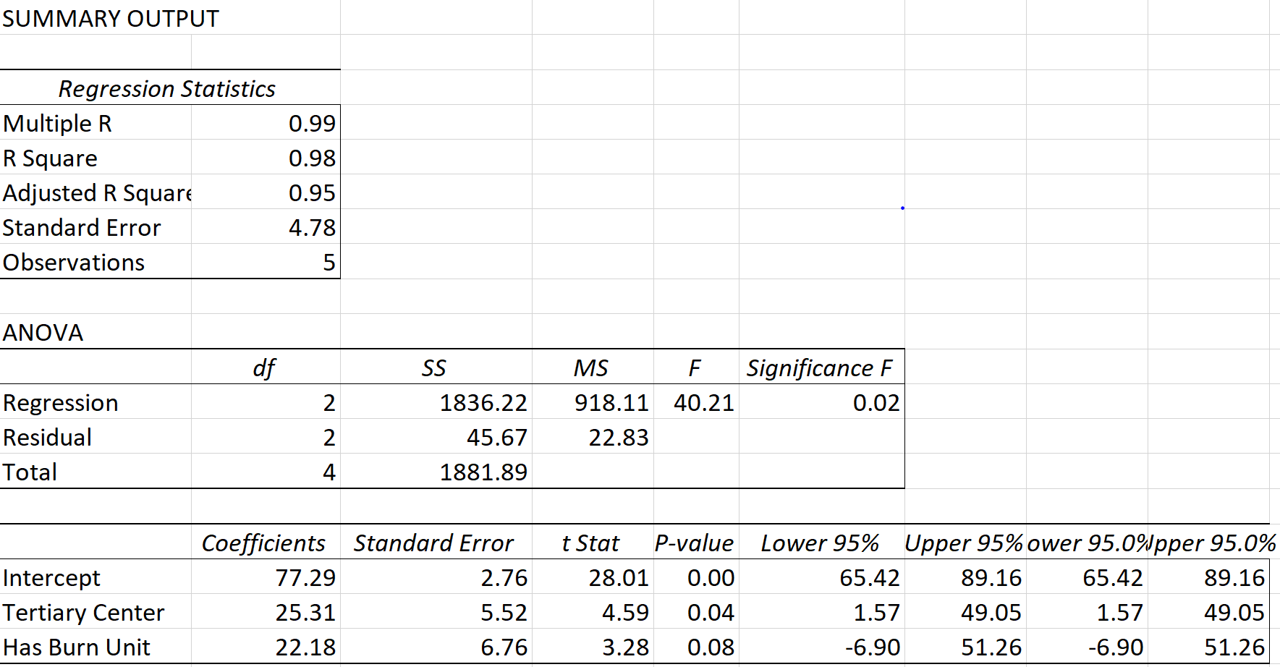

Result:
After removing the effect of patient’s characteristics, the above model shows the overall odds of survival on the type of hospital whether it is a tertiary center or has a burn unit. Thus, the survival odds increase by 25 times when treated in a tertiary center. On the other hand, survival odds increase by 22 folds when treated in a hospital with a burn unit.

1.3: Report the meaning of these two related regressions.
The interpretations for each model are above in the result section. Overall, we can conclude there’s a greater chance of survival in tertiary centers compared to trauma centers. Thus, trauma centers treat patient’s with severe injury compared to those in tertiary centers, which can be one of the reasons for greater chance of survival.

