**HAP 823 | Spring 2018 | Assignment 01 | February 7, 2018**

**Question 3**

OLS multiple regression output from Excel is presented in the table below. The estimated regression equation is:



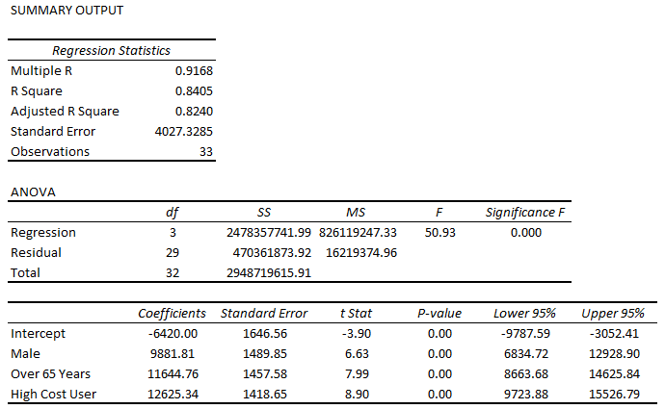

The multiple regression output suggests that all three predictors (gender, age, and last year's cost) are statistically significant predictors of next year's cost. Interpretation of partial slope coefficients is as follows:

**Male:** The average next year's cost for males is $9,881.81 higher than the average for females.

**Over 65 Years:** The average next year's cost for individuals who are over 65 years of age is $11,644.76 higher than the average for individuals who are 65 years or younger.

**High Cost user:** The average next year's for high cost users is $12,625.34 higher than the average for other users.