HAP 823 | Spring 2018 | Assignment 01 | February 7, 2018

Question 1

The regression equation was calculated with Excel using the Analysis Toolpak. Based on the simple regression output shown in Table 1 the estimated ordinary least squares (OLS) simple regression line is :

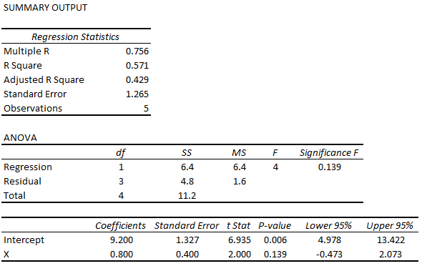
Table 1

The predicted values of Y, residuals, and squared residuals are reported in Table 2. The sum of squared residuals is 4.80. Original data and simple regression line are shown in Figure 1.

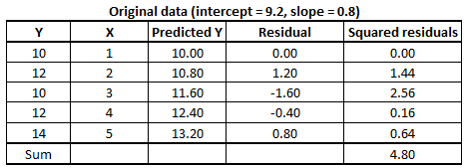
Table 2

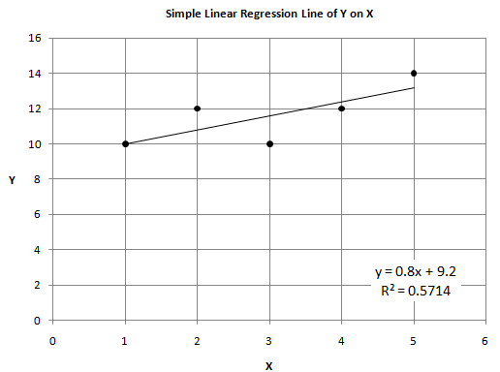
Figure 1

Based on a ±20% change in the intercept of the original regression line, the recalculated predicted values of Y, residuals, and squared residuals are reported in Table 3 (Note: The plotted data points represent original X and Y values). The sum of squared residuals is also reported in the table for each change in the intercept. Regression lines with change in intercept are shown in blue in Figure 2.

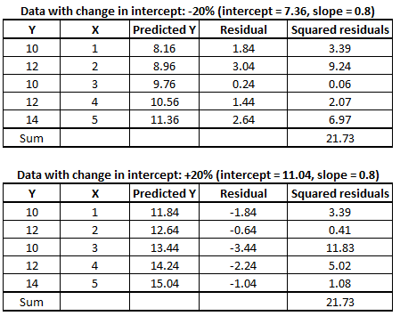
Table 3
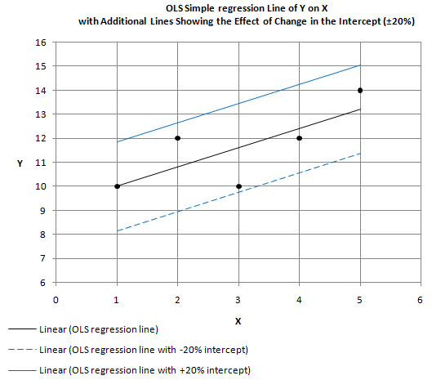
Figure 2

Based on a ±20% change in the slope of the original regression line, the recalculated predicted values of Y, residuals, and squared residuals are reported in Table 4 (Note: The plotted data points represent original X and Y values). The sum of squared residuals is also reported in the table for each change in the slope. Regression lines with change in slope are shown in red in Figure 3.

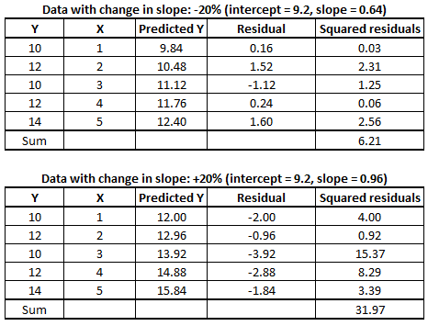
Table 4
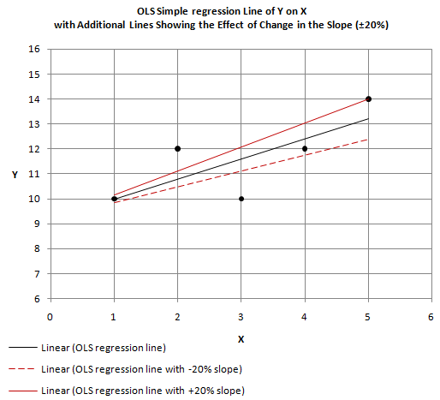
Figure 3

The simple regression line drawn with ordinary least squares (OLS) parameters minimizes the sum of squares. The change in sum of squares of residuals between the OLS simple regression line and lines drawn with modified intercept and slope is summarized in Table 5. This summary suggests that sum of squares of residuals is minimized only by using the OLS intercept and slope estimates.

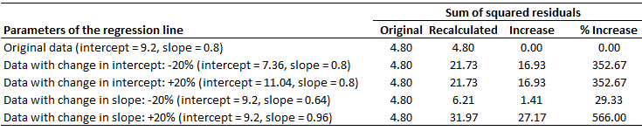
Table 5

