Question 3: The objective of this analysis is to find response to antidepressants. You can select one of the antidepressants.
- These data come from STAR*D experiment conducted by National Institute of Medicine. Read about the study protocol. Protocol►
- Download data. Use instructor's last name as password. Data►
- The data are report bi-weekly or monthly. There are 22,254 records for about 4,000 patients. Organize the data so there is one row for each patient. SQL►
  - Focus: The enclosed data report on citalopram, bupropion, mirzapine, buspirone, lithium, nortriptyline, sertraline, thyroid, tranylclypromine, and venlafaxine. Please focus the analysis on only one of the antidepressants or a combination of two antidepressants taken simultaneously. For the time being ignore the dose of the medication.
  - Exclusions: Patients who did not receive bupropion are assumed to have received the alternative antidepressant. The unit of the analysis is antidepressant trials and not necessary unique person. So the ID that should be used is the combination of patient ID and Concat_Levels.
  - Treatment: If the patient has taken the antidepressant at any time during the study period, then mark it as 1, otherwise 0. Notice that some patients have taken the medication and others have not. Within the combination of ID and Concat_levels look for any occasion of use of bupropion.
  - Covariates: For the covariates, include gender, risk of suicide, heart, vascular, haematopoietic, eyes ears nose throat larynx, gastrointestinal, renal, genitourinary, musculoskeletal Integument, neurological, psychiatric illness, respiratory, liver, endocrine, alcohol, amphetamine, cannibis use, opioid use, panic, specific phobia, social phobia, OCD, PTSD, anxiety, borderline personality, dependent personality, antisocial personality, paranoid personality, personality disorder, anorexia, bulimia, and cocaine use. If the covariate is ever present assume that it is present. Exclude covariates that are not present for any of the patients. Combine covariates that occur occasionally.
  - Outcome: The medication is considered to have caused the remission, if while on the medication, the patient is discharged to follow-up portion of the study, then "Treatment_plan_equal_3" is set to 1. Use "Treatment_Plan_Equal_3" and not "Remission" variable as an indication of effectiveness of the antidepressant, since the remission variable does not indicate that the clinician was in agreement that the patients symptoms are well managed.
Solution:
select * from dbo.STARDantidepressants
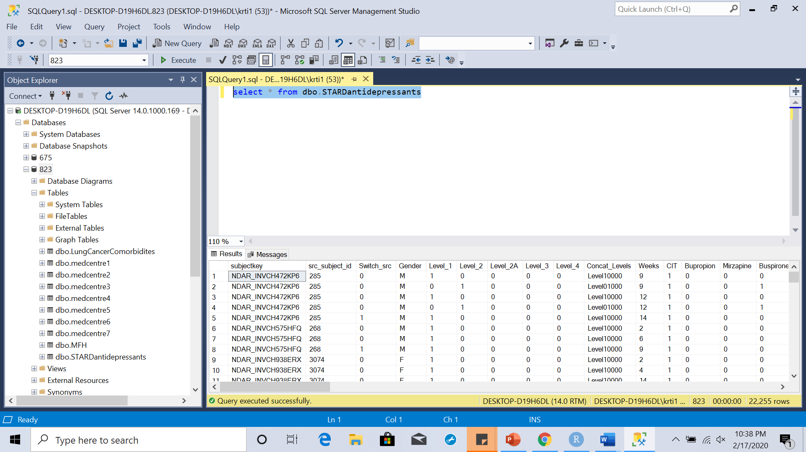
SELECT [subjectkey],[src_subject_id],[Switch_src],[Gender],[Level_1],[Level_2],[Level_2A]
,[Level_3] ,[Level_4],[Concat_Levels]
,cast (weeks as float) as weeks
,cast (CIT as int) as Citalopram
,cast (Bupropion as int) as Bupropion
, cast (Mirzapine as int) as Mirzapine
, cast (Buspirone as int) as Buspirone
, cast (Lithium as int) as Lithium
, cast (Nortriptyline as int) as Nortriptyline
, cast (Sertraline as int) as Sertraline
, cast (Thyroid as int) as Thyroid
, cast (Tranylclypromine as int) as Tranylclypromine
, cast (Venlafaxine as int) as Venlafaxine
, [Concat]
, cast (Switches as int) as Switches
,cast (Patient_Switch as int) as Patient_Switch
,cast (Switches_PerPatient as int) as Switches_PerPatient
,[Med1_dosage]
,[Med2_dosage]
,[Med3_dosage]
,[Med4_dosage]
,cast (Treatment_plan_equal_3 as int) as Treatment_plan_equal_3
,cast (RiskOfSuicide as int) as RiskOfSuicide
,cast (Remission as int) as Remission
,cast (Heart as int) as Heart
,cast (Vascular as int) as Vascular
,cast (Haematopoietic as int) as Haematopoietic
,cast (Eyes_Ears_Nose_Throat_Larynx as int) as Eyes_Ears_Nose_Throat_Larynx
,cast (Gastrointestinal as int) as Gastrointestinal
,cast (Renal as int) as Renal
,cast (Genitourinary as int) as Genitourinary
,cast (Musculoskeletal_Integument as int) as Musculoskeletal_Integument
,cast (Neurological as int) as Neurological
,cast (Psychiatric_Illness as int) as Psychiatric_Illness
,cast (Respiratory as int) as Respiratory
,cast (Liver as int) as Liver
,cast (Endocrine as int) as Endocrine
,cast (Alcohol as int) as Alcohol
,cast (Amphetamine as int) as Amphetamine
,cast (Cannibis as int) as Cannibis
,cast (Opioid as int) as Opioid
,cast (Panic as int) as Panic
,cast (Specific_Phobia as int) as Specific_Phobia
,cast (Social_Phobia as int) as Social_Phobia
,cast (OCD as int) as OCD
,cast (PTSD as int) as PTSD
,cast (Anxiety as int) as Anxiety
,cast (Borderline_Personality as int) as Borderline_Personality
,cast (Dependent_Personality as int) as Dependent_Personality
,cast (Antisocial_Personality as int) as Antisocial_Personality
,cast (Paranoid_Personality as int) as Paranoid_Personality
,cast (Personality_Disorder as int) as Personality_Disorder
,cast (Anorexia as int) as Anorexia
,cast (Bulimia as int) as Bulimia
,cast (Cocaine as int) as Cocaine
into #cast
FROM dbo.STARDantidepressants
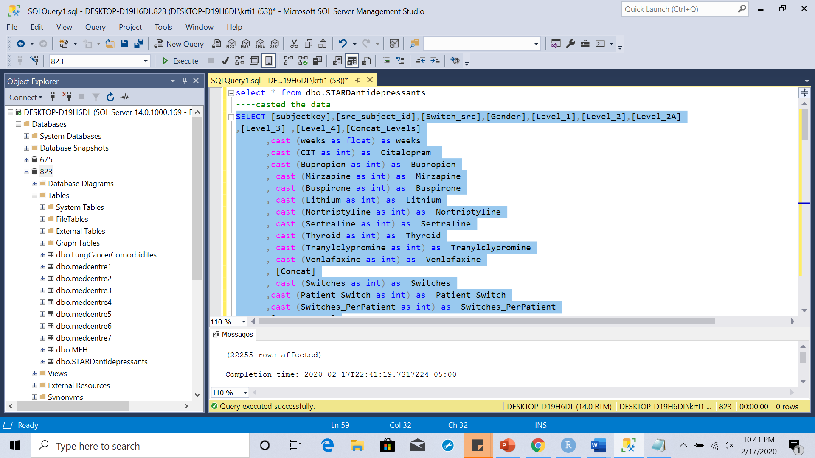

SELECT src_subject_id as id,concat([Concat],Concat_Levels) as Med, concat, concat_levels
,Max(Citalopram) as Citalopram
, Max(CAST([Treatment_plan_equal_3] AS FLOAT)) as Remission
, CASE WHEN Sum([RiskOfSuicide])=0 THEN 0 ELSE 1 END AS [RiskOfSuicide]
, CASE WHEN Sum([Heart])=0 THEN 0 ELSE 1 END AS [Heart]
, CASE WHEN Sum([Vascular])=0 THEN 0 ELSE 1 END AS [vascular]
, CASE WHEN Sum([Haematopoietic])=0 THEN 0 ELSE 1 END AS [Haematopoietic]
, CASE WHEN Sum([Eyes_Ears_Nose_Throat_Larynx])=0 THEN 0 ELSE 1 END AS [Eyes_Ears_Nose_Throat_Larynx]
, CASE WHEN Sum([Gastrointestinal])=0 THEN 0 ELSE 1 END AS [Gastrointestinal]

, CASE WHEN Sum([Renal])=0 THEN 0 ELSE 1 END AS [Renal]

, CASE WHEN Sum([Genitourinary])=0 THEN 0 ELSE 1 END AS [Genitourinary]

, CASE WHEN Sum([Musculoskeletal_Integument])=0 THEN 0 ELSE 1 END AS [Musculoskeletal_Integument]

, CASE WHEN Sum([Neurological])=0 THEN 0 ELSE 1 END AS [Neurological]

, CASE WHEN Sum([Psychiatric_Illness])=0 THEN 0 ELSE 1 END AS [Psychiatric_Illness]
, CASE WHEN Sum([Respiratory])=0 THEN 0 ELSE 1 END AS [Respiratory]

, CASE WHEN Sum([Liver])=0 THEN 0 ELSE 1 END AS [Liver]

, CASE WHEN Sum([Endocrine])=0 THEN 0 ELSE 1 END AS [Endocrine]

, CASE WHEN Sum([Alcohol])=0 THEN 0 ELSE 1 END AS [Alcohol]

, CASE WHEN Sum([Amphetamine])=0 THEN 0 ELSE 1 END AS [Amphetamine]

, CASE WHEN Sum([Cannibis])=0 THEN 0 ELSE 1 END AS [Cannibis]

, CASE WHEN Sum([Opioid])=0 THEN 0 ELSE 1 END AS [Opioid]
, CASE WHEN Sum([Panic])=0 THEN 0 ELSE 1 END AS [Panic]

, CASE WHEN Sum([Specific_Phobia])=0 THEN 0 ELSE 1 END AS [Specific_Phobia]

, CASE WHEN Sum([OCD])=0 THEN 0 ELSE 1 END AS [OCD]

, CASE WHEN Sum([PTSD])=0 THEN 0 ELSE 1 END AS [PTSD]

, CASE WHEN Sum([Anxiety])=0 THEN 0 ELSE 1 END AS [Anxiety]

, CASE WHEN Sum([Borderline_Personality])=0 THEN 0 ELSE 1 END AS [Borderline_Personality]
, CASE WHEN Sum([Dependent_Personality])=0 THEN 0 ELSE 1 END AS [Dependent_Personality]

, CASE WHEN Sum([Antisocial_Personality])=0 THEN 0 ELSE 1 END AS [Antisocial_Personality]

, CASE WHEN Sum([Paranoid_Personality])=0 THEN 0 ELSE 1 END AS [Paranoid_Personality]

, CASE WHEN Sum([Personality_Disorder])=0 THEN 0 ELSE 1 END AS [Personality_Disorder]

, CASE WHEN Sum([Anorexia])=0 THEN 0 ELSE 1 END AS [Anorexia]

, CASE WHEN Sum([Bulimia])=0 THEN 0 ELSE 1 END AS [Bulimia]

, CASE WHEN Sum([Cocaine])=0 THEN 0 ELSE 1 END AS [Cocaine]

INTO #Data
FROM #cast
group by src_subject_id,[Concat],Concat_Levels
Order by src_subject_id, Concat_Levels desc
Go
