Assignment “Cost Effectiveness”
HAP 823
Arpitha Thakkalapally and Brinda Somasundaram
SQL queries for Stratified Covariate Balancing to evaluate the cost effectiveness of the Medical Foster Home (MFH) program compared to Contract Nursing Home (CNH) . The data includes multiple comorbidities for each patient. Control for these variables as well as demographics .
Method: Stratified Covariate Balancing to remove the confounding of the covariates.
- Generate various combination of covariates:
SELECT Count(MFHvsCNH2.mfh) AS n, MFHvsCNH2.mfh, MFHvsCNH2.LateAdmit, MFHvsCNH2.CHF, MFHvsCNH2.Cardiac, MFHvsCNH2.Valvular, MFHvsCNH2.Pulmonary, MFHvsCNH2.Vascular, MFHvsCNH2.Hypertension, MFHvsCNH2.Paralysis, MFHvsCNH2.Neurological, MFHvsCNH2.COPD, MFHvsCNH2.Diabetes, MFHvsCNH2.Hypothyroidism, MFHvsCNH2.Renal, MFHvsCNH2.Liver, MFHvsCNH2.Ulcer, MFHvsCNH2.Liver, MFHvsCNH2.Ulcer, MFHvsCNH2.HIV, MFHvsCNH2.Lymphoma, MFHvsCNH2.MetastiticCancer, MFHvsCNH2.TumorNoMetastasis, MFHvsCNH2.Artheritis, MFHvsCNH2.Coagulopathy, MFHvsCNH2.Obesity, MFHvsCNH2.Weightloss, MFHvsCNH2.Electrolyte, MFHvsCNH2.BloodLossAnemia, MFHvsCNH2.DeficincyAnemia, MFHvsCNH2.Alcohol, MFHvsCNH2.Drug, MFHvsCNH2.Psychoses, MFHvsCNH2.Depression, MFHvsCNH2.DeadInPeriod, MFHvsCNH2.Plus75, MFHvsCNH2.Male, MFHvsCNH2.SingleNeverMarried, MFHvsCNH2.Widowed, MFHvsCNH2.Married, MFHvsCNH2.[DivorcedSeperated ]
FROM MFHvsCNH2
WHERE (((MFHvsCNH2.TotalCost)<>0))
GROUP BY MFHvsCNH2.mfh, MFHvsCNH2.LateAdmit, MFHvsCNH2.CHF, MFHvsCNH2.Cardiac, MFHvsCNH2.Valvular, MFHvsCNH2.Pulmonary, MFHvsCNH2.Vascular, MFHvsCNH2.Hypertension, MFHvsCNH2.Paralysis, MFHvsCNH2.Neurological, MFHvsCNH2.COPD, MFHvsCNH2.Diabetes, MFHvsCNH2.Hypothyroidism, MFHvsCNH2.Renal, MFHvsCNH2.Liver, MFHvsCNH2.Ulcer, MFHvsCNH2.HIV, MFHvsCNH2.Lymphoma, MFHvsCNH2.MetastiticCancer, MFHvsCNH2.TumorNoMetastasis, MFHvsCNH2.Artheritis, MFHvsCNH2.Coagulopathy, MFHvsCNH2.Obesity, MFHvsCNH2.Weightloss, MFHvsCNH2.Electrolyte, MFHvsCNH2.BloodLossAnemia, MFHvsCNH2.DeficincyAnemia, MFHvsCNH2.Alcohol, MFHvsCNH2.Drug, MFHvsCNH2.Psychoses, MFHvsCNH2.Depression, MFHvsCNH2.DeadInPeriod, MFHvsCNH2.Plus75, MFHvsCNH2.Male, MFHvsCNH2.SingleNeverMarried, MFHvsCNH2.Widowed, MFHvsCNH2.Married, MFHvsCNH2.[DivorcedSeperated ], MFHvsCNH2.Liver, MFHvsCNH2.Ulcer;

Design view:
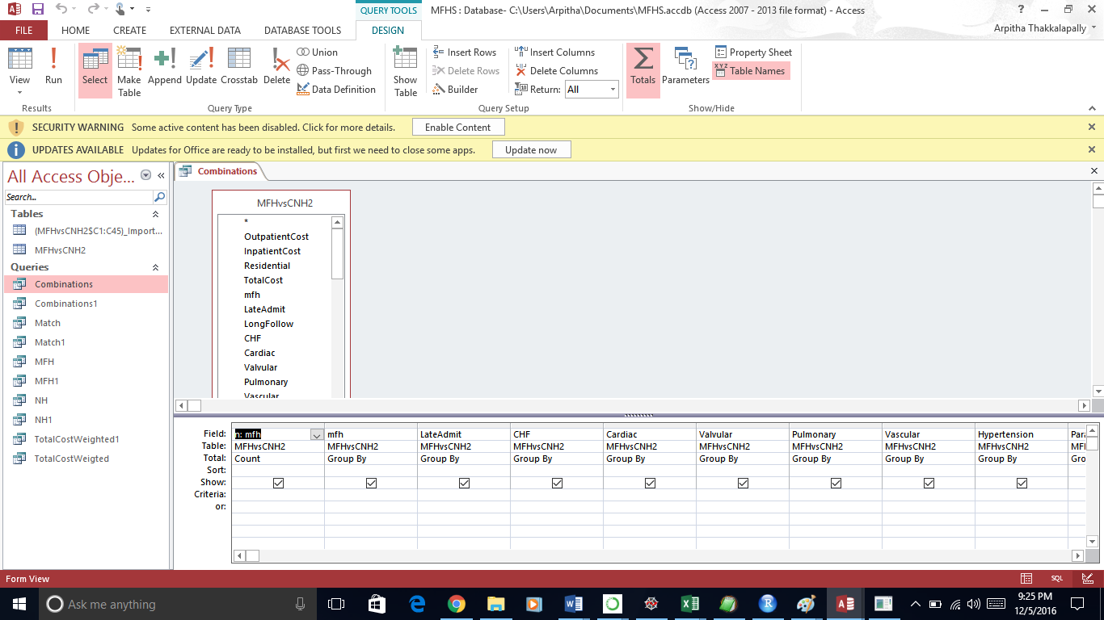

Datasheet View:
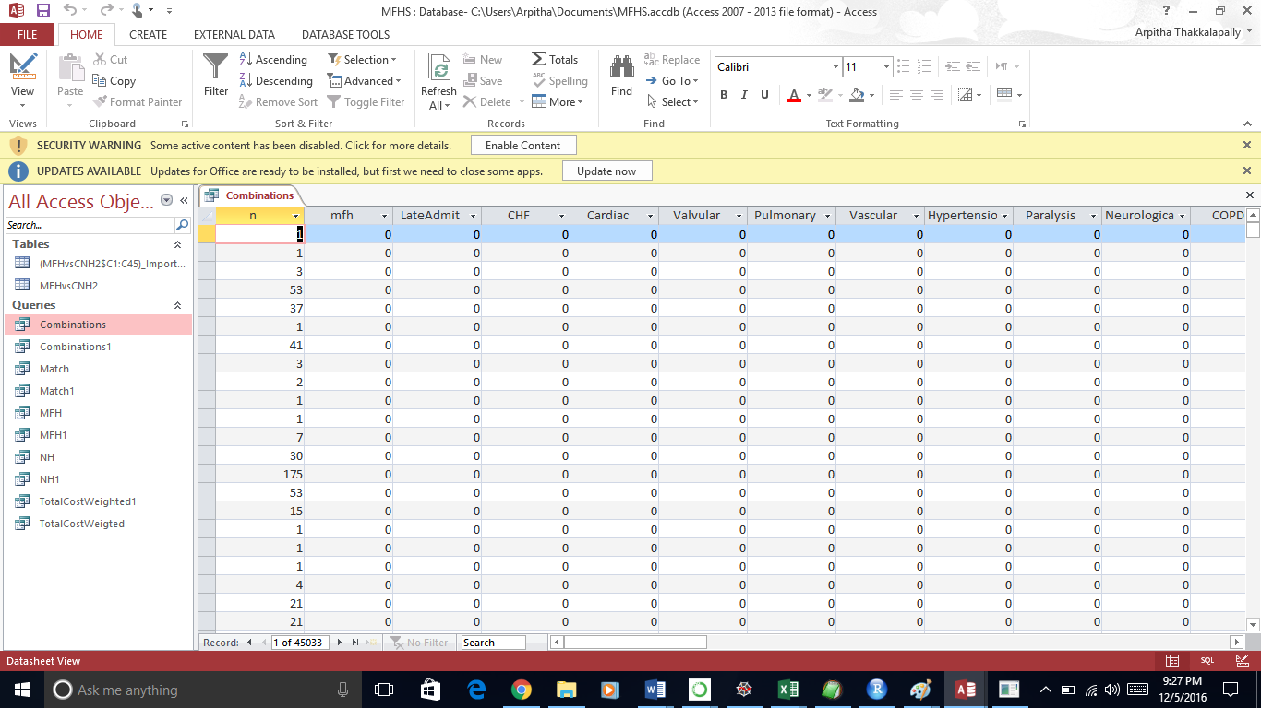

- Separate Cases and controls from combinations.
- Generate Cases where mfh=1:
SELECT Combinations.mfh AS Cases, Combinations.*
FROM Combinations
WHERE (((Combinations.mfh)=1));
- Generate Controls where mfh=0:
SELECT Combinations.mfh AS Controls, Combinations.*
FROM Combinations
WHERE (((Combinations.mfh)=0));
- Match the cases and controls in naturally occurring strata. (Making controls and cases equal by weighing)

SELECT NH.n, NH.Controls, [MFH]![n]/[NH]![n] AS w, MFH.*
FROM MFH INNER JOIN NH ON (MFH.[DivorcedSeperated ] = NH.[DivorcedSeperated ]) AND (MFH.Married = NH.Married) AND (MFH.Widowed = NH.Widowed) AND (MFH.SingleNeverMarried = NH.SingleNeverMarried) AND (MFH.Male = NH.Male) AND (MFH.Plus75 = NH.Plus75) AND (MFH.DeadInPeriod = NH.DeadInPeriod) AND (MFH.Depression = NH.Depression) AND (MFH.Psychoses = NH.Psychoses) AND (MFH.Drug = NH.Drug) AND (MFH.Alcohol = NH.Alcohol) AND (MFH.DeficincyAnemia = NH.DeficincyAnemia) AND (MFH.BloodLossAnemia = NH.BloodLossAnemia) AND (MFH.Electrolyte = NH.Electrolyte) AND (MFH.Weightloss = NH.Weightloss) AND (MFH.Obesity = NH.Obesity) AND (MFH.Coagulopathy = NH.Coagulopathy) AND (MFH.Artheritis = NH.Artheritis) AND (MFH.TumorNoMetastasis = NH.TumorNoMetastasis) AND (MFH.MetastiticCancer = NH.MetastiticCancer) AND (MFH.Lymphoma = NH.Lymphoma) AND (MFH.HIV = NH.HIV) AND (MFH.Ulcer = NH.Ulcer) AND (MFH.Liver = NH.Liver) AND (MFH.Expr1016 = NH.Expr1016) AND (MFH.Expr1015 = NH.Expr1015) AND (MFH.Renal = NH.Renal) AND (MFH.Hypothyroidism = NH.Hypothyroidism) AND (MFH.Diabetes = NH.Diabetes) AND (MFH.COPD = NH.COPD) AND (MFH.Neurological = NH.Neurological) AND (MFH.Paralysis = NH.Paralysis) AND (MFH.Hypertension = NH.Hypertension) AND (MFH.Vascular = NH.Vascular) AND (MFH.Pulmonary = NH.Pulmonary) AND (MFH.Valvular = NH.Valvular) AND (MFH.Cardiac = NH.Cardiac) AND (MFH.CHF = NH.CHF) AND (MFH.LateAdmit = NH.LateAdmit);

Design View:
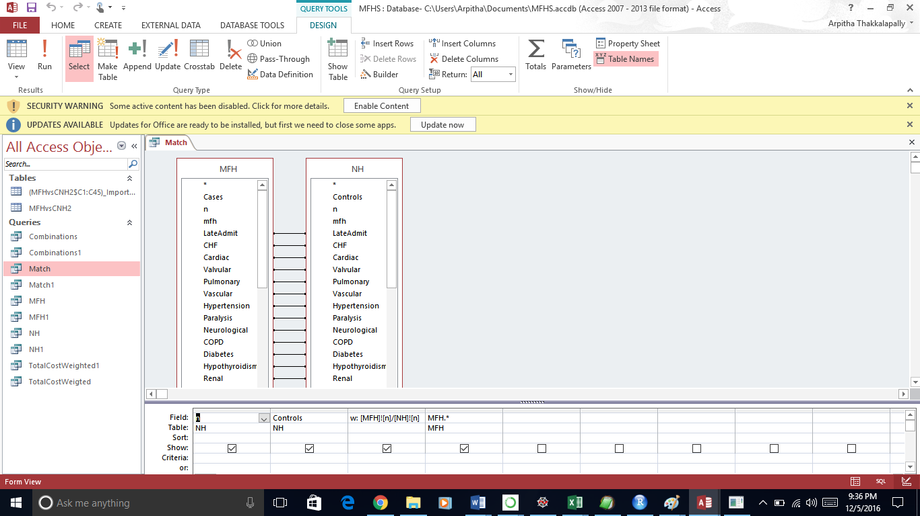

Data Sheet View:
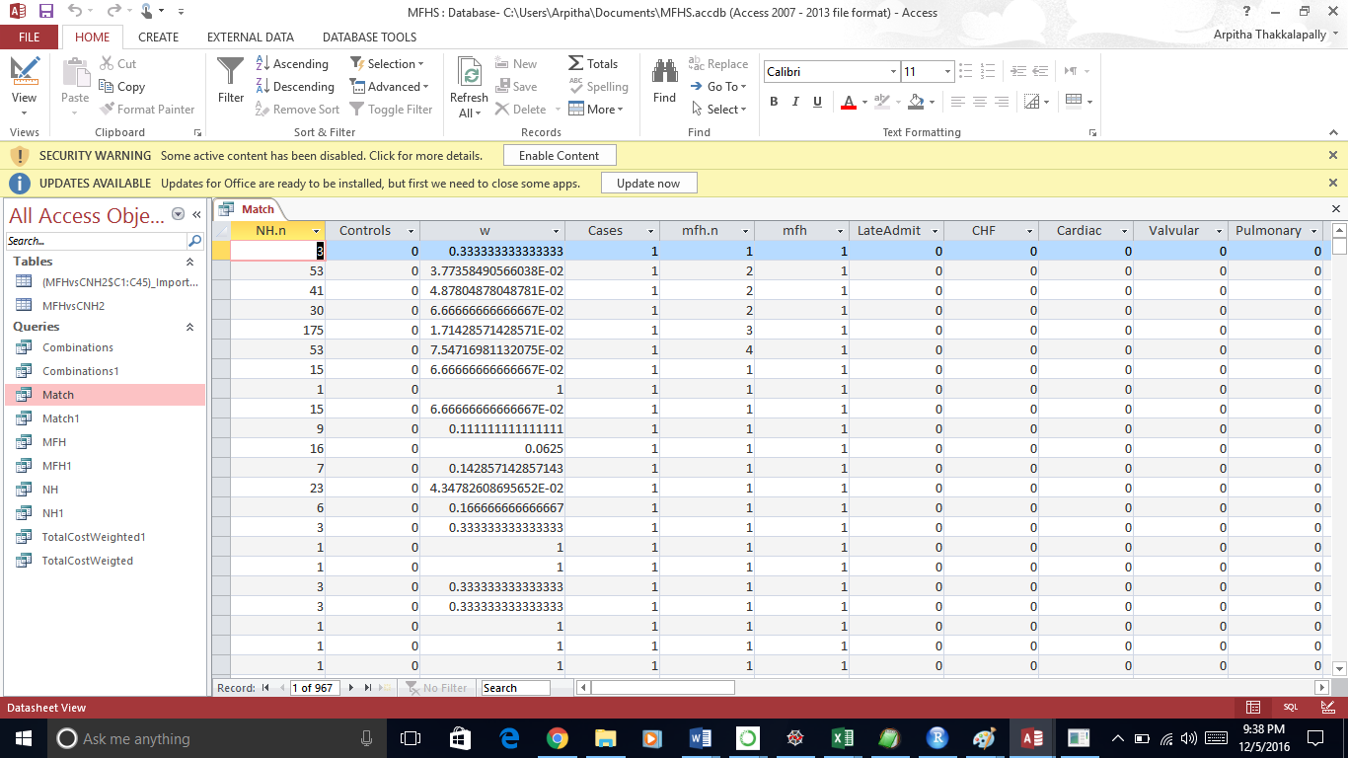

- Comparing the Total Cost for MFH vs Total Cost for NH while all the covariates are controlled.
SELECT MFHvsCNH2.mfh, Avg([TotalCost]*IIf([Match]![mfh]=1,1,[w])) AS Expr1
FROM [Match] INNER JOIN MFHvsCNH2 ON (Match.[DivorcedSeperated ] = MFHvsCNH2.[DivorcedSeperated ]) AND (Match.Married = MFHvsCNH2.Married) AND (Match.Widowed = MFHvsCNH2.Widowed) AND (Match.SingleNeverMarried = MFHvsCNH2.SingleNeverMarried) AND (Match.Male = MFHvsCNH2.Male) AND (Match.Plus75 = MFHvsCNH2.Plus75) AND (Match.DeadInPeriod = MFHvsCNH2.DeadInPeriod) AND (Match.Depression = MFHvsCNH2.Depression) AND (Match.Psychoses = MFHvsCNH2.Psychoses) AND (Match.Drug = MFHvsCNH2.Drug) AND (Match.Alcohol = MFHvsCNH2.Alcohol) AND (Match.DeficincyAnemia = MFHvsCNH2.DeficincyAnemia) AND (Match.BloodLossAnemia = MFHvsCNH2.BloodLossAnemia) AND (Match.Electrolyte = MFHvsCNH2.Electrolyte) AND (Match.Weightloss = MFHvsCNH2.Weightloss) AND (Match.Obesity = MFHvsCNH2.Obesity) AND (Match.Coagulopathy = MFHvsCNH2.Coagulopathy) AND (Match.Artheritis = MFHvsCNH2.Artheritis) AND (Match.TumorNoMetastasis = MFHvsCNH2.TumorNoMetastasis) AND (Match.MetastiticCancer = MFHvsCNH2.MetastiticCancer) AND (Match.Lymphoma = MFHvsCNH2.Lymphoma) AND (Match.HIV = MFHvsCNH2.HIV) AND (Match.Ulcer = MFHvsCNH2.Ulcer) AND (Match.Liver = MFHvsCNH2.Liver) AND (Match.Renal = MFHvsCNH2.Renal) AND (Match.Hypothyroidism = MFHvsCNH2.Hypothyroidism) AND (Match.Diabetes = MFHvsCNH2.Diabetes) AND (Match.COPD = MFHvsCNH2.COPD) AND (Match.Neurological = MFHvsCNH2.Neurological) AND (Match.Paralysis = MFHvsCNH2.Paralysis) AND (Match.Hypertension = MFHvsCNH2.Hypertension) AND (Match.Vascular = MFHvsCNH2.Vascular) AND (Match.Pulmonary = MFHvsCNH2.Pulmonary) AND (Match.Valvular = MFHvsCNH2.Valvular) AND (Match.Cardiac = MFHvsCNH2.Cardiac) AND (Match.CHF = MFHvsCNH2.CHF) AND (Match.LateAdmit = MFHvsCNH2.LateAdmit)
GROUP BY MFHvsCNH2.mfh;

Design view:
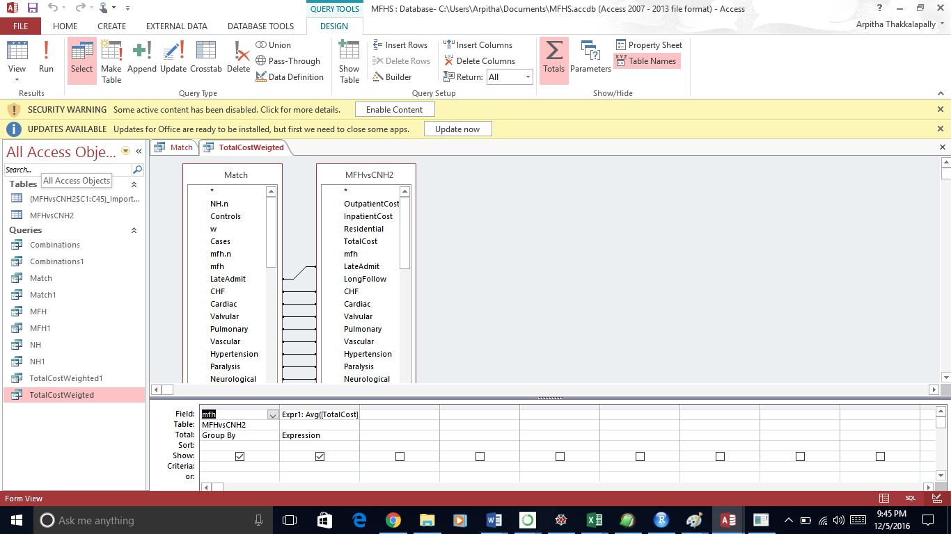

Data sheet View:
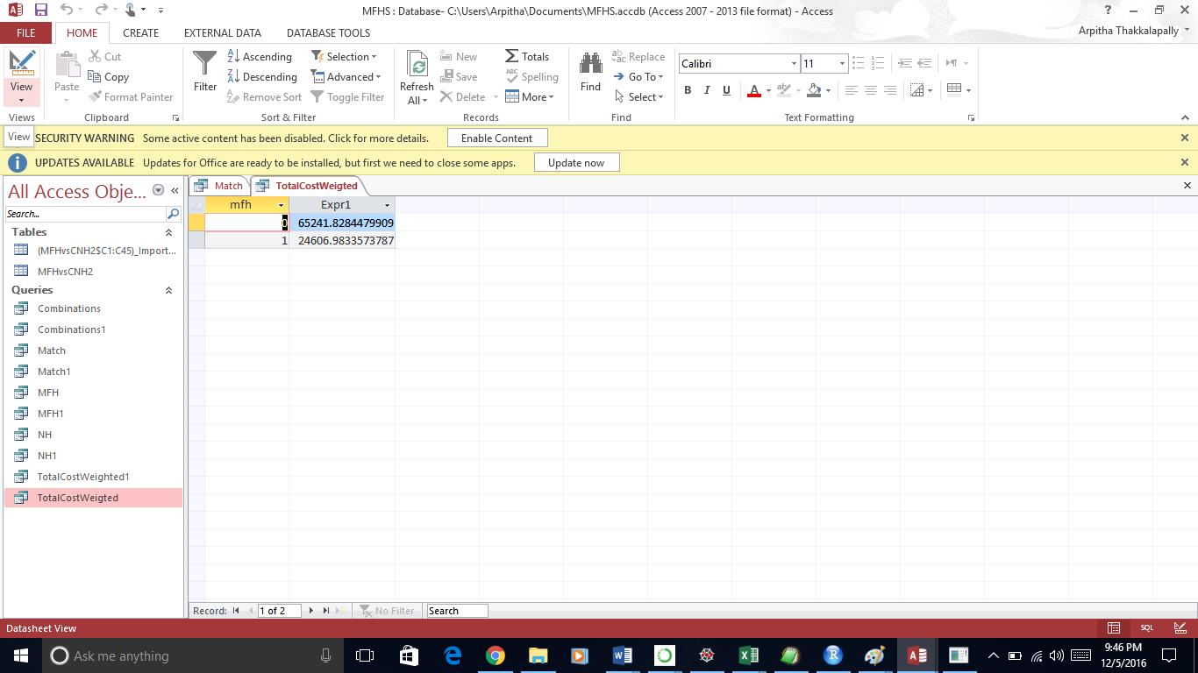

Conclusion: Average total cost associated with MFH program is $24606.00
Average total cost associated with CNH program is $65241.00
The average of expected total cost savings associated with MFH program as compared to CNH, while holding demographics, family status and comorbidities constant is $40,635.00

