Bushra Hamdan Alghamdi
Assignment 5
HAP 820

- Construct a Bayesian probability network model that would predict success with citalopram

A network model will include variables, and mediators of the effect of variables, on response to citalopram. Include at least 5 variables in your model. Remission or relapse should be considered an end node. Variables that cannot be altered (e.g. year of birth) should be considered root nodes. All other variables are either root or intermediary variables. The structure of the network model could be based on expert's opinion, analysis of conditional independence, and your own analysis of association among the variables. The probabilities among the variables should be estimated from the data.

First we need to choose the nodes and values to predict Citalopram success

Node name | Type | Values
Response to CIT  Family History  Alcohol Abuse  Drug Abuse  OBCD | Boolean  Boolean  Boolean  Boolean  Boolean | {0, 1}  {0, 1}  {0, 1}  {0, 1}  {0, 1}

Solution Using Netica:

Gender =M (Coded 0)

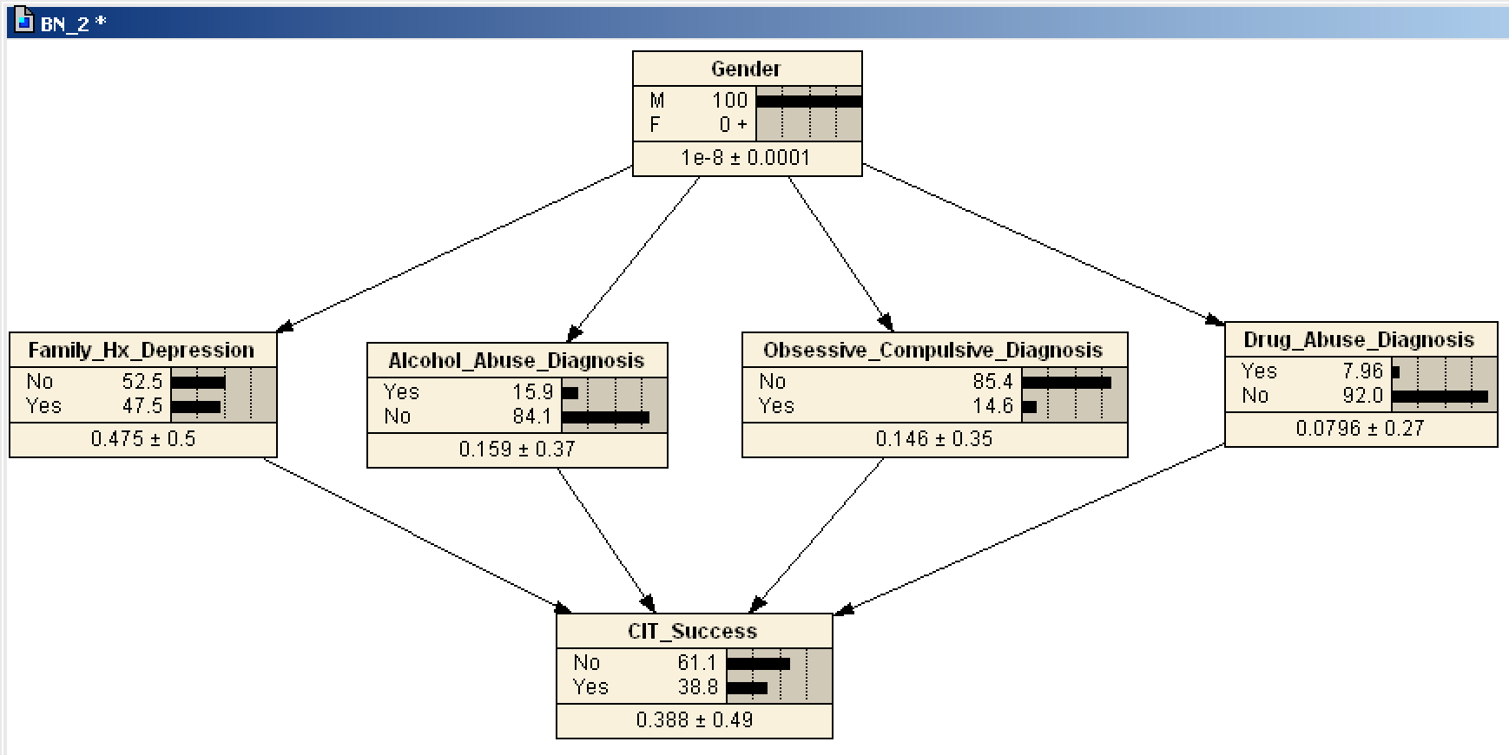
Gender=F (Coded 1)

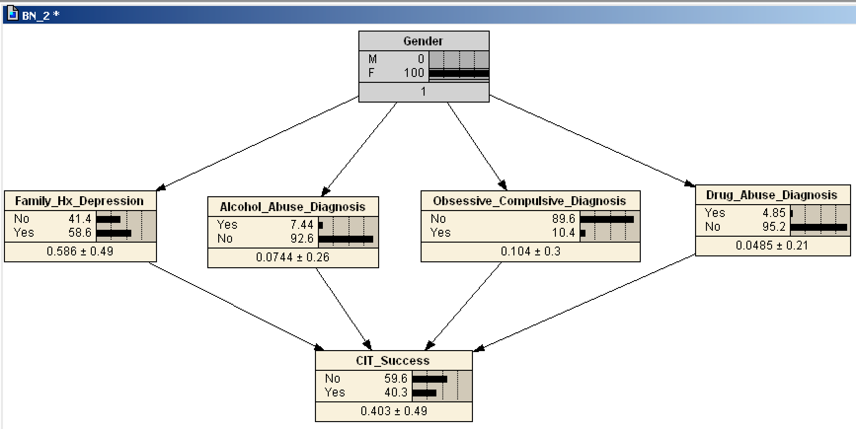

Solution Using SPSS Modeler:

I used SPSS Modeler to, imported the SPSS file with all the variables and then specified the Type of my variables and the target variable which is CIT Success, then we need to choose Bayes Net from Modeling Option, after running the model the Bays network constructed for the variables that we specified earlier.

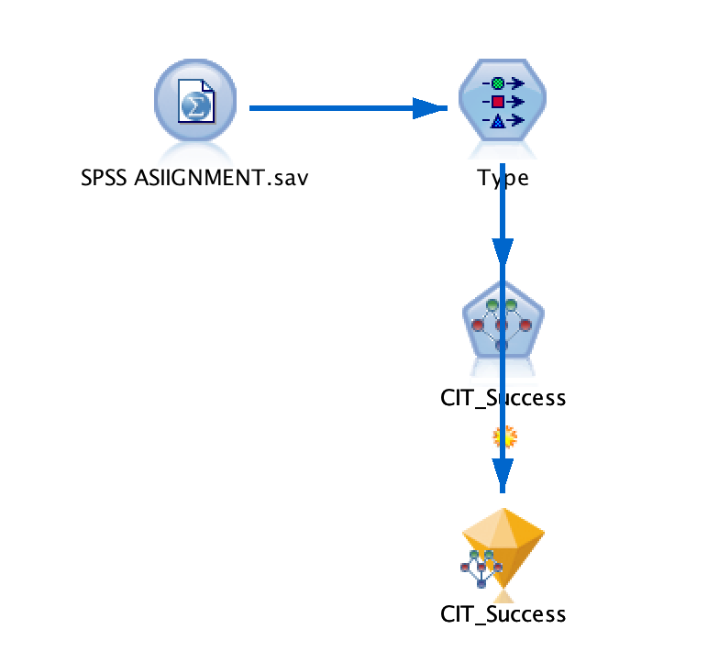

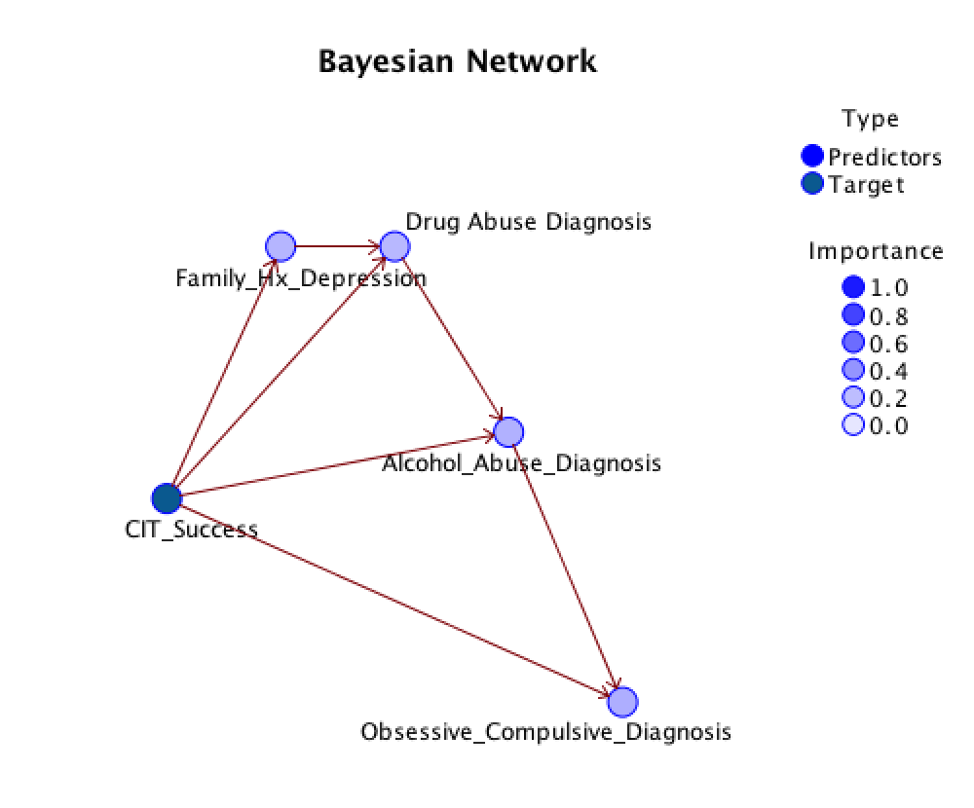

Conditional Probabilities Tables

