Bushra Hamdan Alghamdi
Assignment 5- Section 3
HAP 820

Write an SQL code to calculate the probability of adverse outcome in the following situation:

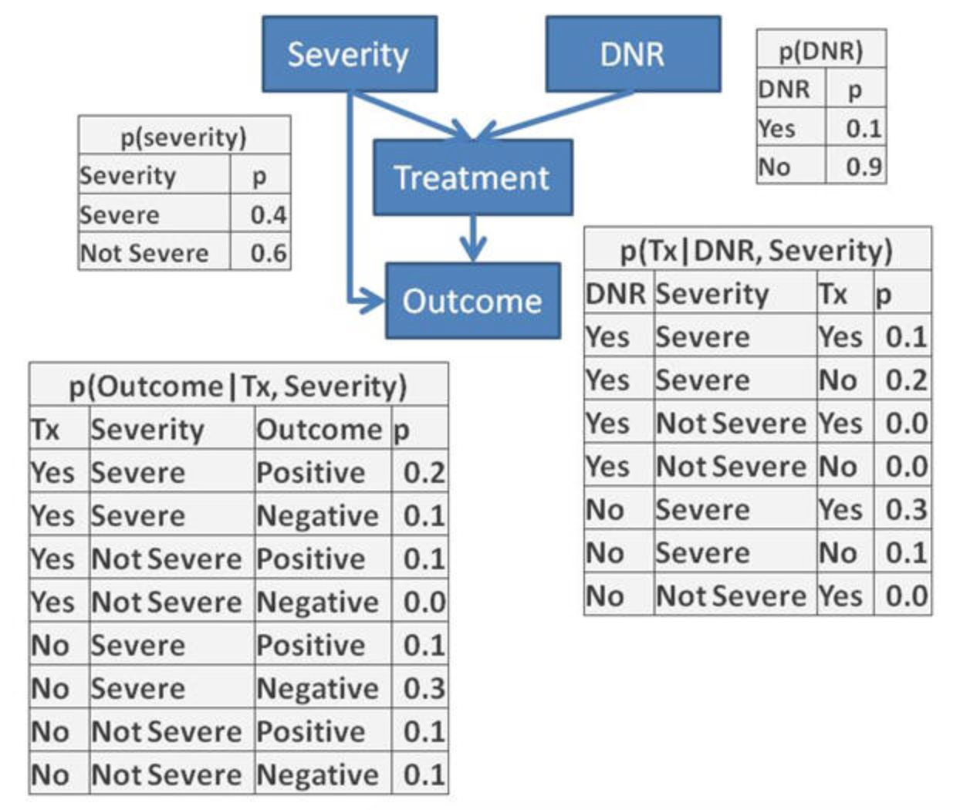

First, we need to eliminate the variables that we are not focusing on which are “Not Severe” cases.

p(severity) |  |  | p(DNR) |  |  | p(Tx|DNR, Severity) |  |  |  |  | p(Outcome|Tx, Severity)
Severity | p |  | DNR | p |  | DNR | Severity | Tx | p |  | Tx | Severity | Outcome | p
Severe | 0.4 |  | Yes | 0.1 |  | Yes | Severe | Yes | 0.1 |  | Yes | Severe | Positive | 0.2
Not Severe | 0.6 |  | No | 0.9 |  | Yes | Severe | No | 0.2 |  | Yes | Severe | Negative | 0.1
 |  |  |  |  |  | Yes | Not Severe | Yes | 0.0 |  | Yes | Not Severe | Positive | 0.1
 |  |  |  |  |  | Yes | Not Severe | No | 0.0 |  | Yes | Not Severe | Negative | 0.0
 |  |  |  |  |  | No | Severe | Yes | 0.3 |  | No | Severe | Positive | 0.1
 |  |  |  |  |  | No | Severe | No | 0.1 |  | No | Severe | Negative | 0.3
 |  |  |  |  |  | No | Not Severe | Yes | 0.0 |  | No | Not Severe | Positive | 0.1

Now we should join the first two tables using cross join as they don’t share features.

p(severity) |  |  | p(DNR)
Severity | p |  | DNR | p
Severe | 0.4 |  | Yes | 0.1
Not Severe | 0.6 |  | No | 0.9

p(Sev DNR)
Severity | DNR | p
Severe | Yes | 0.4
Severe | No | 0.36

The final table is the probabilities product of severity and DNR.
The SQl code will specify our selection of variables from which table we want to have or variables from, which in our case p(sev) table and p(DNR) and the condition is that we want only sever cases, so not sever cases will be eliminated.
SELECT [p(Sev)].Severity, [p(DNR)].DNR, [p(DNR)]![p]*[p(Sev)]![p] AS p
FROM [p(DNR)], [p(Sev)]
WHERE ((([p(Sev)].Severity)="Severe"));
Now that we have our variables of interest that will reflect the severity and DNR through our network, we want to combined the resulting table with treatment table given DNR and severity.

p(Sev DNR)
Severity | DNR | p
Severe | Yes | 0.4
Severe | No | 0.36

p(Tx|DNR, Severity)
DNR | Severity | Tx | p
Yes | Severe | Yes | 0.1
Yes | Severe | No | 0.2
No | Severe | Yes | 0.3
No | Severe | No | 0.1
We will do inner join using SQL coding for sever cases, with all the probabilities of DNR and the treatment, we will do the same multiply the probabilities with its equivalent from each table.
SELECT
[p(Tx|DNR Sev)].Tx,
[p(Tx|DNR Sev)].Severity,
[p(Tx|DNR Sev)].DNR,
+[p(Tx|DNR Sev)]![p]*[p(Sev DNR)]![p] AS p
FROM [p(Sev DNR)] INNER JOIN [p(Tx|DNR Sev)]
ON ([p(Sev DNR)].Severity = [p(Tx|DNR Sev)].Severity) AND ([p(Sev DNR)].DNR = [p(Tx|DNR Sev)].DNR);
Severity
Tx | Severity | DNR | p
Yes | Severe | No | 0.108
No | Severe | No | 0.036
Yes | Severe | Yes | 0.04
No | Severe | Yes | 0.08

Now we are not interested any more in DNR values given that we have our treatment and severity variables. So, we will select from the treatment table above severity and treatment variables and the probabilities for each treatment and severity will be sum by combining each no and yes cases for treatment across different values of DNR and then we need to specify the grouping based on the treatment and severity only.
SELECT [p(Tx Sev DNR)].Tx, [p(Tx Sev DNR)].Severity, Sum([p(Tx Sev DNR)].p) AS psum
FROM [p(Tx Sev DNR)]
GROUP BY [p(Tx Sev DNR)].Tx, [p(Tx Sev DNR)].Severity;
p(Tx Sev)
Tx | Severity | psum
No | Severe | 0.12
Yes | Severe | 0.15

Now we will join the previous table with the outcome table.
p(Outcome|Tx, Severity)
Tx | Severity | Outcome | p
Yes | Severe | Positive | 0.2
Yes | Severe | Negative | 0.1
No | Severe | Positive | 0.1
No | Severe | Negative | 0.3
The resulted table:

p(Tx Sev Outcome)
Tx | Severity | Outcome | p
Yes | Severe | Positive | 0.03
Yes | Severe | Negative | 0.015
No | Severe | Positive | 0.012
No | Severe | Negative | 0.036

Because we are interested in the adverse outcome we will sum the probabilities of negative outcome over treatment values, and we can also add the probabilities of the positive values to compare:

SELECT
[p(tx sev outcome)].Severity,
[p(tx sev outcome)].Outcome,
Sum([p(tx sev outcome)]![p]/[SumOfp]) AS p
FROM [p(tx sev outcome)], SumOfP
GROUP BY [p(tx sev outcome)].Severity, [p(tx sev outcome)].Outcome;

Severity | Outcome | p
Severe | Negative | 0.51
Severe | Positive | 0.042

So, the probability of adverse outcome is 0.51.

Lastly, we need to normalize the probabilities so they sum to one.

Severity | Outcome | p | p normalized
Severe | Negative | 0.51 | 0.92391304
Severe | Positive | 0.042 | 0.07608696
 | Total | 0.552 | 1

So we have 92.4% of our severe patients have adverse outcomes.

