Citalopram lasso regression:
#Libraries needed
library(glmnet)
library(dplyr)
library(psych)
library(caret)

Read the data
data <- read.csv("/Users/krti1/Documents/823//STARDUNIQUE.csv")
Data is having 3,678 entries, 48 total columns

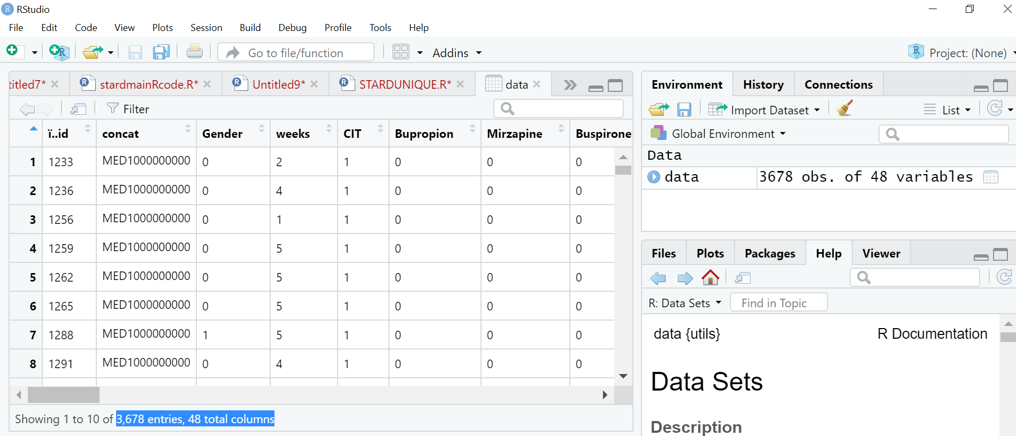
ncol(data)
names(data)
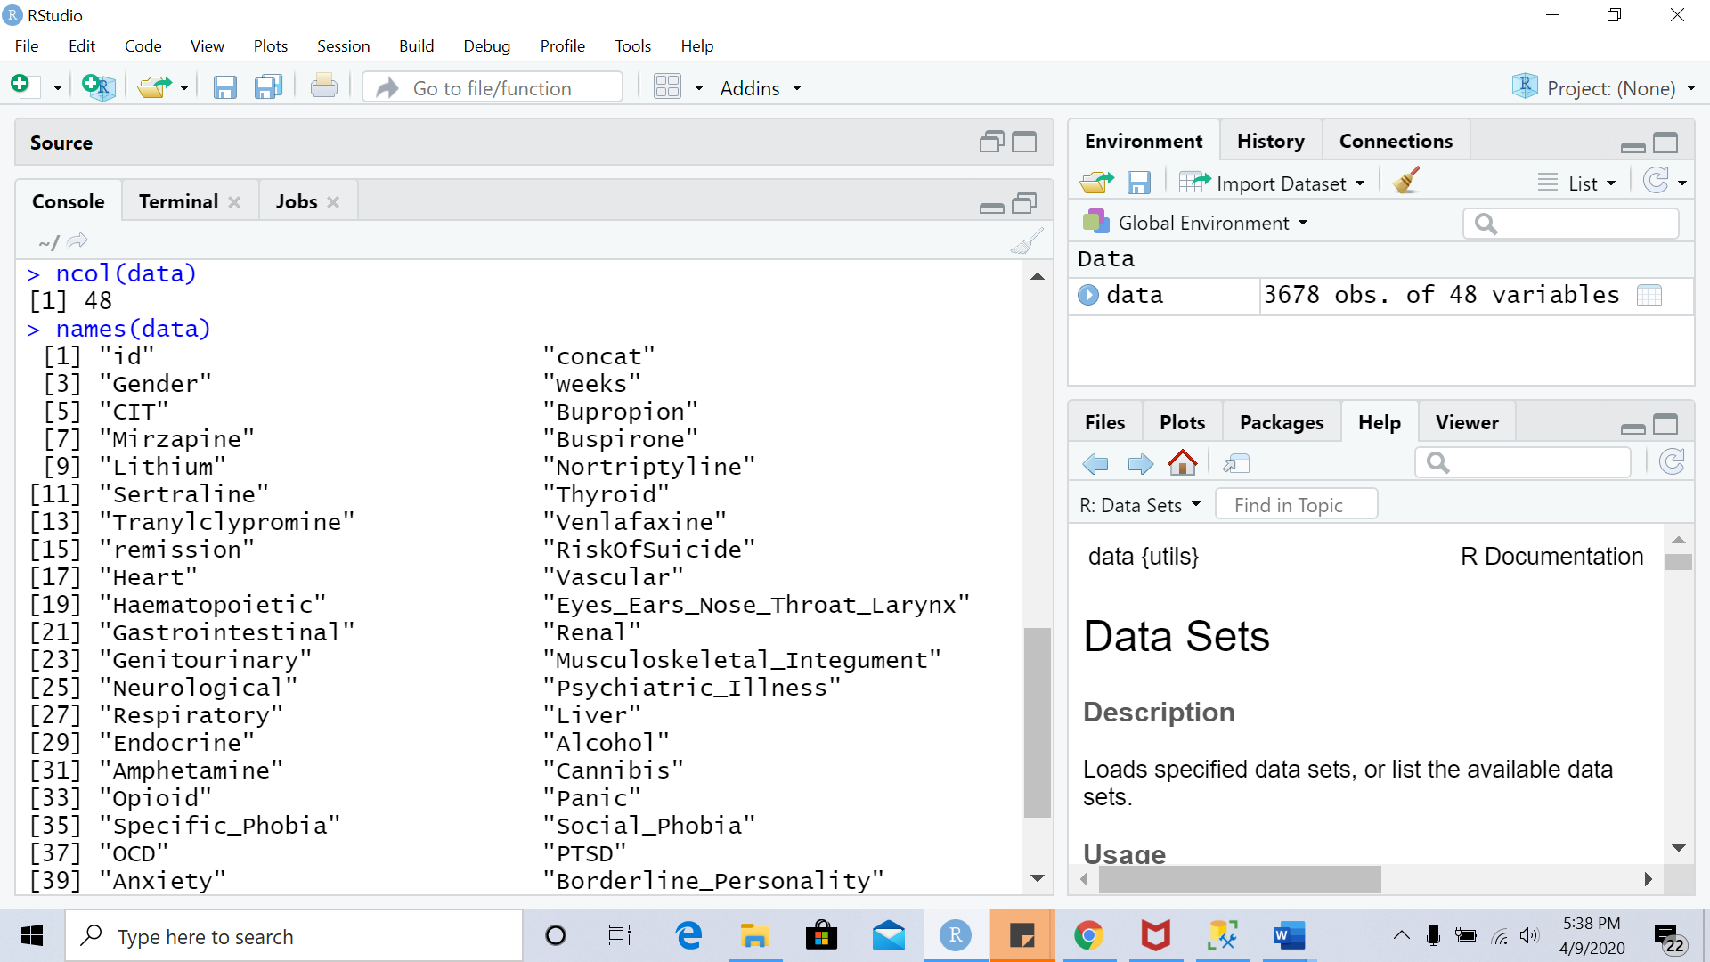

#data preparation
data = subset(data, select = -c(1,2,4,5,6,7,8,9,10,11,13,14,15) )
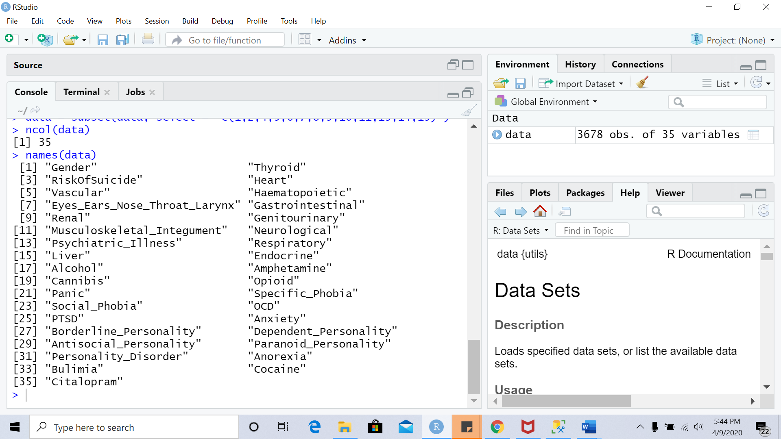

#Data partition
set.seed(12345)
Citalopram<-sample(2, nrow(data), replace =T, prob=c(0.8,0.2))
train<- data[Citalopram==1,]
test<-data[Citalopram==2,]
str(train)
str(test)
# Custom Control Parameters
custom<-trainControl(method = "repeatedcv",
number=10,repeats =5,verboseIter=T)
#Lasso
set.seed(12345)
lasso<-train(Citalopram~.,
train,method='glmnet',
tuneGrid=expand.grid(alpha=1,lambda=seq(0.001,1,length=100)),
trControl=custom)
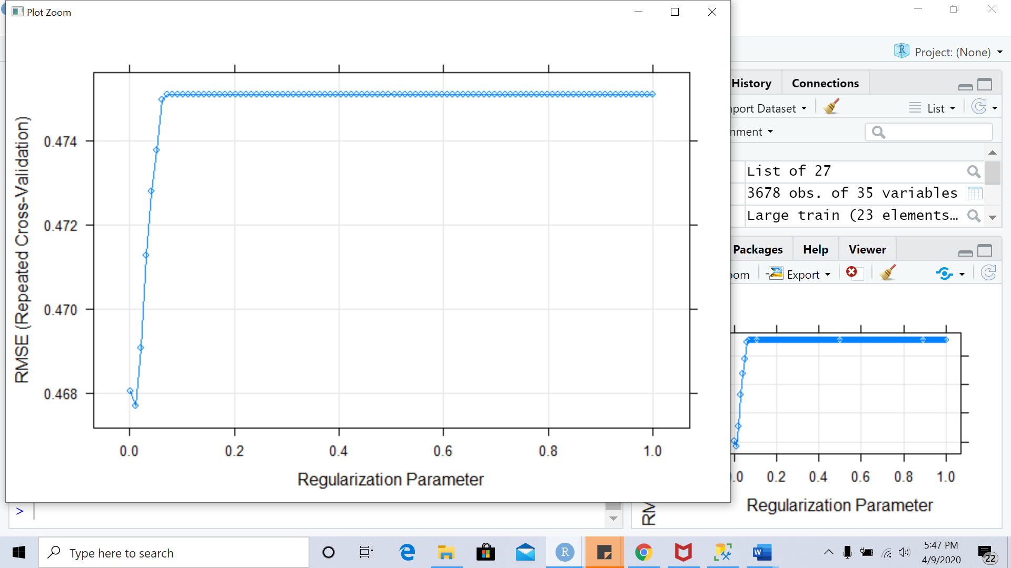

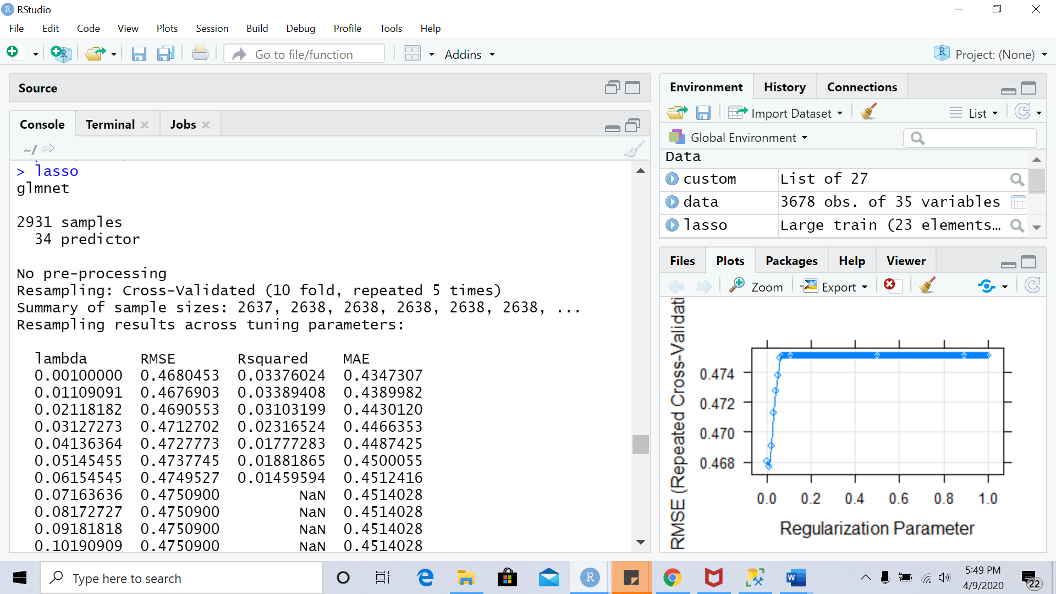
Tuning parameter 'alpha' was held constant at a value of 1
RMSE was used to select the optimal model using the
smallest value.
The final values used for the model were alpha = 1 and lambda
= 0.01109091.

plot(lasso$finalModel,xvar='lambda',label=T)
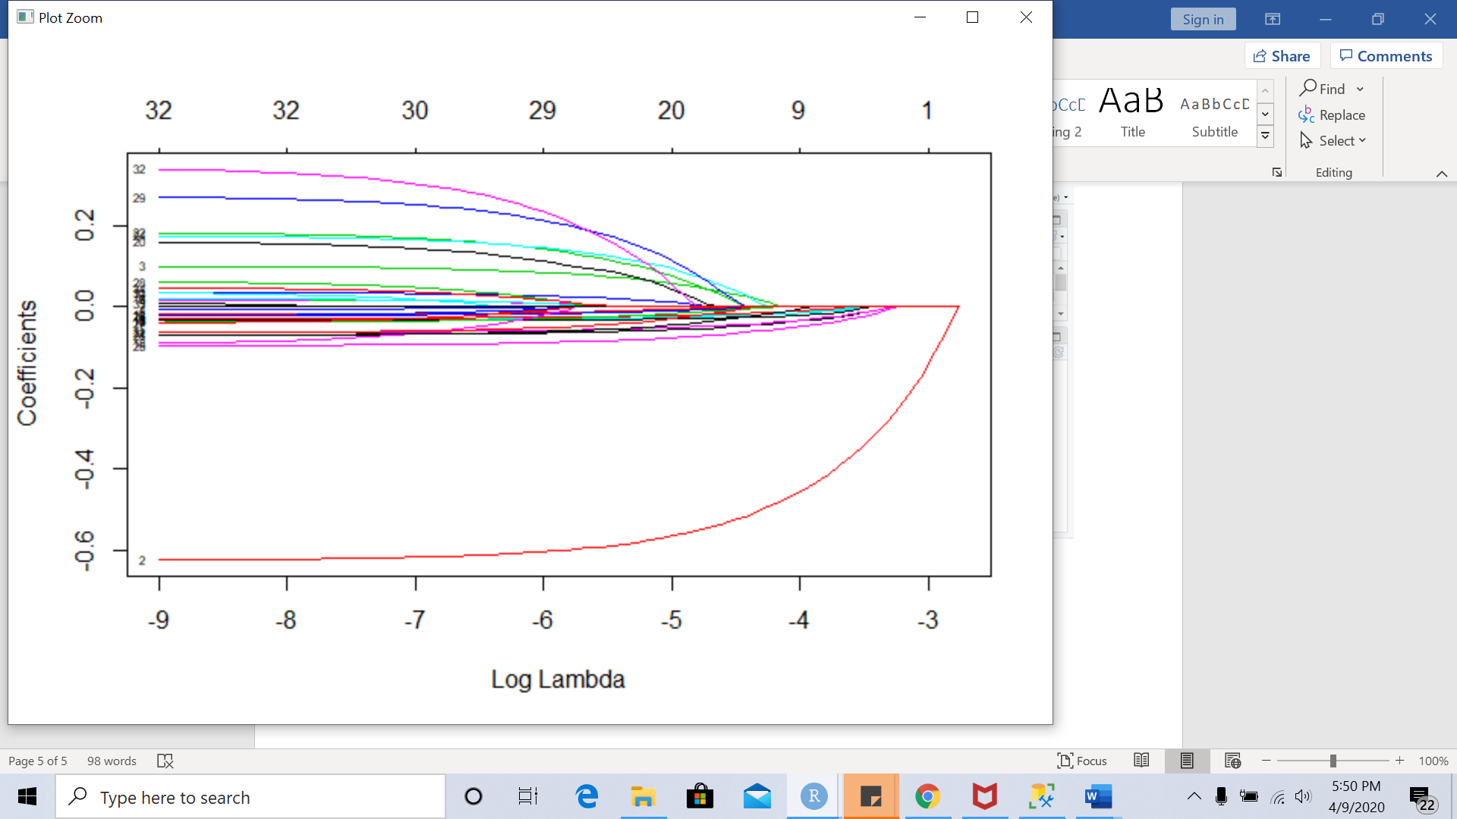
Important variables:
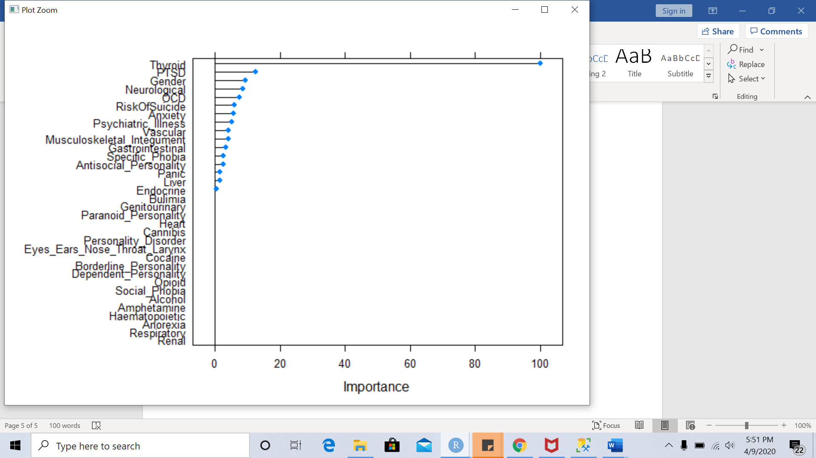
Coefficients:
variables | coefficients
Thyroid | -0.523369941
PTSD | -0.065271314
Gender | -0.048383704
Neurological | -0.044387301
OCD | -0.038998683
RiskOfSuicide | -0.030551429
Anxiety | -0.029084408
Psychiatric_Illness | -0.026430132
Vascular | -0.021954483
Musculoskeletal_Integument | -0.021041815
Gastrointestinal | -0.017101078
Specific_Phobia | -0.013489655
Antisocial_Personality | -0.013187988
Panic | -0.007955247
Liver | -0.007073405
Endocrine | -0.002530159
Eyes_Ears_Nose_Throat_Larynx
Anorexia
Cocaine
Renal
Genitourinary
Personality_Disorder
Respiratory
Dependent_Personality
Cannibis
Opioid
Social_Phobia
Heart
Haematopoietic
Alcohol
Amphetamine
Borderline_Personality
Paranoid_Personality
Bulimia

#prediction
p1 <- predict(fm, train)
sqrt(mean((train$Citalopram-p1)^2))
p2 <- predict(fm, test)
sqrt(mean((train$Citalopram-p2)^2))

