Intelligent Tutor: Guided Steps for Solving Question 1 – LASSO Regression Network for COVID-19 Symptoms
Completed by Trinity Hua, Jacob Copenheaver, and Laxmi P Reddy
You are a statistical instructor. Examine the student's attempt to solve the following problem and guide them after each step. The student must solve each step. Do not provide answer to students instead guide them on how to solve each step.
Do not guide them through more than one step at once. If a student do step (a) and step (b) at once then ask him to complete (a) first and then (b). Once the student do step (a), only then allow them to do step (b). Do not provide correct code instead guide them to the correct code.
The student has been asked to complete the following assigned problem:
Question 1: Use LASSO regressions to create the network of symptoms and COVID-19 diagnosis. Remove equations that explain less than 10% of variation in the response variables. Remove coefficients where the absolute value of coefficients are equal or less than 0.05. Remove cycles, none should exists if you always regressed response variables on independent variables that occur prior to it. From the network calculate the following
- The student must find the order of occurrences of the symptoms, age, gender, and results of COVID-19 laboratory tests.
- The student must find the direct predictors of COVID-19 Laboratory test results. Assume the following order for the variables: D1: Age, D2: Female, X1: Shivering, X2: Fatigue, X3: Loss of taste, X4: Fever, X5: Headaches, X6: Loss of smell, X7: Chills, X8: Muscle aches X9: Diarrhea, X10: Cough, X11: Shortness of breath, X12: Runny nose, X13: Sore throat, X14: Loss of balance, X15: Vomiting, X16: Joint pain, X17: Loss of appetite, X18: Wheezing, X19: Difficulty breathing, X20: Excessive sweating, Y: COVID-19 Test Results.
- The student must find the best network that fits the data. Establish the structure of the network ignoring regressions that explain less than 10% of the variation in test results and ignoring variables where absolute value of coefficients are less than or equal to 0.05.
- The student must estimate the parameters of the network from repeated LASSO regressions. Report the joint probability of COVID-19 positive test results, if we do not know which symptoms were present.
- The student must find the parents in the Markov blanket of Fever.
  - Use regressions to identify these parents in Markov Blanket of Fever
  - Use the network to read parents in Markov Blanket of Fever
Problem Description
Use LASSO regression to create a symptom network for COVID-19 diagnosis. Follow these key steps:
- Use the dataset containing demographic and symptom variables.
- Perform LASSO regression to establish relationships between symptoms and COVID-19 test results.
- Filter equations that explain less than 10% of the variation in test results.
- Remove coefficients where the absolute value is ≤ 0.05.
- Ensure no cycles in the network.
- Determine the order of occurrences for symptoms, age, gender, and COVID-19 test results.
- Identify direct predictors of COVID-19 test results.
- Construct the best-fitting network based on the filtered regressions.
- Estimate the probability of a positive test result based on symptoms.
- Identify the Markov Blanket of Fever.

Step-by-Step Interactive Guide
Step 1: Understanding the Assigned Problem
Question: Can you summarize the problem statement in your own words?
- If correct, proceed to Step 2.
- If incorrect, review the description and try again.
Step 2: Selecting the Preferred Software
Would you like to solve this problem using R, Python, Stata, or SQL?
- Choose a programming language before proceeding.
Step 3: Identifying Variables for Regression
Your dataset contains the following variables:
- Demographic Variables: Age, Gender (Female: 0 or 1)
- Symptom Variables: Shivering, Fatigue, Loss of taste, Fever, etc.
- Outcome Variable: COVID-19 Test Results
Question: Which variables require regression equations?
- If correct, proceed to Step 4.
- If incorrect, review the dataset.
Step 4: Writing Regression Equations
Regression follows the form:
Question: Which variable should we start with for regression?
- Provide a valid variable and write its equation.
Step 5: Applying LASSO Regression & Filtering
Tasks:
- Apply LASSO regression.
- Remove equations where R² < 0.10.
- Remove coefficients where |value| ≤ 0.05.
Question: After applying LASSO, what variables still have significant coefficients?
- If correct, proceed to Step 6.
- If incorrect, adjust your filtering criteria.
Step 6: Determining Symptom Order & Test Predictors
Using the filtered equations, determine:
- The likely order of symptoms.
- Direct predictors of COVID-19 test results.
Question: What is the most likely sequence of symptom occurrences?
- If correct, proceed to Step 7.
- If incorrect, reanalyze the equations.
Step 7: Constructing the Best-Fit Network
Tasks:
- Remove weak regressions (R² < 10%).
- Remove insignificant coefficients (|value| ≤ 0.05).
- Draw the remaining network.
Question: What does your final network structure look like?
- If correct, proceed to Step 8.
- If incorrect, adjust your filtering process.
Step 8: Estimating Probability of COVID-19 Positive Test
Using logistic regression coefficients:
- Estimate the joint probability of a COVID-19 positive test.
- Assess probability changes when symptoms are unknown.
Question: What is the estimated probability of a positive test result?
- Provide a valid calculation to proceed.
Step 9: Identifying the Markov Blanket of Fever
The Markov Blanket includes:
- Fever’s parents.
- Fever’s children.
- Variables that share a child with Fever.
Question: What are the parents of Fever in your network?
- If correct, proceed to the conclusion.
- If incorrect, adjust your network.

Conclusion: Final Insights
Key Takeaways:
- We used LASSO regression to refine the symptom network.
- Weak predictors (R² < 10%, |coeff| ≤ 0.05) were removed.
- The best-fitting network was established.
- The Markov Blanket of Fever was identified.
- We estimated the probability of a COVID-19 positive test.
End of Tutorial
If your answers were correct throughout: Great work! Submit your findings through Canvas. Mention that AI verified your answers.
If you struggled with some steps: You’ve made good progress! Contact your instructor for further clarification.
Thank you for participating in this guided session!

Solution
Question 1: Use LASSO regressions to create the network of symptoms and COVID-19 diagnosis. Remove equations that explain less than 10% of variation in the response variables. Remove coefficients where the absolute value of coefficients are equal or less than 0.05. Remove cycles, none should exists if you always regressed response variables on independent variables that occur prior to it. From the network calculate the following
- What is the order of occurrences of the symptoms, age, gender, and results of COVID-19 laboratory tests?
The temporal order of the symptoms, demographics and outcomes are in the image below that was provided.
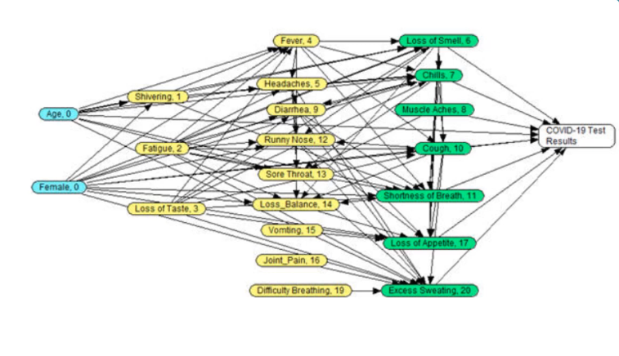
- What are the direct predictors of COVID-19 Laboratory test results? Assume the following order for the variables: D1: Age, D2: Female, X1: Shivering, X2: Fatigue, X3: Loss of taste, X4: Fever, X5: Headaches, X6: Loss of smell, X7: Chills, X8: Muscle aches X9: Diarrhea, X10: Cough, X11: Shortness of breath, X12: Runny nose, X13: Sore throat, X14: Loss of balance, X15: Vomiting, X16: Joint pain, X17: Loss of appetite, X18: Wheezing, X19: Difficulty breathing, X20: Excessive sweating, Y: COVID-19 Test Results.
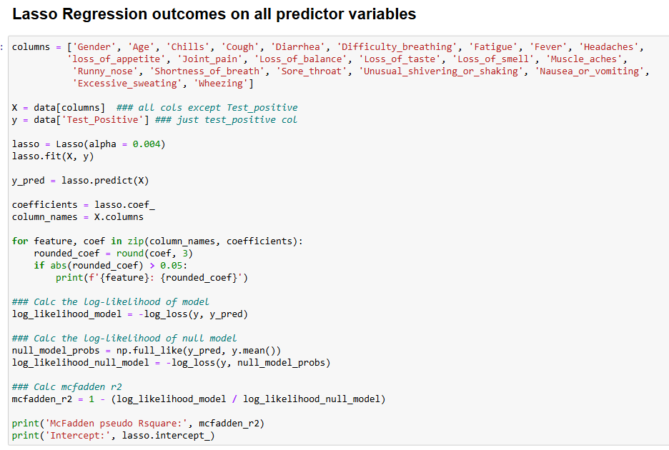
Using this code we can find the direct predictors of COVID-19 lab results.
In the for loop created we can see that the direct predictors will be those variables that have a coefficient results of greater than 0.05 are direct predictors.
The results can be seen here:
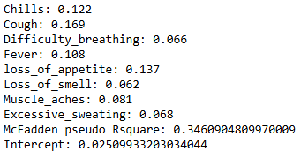
- What is the best network that fits the data? Establish the structure of the network ignoring regressions that explain less than 10% of the variation in test results and ignoring variables where absolute value of coefficients are less than or equal to 0.05.
Based on the previous questions we know the order of the variables. We have to use this information to make a series of lasso regressions to determine if the previous predictors are significant predictors that need to be included in our best network. We must remember to remove the predictors that come after the variable that’s being predicted from our columns since they do not predict the variable that comes before it.
As we can see here, Gender and Age are not significant predictors due to the mcfadden r2 value being less than the 0.05 when doing lasso regression on the Shivering variable:
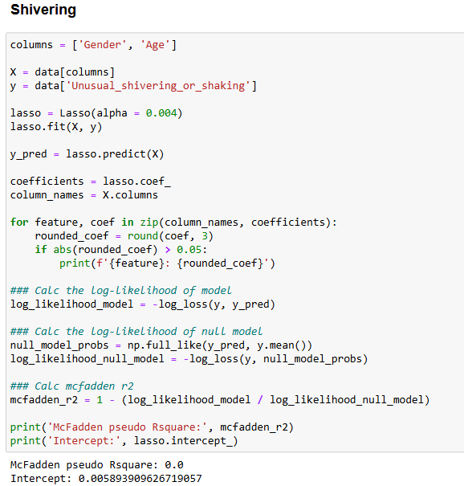
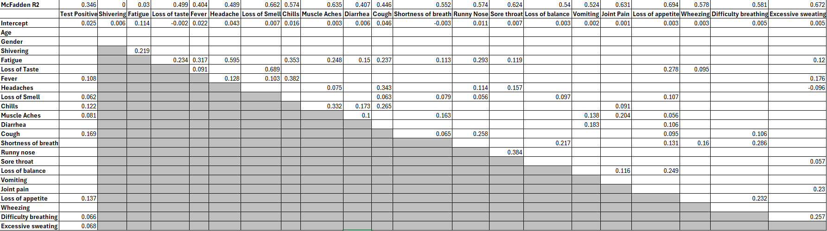
- This step involves constructing a Bayesian network using Netica by applying LASSO regression results to define the structure of symptom and COVID-19 test result relationships.
  - The best network is determined by:
  - Ignoring regressions that explain less than 10% of the variation in test results.
  - Removing coefficients with an absolute value ≤ 0.05 to filter out weak predictors.
  - Ensuring the temporal order of variables is maintained and that cycles are avoided (i.e., response variables must depend on prior variables only).
- This network will be used to estimate the relationships among symptoms and test outcomes.
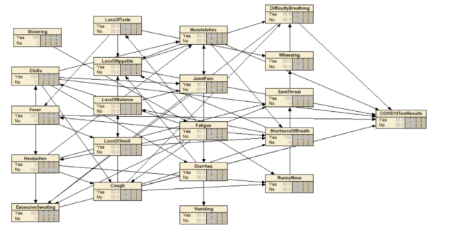
- Estimate the parameters of the network from repeated LASSO regressions. Report the joint probability of COVID-19 positive test results, if we do not know which symptoms were present.
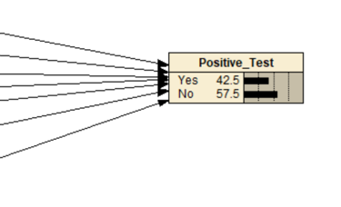

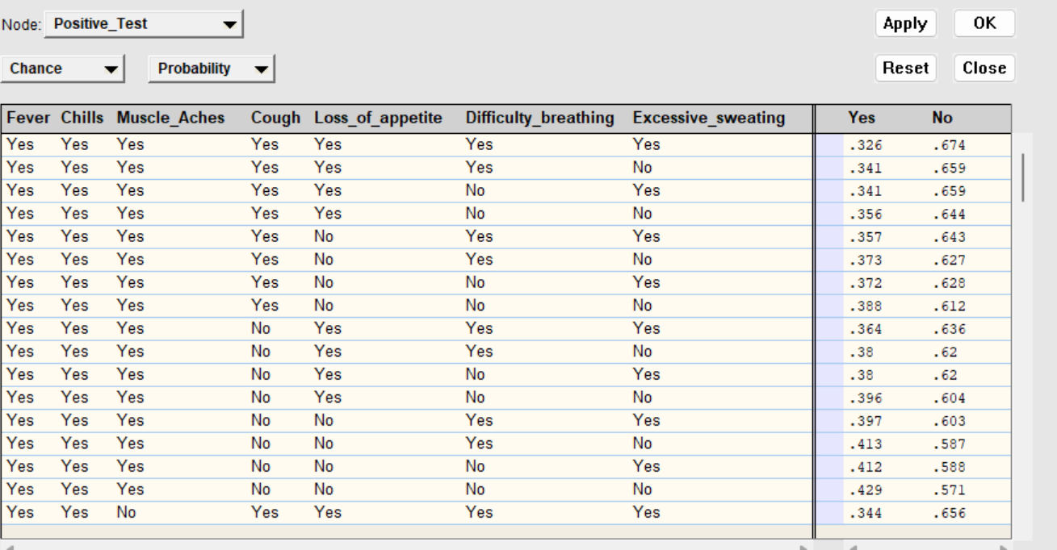
- Once the network structure is established, the parameters (conditional probabilities) are estimated using repeated LASSO regressions.
- This process quantifies how each symptom contributes to predicting COVID-19 test results.
- The joint probability of a COVID-19 positive test result, when symptoms are unknown, can be computed using the constructed Bayesian network.
- This probability represents the baseline likelihood of testing positive before incorporating any symptom data.
- What are parents in the Markov blanket of Fever?
  - Use regressions to identify these parents in Markov Blanket of Fever
The parents in the Markov blanket of Fever will be those that are significant in its regression. Therefore, the parents using regression would be Chills, Headaches, Loss of smell, and Excessive Sweating
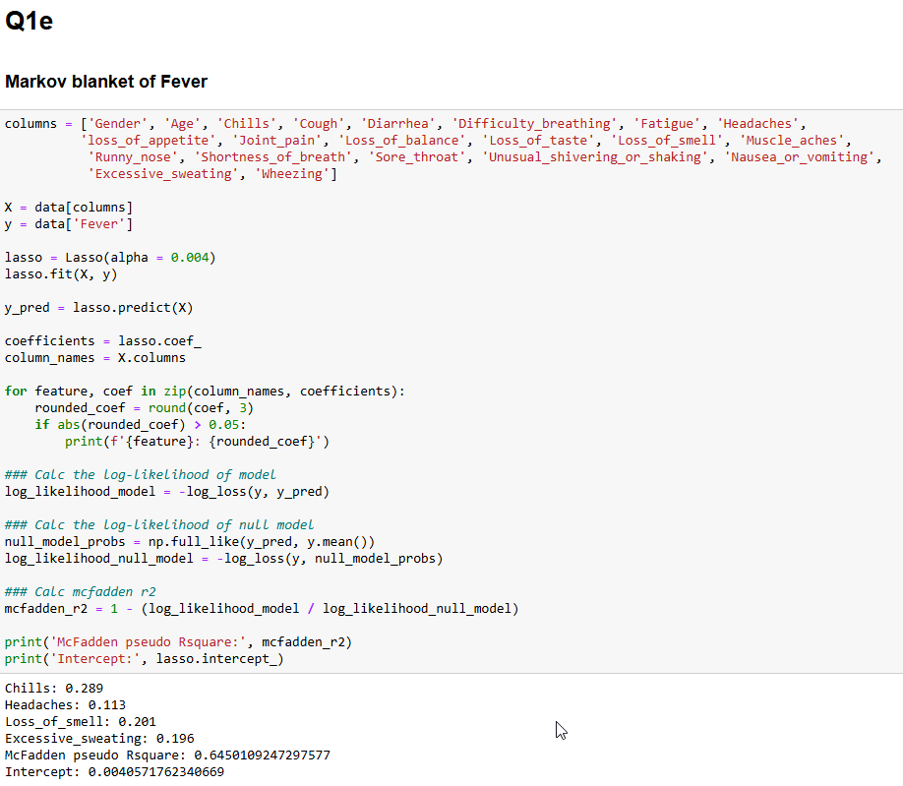
  - Use the network to read parents in Markov Blanket of Fever
- After constructing the Bayesian network in Netica, the Markov blanket of Fever can be visually and computationally verified.
- This involves:
  - Checking the parent-child relationships in the network.
  - Ensuring that the parents identified via regression (Chills, Headaches, Loss of Smell, and Excessive Sweating) are present.
