Question 1: Use LASSO regressions to create the network of symptoms and COVID-19 diagnosis. Remove equations that explain less than 10% of variation in the response variables. Remove coefficients where the absolute value of coefficients are equal or less than 0.05. Remove cycles, none should exists if you always regressed response variables on independent variables that occur prior to it. From the network calculate the following
- What is the order of occurrences of the symptoms, age, gender, and results of COVID-19 laboratory tests?
The temporal order of the symptoms, demographics and outcomes are in the image below that was provided.
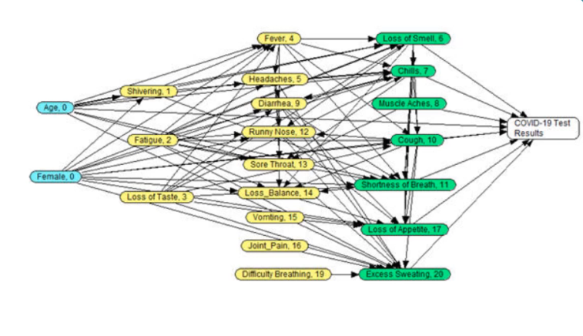
- What are the direct predictors of COVID-19 Laboratory test results? Assume the following order for the variables: D1: Age, D2: Female, X1: Shivering, X2: Fatigue, X3: Loss of taste, X4: Fever, X5: Headaches, X6: Loss of smell, X7: Chills, X8: Muscle aches X9: Diarrhea, X10: Cough, X11: Shortness of breath, X12: Runny nose, X13: Sore throat, X14: Loss of balance, X15: Vomiting, X16: Joint pain, X17: Loss of appetite, X18: Wheezing, X19: Difficulty breathing, X20: Excessive sweating, Y: COVID-19 Test Results.
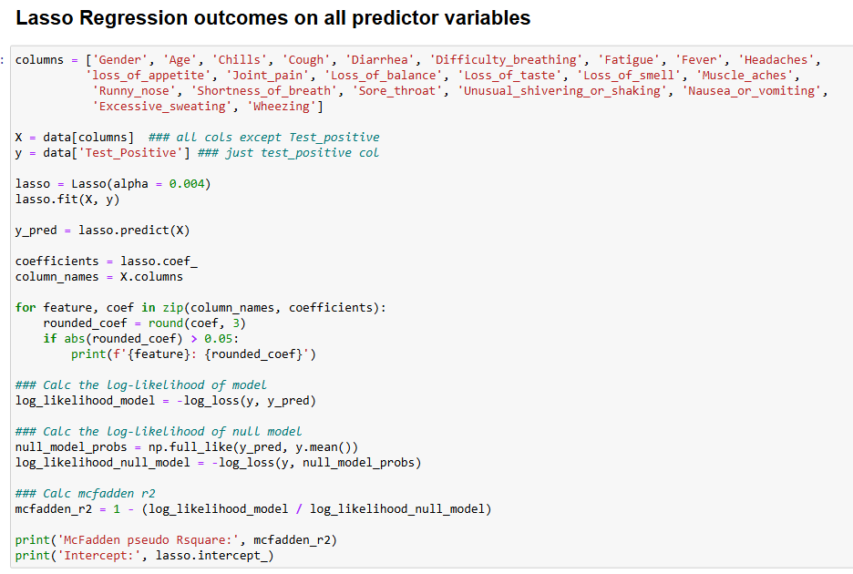
Using this code we can find the direct predictors of COVID-19 lab results.
In the for loop created we can see that the direct predictors will be those variables that have a coefficient results of greater than 0.05 are direct predictors.
The results can be seen here:
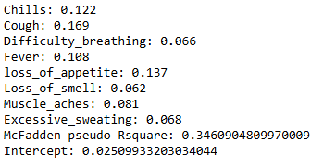
- What is the best network that fits the data? Establish the structure of the network ignoring regressions that explain less than 10% of the variation in test results and ignoring variables where absolute value of coefficients are less than or equal to 0.05.
Based on the previous questions we know the order of the variables. We have to use this information to make a series of lasso regressions to determine if the previous predictors are significant predictors that need to be included in our best network. We must remember to remove the predictors that come after the variable that’s being predicted from our columns since they do not predict the variable that comes before it.
As we can see here, Gender and Age are not significant predictors due to the mcfadden r2 value being less than the 0.05 when doing lasso regression on the Shivering variable:
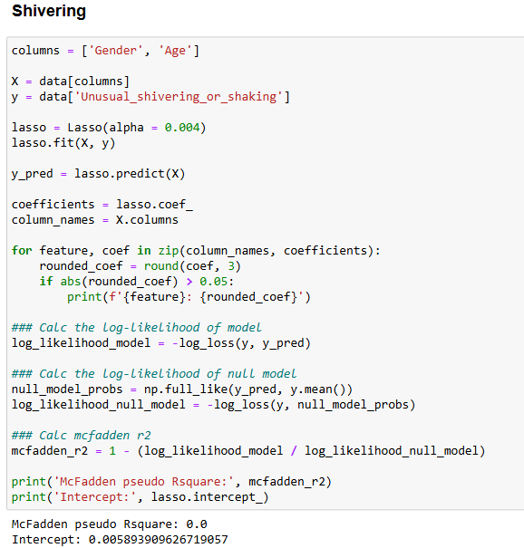
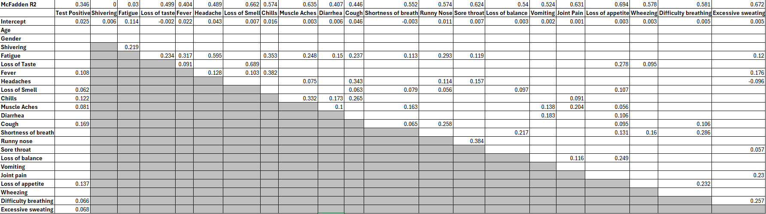
- This step involves constructing a Bayesian network using Netica by applying LASSO regression results to define the structure of symptom and COVID-19 test result relationships.
  - The best network is determined by:
  - Ignoring regressions that explain less than 10% of the variation in test results.
  - Removing coefficients with an absolute value ≤ 0.05 to filter out weak predictors.
  - Ensuring the temporal order of variables is maintained and that cycles are avoided (i.e., response variables must depend on prior variables only).
- This network will be used to estimate the relationships among symptoms and test outcomes.
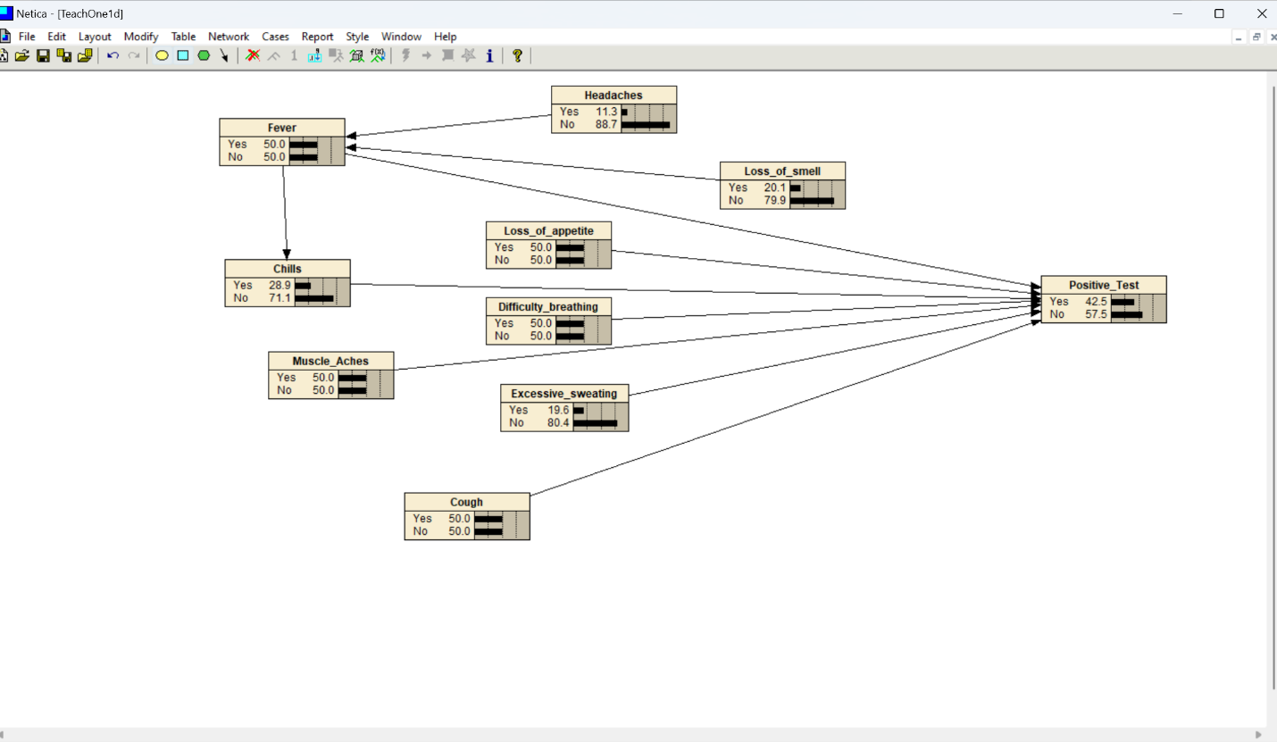
- Estimate the parameters of the network from repeated LASSO regressions. Report the joint probability of COVID-19 positive test results, if we do not know which symptoms were present.
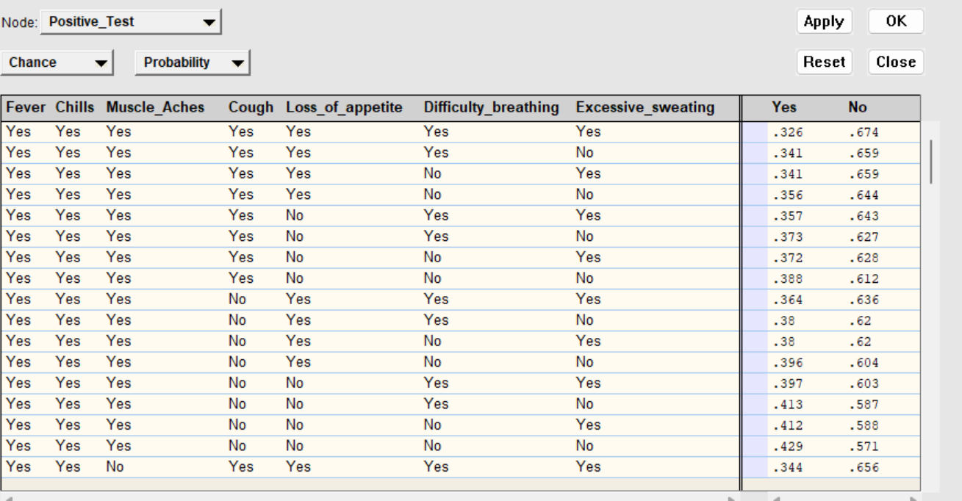
- Once the network structure is established, the parameters (conditional probabilities) are estimated using repeated LASSO regressions.
- This process quantifies how each symptom contributes to predicting COVID-19 test results.
- The joint probability of a COVID-19 positive test result, when symptoms are unknown, can be computed using the constructed Bayesian network.
- This probability represents the baseline likelihood of testing positive before incorporating any symptom data.
- What are parents in the Markov blanket of Fever?
  - Use regressions to identify these parents in Markov Blanket of Fever
The parents in the Markov blanket of Fever will be those that are significant in its regression. Therefore, the parents using regression would be Chills, Headaches, Loss of smell, and Excessive Sweating
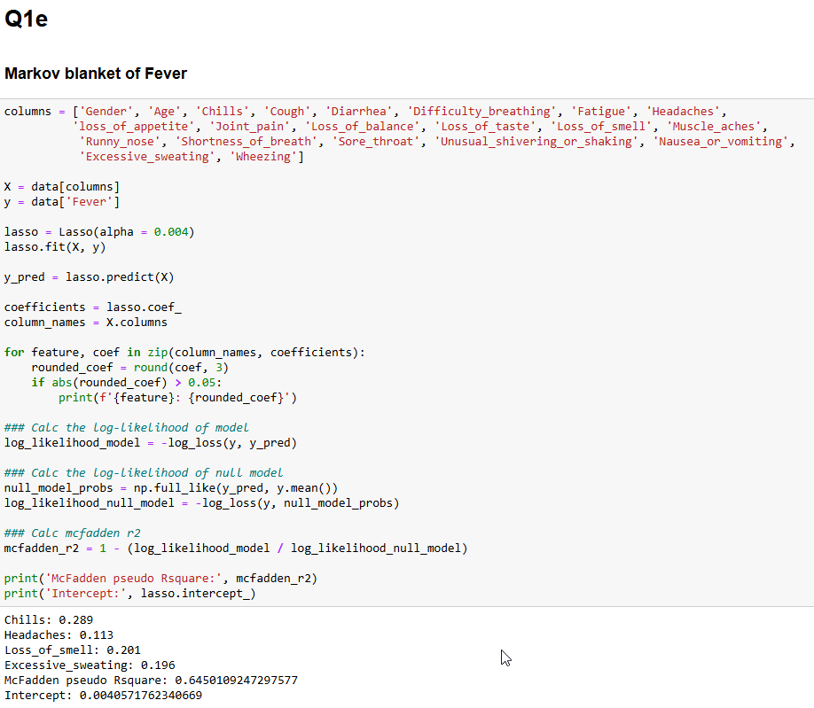
  - Use the network to read parents in Markov Blanket of Fever
- After constructing the Bayesian network in Netica, the Markov blanket of Fever can be visually and computationally verified.
- This involves:
  - Checking the parent-child relationships in the network.
  - Ensuring that the parents identified via regression (Chills, Headaches, Loss of Smell, and Excessive Sweating) are present.
