Part C
Connect with lines to remission or antidepressant based off of if the variable was nonzero during the lasso regression r-code.
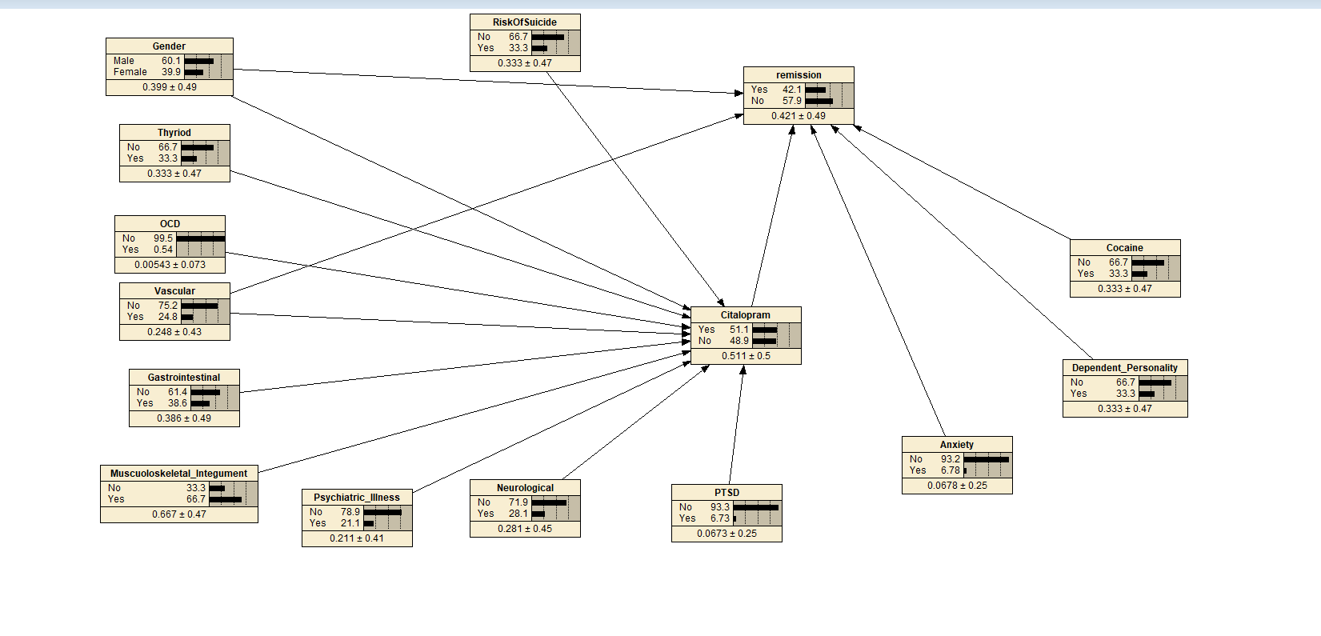
Part D
Use the read case button and choose data set.
Next use the case learn incorporated case button.
Hit lighting button to get percentages.
Part E
