***## First read the data into R***

***data=read.csv("TraumaData.csv" )***

***data=data[,-1]***

***## Q1.1 ) run the regression***

***model = lm (Prob.Survival ~ Severe.Burn  + Head.Injury + X65..Years + Male + as.factor(Hosp), data= data)***

***summary(model)***

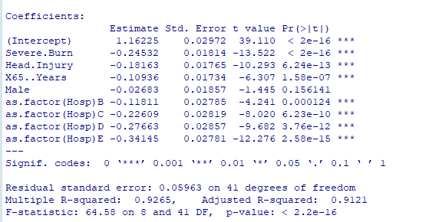

Q1.2) For this part, we need to create the table in the question and attach to it the the table and then run a new regression

***## Q1.2 ) create the table in the question***

***data2=matrix(nrow= 5 , ncol = 3 )***

***data2[,1] = c(1,1,0,0,0)***

***data2[,2] = c(0,1,0,0,0)***

***data2[1,3] = 0***

***data2[2,3] = 1.162-0.118***

***data2[3,3] = 1.162 - 0.226***

***data2[4,3] = 1.162 - 0.276***

***data2[5,3] = 1.162 - 0.341***

***data2=as.data.frame(data2)***

***colnames(data2) = c("TertiaryCenter" , "BurnCenter" , "DiffIntercept")***

***##run the regression***

***model2=lm ( DiffIntercept ~. , data = data2 )***

***summary(model2)***

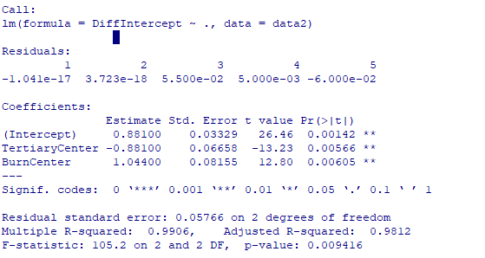

Q1.3) Interpretation of results is as follows

- from the first regression we can see that all the  variables are statistically significant predictors of the probability of mortality. This includes the 5 hospitals.

- from the second regression we can see that after holding the patient characteristics, hospitals with tertiary centers reduce the probability of mortality and hospitals with burn centers , increase the risk of mortality.