HAP 823
Aryan Mazloum
Saeed Alshehri
We will being by importing the data into Access. The following steps demonstrate how to do this.
Click External Data
Click Excel. (this is assuming you have already saved the data in an excel format)(If you have it in different format it is okay)
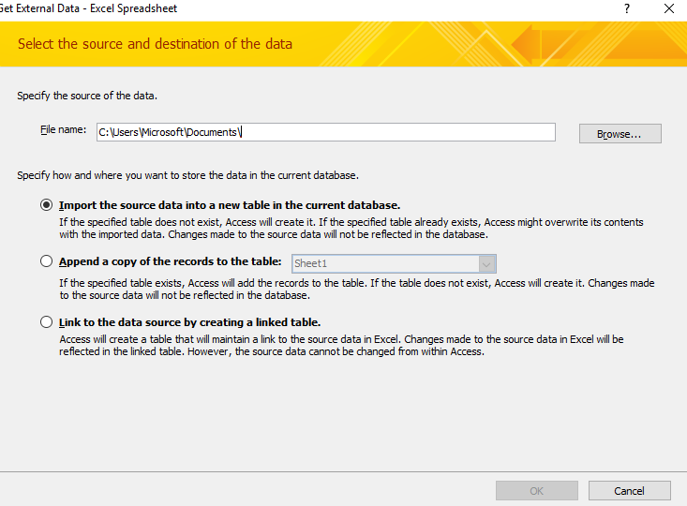
Choose browse and find the file you want on your computer. Click ok. Make sure the box which says “first row contains column header” is checked. Choose no primary key and finish importing the file.
My file is called Sheet1
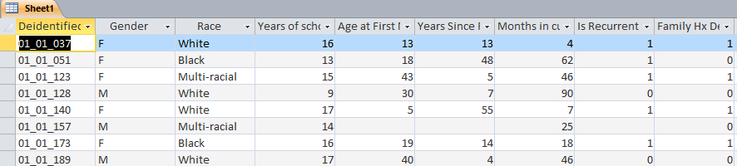
From Sheet 1 we will now choose three variables that we want to work with. In this example we have chosen: Generalized Anxiety Disorder, Panic Disorder, and CIT Success.
Now one of the first things we want to do is simply checking the count of a pair of the three variables along with the combinations where they are present.
To do so click “Create” then chose query design. Next we click Sheet 1 (or whatever you have called your file). Now chose your variables. I have chosen Generalized Anxiety Disorder and Panic Disorder along with the patient ID in design view. We will set the Patient ID to count and all other variables to Group By.
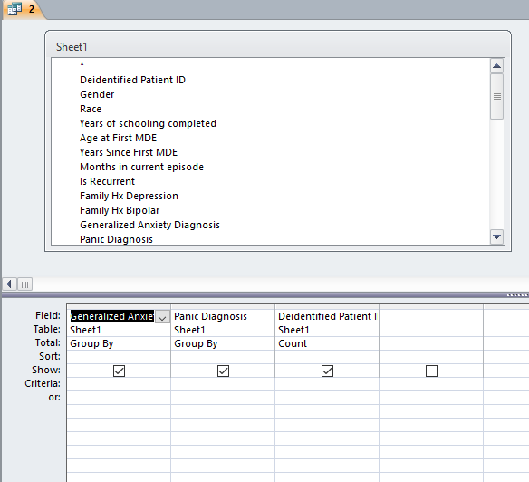
Here is what the SQL view looks like if you prefer to do this step in SQL instead of design view.
SELECT Sheet1.[Generalized Anxiety Diagnosis], Sheet1.[Panic Diagnosis], Count(Sheet1.[Deidentified Patient ID]) AS [CountOfDeidentified Patient ID]
FROM Sheet1
GROUP BY Sheet1.[Generalized Anxiety Diagnosis], Sheet1.[Panic Diagnosis];
Now once you run this you will get the different combinations of your variables alone with their respected counts.
You will want to do this with all combinations of your variable.

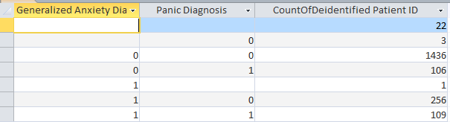

Moving forward we want to include all three variables and also we want the
1’s to be Yes
0’s to be No
And null to be Missing
We will start by creating a new query. And repeating the same steps as above except we will include Anxiety, Panic, CIT Success, along with Patient ID. We will still set the Patient Id to Count. Additionally for Generalized Anxiety we will input into the “field” box the following:
AnxietyObsv: IIf([Generalized Anxiety Diagnosis]="1","Yes",IIf([Generalized Anxiety Diagnosis]="0","No","Missing"))
This will get rid of the 0, 1, and blanks and give us an output which is easy to read.
Do this for the other two remaining variables.
PanicObsv: IIf([Panic Diagnosis]=1,"Yes",IIf([Panic Diagnosis]=0,"No","Missing"))
CITObsv: IIf([CIT Success]=1,"Yes",IIf([CIT Success]=0,"No","Missing"))
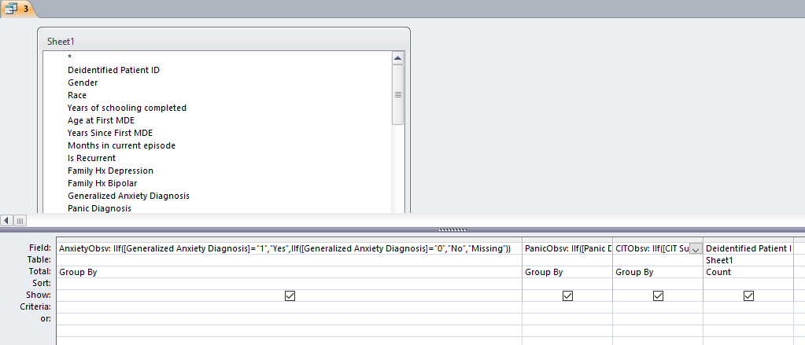
Here is the SQL code for the above:
SELECT IIf([Generalized Anxiety Diagnosis]="1","Yes",IIf([Generalized Anxiety Diagnosis]="0","No","Missing")) AS AnxietyObsv, IIf([Panic Diagnosis]=1,"Yes",IIf([Panic Diagnosis]=0,"No","Missing")) AS PanicObsv, IIf([CIT Success]=1,"Yes",IIf([CIT Success]=0,"No","Missing")) AS CITObsv, Count(Sheet1.[Deidentified Patient ID]) AS [CountOfDeidentified Patient ID]
FROM Sheet1
GROUP BY IIf([Generalized Anxiety Diagnosis]="1","Yes",IIf([Generalized Anxiety Diagnosis]="0","No","Missing")), IIf([Panic Diagnosis]=1,"Yes",IIf([Panic Diagnosis]=0,"No","Missing")), IIf([CIT Success]=1,"Yes",IIf([CIT Success]=0,"No","Missing"));

Now run the query to see the results:
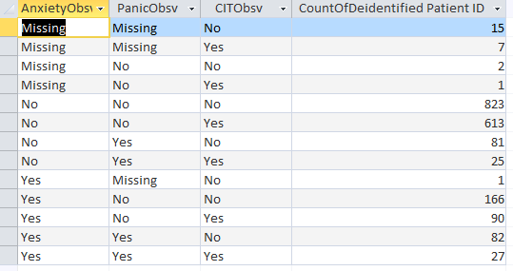

We are done with this query so save it and close it. I named it “3”

Now we want to get the counts of three variables. We will start by creating a new query. In design view import Sheet1 (or whatever you called your imported data).
Choose your first variable (in my case it is Anxiety).
Set it to count.
In the field next to it input the following:
Anxiety Count: IIf([Generalized Anxiety Diagnosis]="1","Yes",IIf([Generalized Anxiety Diagnosis]="0","No","Missing"))

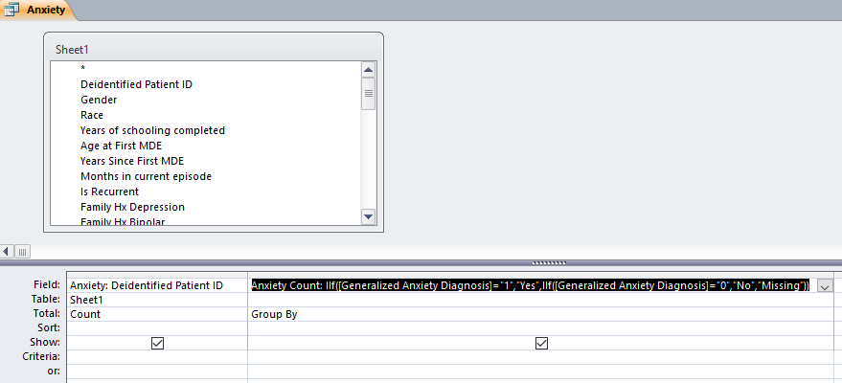
Here is the SQL code for it:
SELECT Count(Sheet1.[Deidentified Patient ID]) AS Anxiety, IIf([Generalized Anxiety Diagnosis]="1","Yes",IIf([Generalized Anxiety Diagnosis]="0","No","Missing")) AS [Anxiety Count]
FROM Sheet1
GROUP BY IIf([Generalized Anxiety Diagnosis]="1","Yes",IIf([Generalized Anxiety Diagnosis]="0","No","Missing"));
Now run the query and you should have the counts of Anxiety when Anxiety is Present, Absent, and Null.
Save the query and close it.
***Repeat the same process with the other two variables.
Now that you have the counts of all three variables, we also need sample size or n.
To do so create a new query and add the Patient Id to this query; and set the total to count.
In the field box you should call the field n
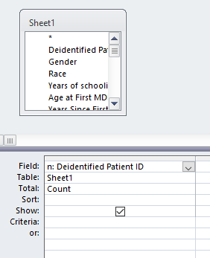
Run the query and you should have the total number of patients in the study (n)
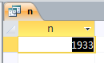
Here is the SQL code for this query
SELECT Count(Sheet1.[Deidentified Patient ID]) AS n
FROM Sheet1;
We are done with this query. Save it and close it. (I saved it as n)
In the next step we want to get the predicted values of the queries we just made. Here is how we do this. Start by creating a new query.
In this new query add your sample size query “n”. Also add the queries for the three variables you made. Lastly add the query with the three variables which include the count of observations (called “3”)
Now join the disorders from query “3” to each respected query for that disorder.
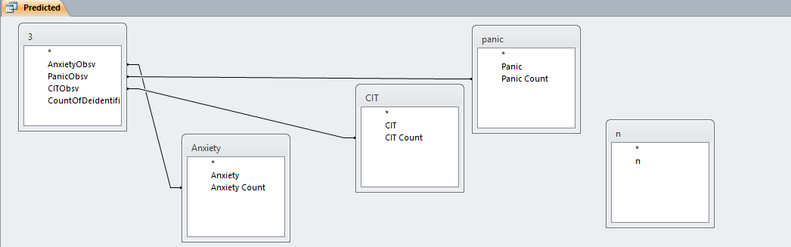
We now want a field for predicted values so we will input the following in the first field.
Predicted: [Anxiety]*[CIT]*[panic]/[n]^2
Here we can see that we are calling the column Predicted:
Then we have multiplied Anxiety by CIT by Panic
And then divided it by n squared.
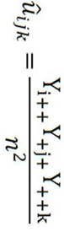
Additionally add another field with the patient ID
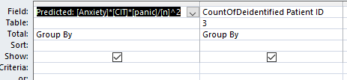
You can now run your query and observe the predicted values
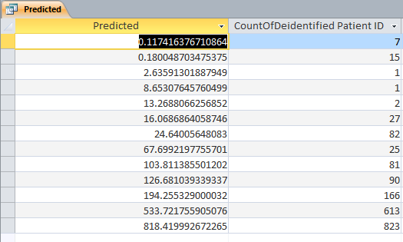
Furthermore you can show rounded predicted values by adding a new field like so:
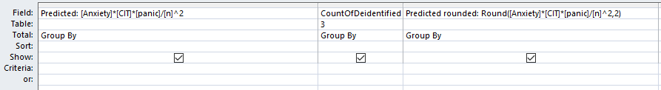
You can run the query again and see the rounded predicted values.
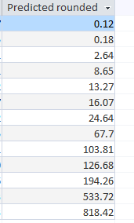
Here is the SQL code:
SELECT [Anxiety]*[CIT]*[panic]/[n]^2 AS Predicted, [3].[CountOfDeidentified Patient ID], Round([Anxiety]*[CIT]*[panic]/[n]^2,2) AS [Predicted rounded]
FROM n, ((3 INNER JOIN Anxiety ON [3].AnxietyObsv = Anxiety.[Anxiety Count]) INNER JOIN panic ON [3].PanicObsv = panic.[Panic Count]) INNER JOIN CIT ON [3].CITObsv = CIT.[CIT Count]
GROUP BY [Anxiety]*[CIT]*[panic]/[n]^2, [3].[CountOfDeidentified Patient ID], Round([Anxiety]*[CIT]*[panic]/[n]^2,2);
Now that we have our predicted values we can save and close this query.

Next we would like to obtain the predicted values of the pairs of variables.
To do so we will again start by creating a new query.
We will import query “3” along with “n” along with the two variables we want to pair.
Then join the variables like so:
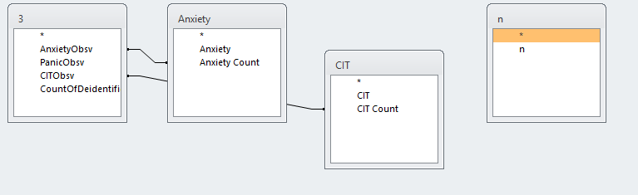
Now we use the same formula to get predicted values.
Predicted: [Anxiety]*[CIT]/[n]^2
We have simply multiplied our two variables and divided by n squared
Also add Patient ID
Our fields look like this:
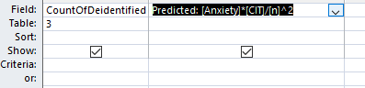
Run the query and you have the values for the pairs.
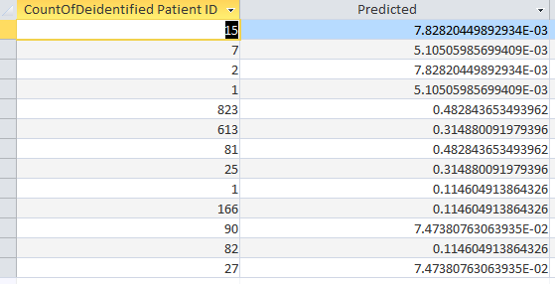
To show rounded values add another field with the following:
Predicted rounded: Round([Anxiety]*[CIT]*[panic]/[n]^2,2)
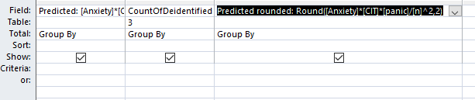
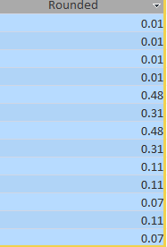
Here is the SQL code:
SELECT [Anxiety]*[CIT]*[panic]/[n]^2 AS Predicted, [3].[CountOfDeidentified Patient ID], Round([Anxiety]*[CIT]*[panic]/[n]^2,2) AS [Predicted rounded]
FROM n, ((3 INNER JOIN Anxiety ON [3].AnxietyObsv = Anxiety.[Anxiety Count]) INNER JOIN panic ON [3].PanicObsv = panic.[Panic Count]) INNER JOIN CIT ON [3].CITObsv = CIT.[CIT Count]
GROUP BY [Anxiety]*[CIT]*[panic]/[n]^2, [3].[CountOfDeidentified Patient ID], Round([Anxiety]*[CIT]*[panic]/[n]^2,2);

Save the query and close it.
***Repeat this for all pairs

