Use of New Code for Stratified Covariate Balancing

Please find attached the SCB package in the R file above. These are the instructions on how to use it

1.) **Sourcing the file in R**

first you need to make sure the file is in the correct working directory using setwd() and copying the file into that directory

cid:49d199b3-161c-4124-8e9c-0984f8d1a22e

next we need to use the function "source()" as follows

cid:3df3ff97-e004-4596-8247-68a99bca5f1a

**If you have any problems with sourcing the file in R please use RStudio instead.**

2.) Once the file has been sourced and all the necessary packages have been downloaded we are now ready to use it . I will use a simple data set here as an example where all the variables are discrete. The variables in this data set are

cid:841de9d7-11ea-4732-abe8-586066e52e31

So treatment is the 4th column and Outcome is the 5th. In this case we simply use

cid:d120fb6b-5e4c-4457-9997-5c38051547e1

where we have specified which column contains the Treatment, which column contains the Outcome, where the data is  and whether or not to use Markov blanket to reduce the data.

and we get

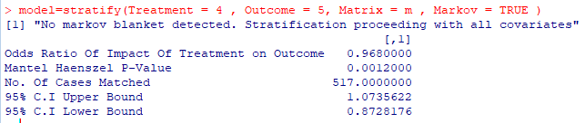

we can also inspect the item we created called "model" by looking at the names in it

cid:554e3f16-95a0-43fe-a421-4c3930d8f825

so we have the strata and the odds ratio and to inspect either we use the name. So for example we can use the command

model$OddsRatio as shown below  to view the odds table again.

