Make sure to read the simulated data into your R console as “d” otherwise the following code will NOT work.
Time 1
q=d[,(1:3)]
t=ddply(q,(1:3),nrow)
u=glm(V1~ DME:P + DME:CL + P:CL,data=t,family=poisson)
summary(u)
Time 2
q=d[,(1:4)]
t=ddply(q,(1:4),nrow)
u=glm(V1 ~ DME + H + P + CL + DME:H + CL:H + P:H ,data=t,family=poisson)
summary(u)
Time 3
q=d[,-(9:12)]
t=ddply(q,(1:9),nrow)
u=glm(V1 ~ DME + H + P + DME:H + CL:H + P:H + CL:SNF + DME:SNF + H:SNF + P:SNF + CL:PBD + DME:PBD + H:PBD + P:PBD + CL:RF + DME:RF + H:RF + P:RF + CL:LTH + DME:LTH + P:LTH + H:LTH + CL:HHA + DME:HHA + P:HHA + H:HHA + (PBD + SNF + HHA + RF + LTH)^2,data=t,family=poisson)
summary(u)
Cleans up were performed by placing the names of the markov blanket of each variable into a vector called “c” and running the code provided.
Cleaning up for time 3
For H
c=c("DME", "CL" , "P" ,"SNF" , "RF" , "LTH", "H" )
q=d[c]
q=as.data.frame(q)
a=ncol(q)
t=ddply(q,(1:a),nrow)
u=glm(V1~.*.,data=t,family=poisson)
summary(u)
Coefficients:
Estimate Std. Error z value Pr(>|z|)
(Intercept) 4.750592 0.053671 88.513 < 2e-16 ***
CL -0.525289 0.057858 -9.079 < 2e-16 ***
DME -0.630095 0.058445 -10.781 < 2e-16 ***
P -1.950873 0.068105 -28.645 < 2e-16 ***
H -2.156731 0.070427 -30.624 < 2e-16 ***
SNF -0.038642 0.057618 -0.671 0.50244
RF 0.144036 0.057253 2.516 0.01188 *
LTH 0.143531 0.056958 2.520 0.01174 *
CL:DME -0.093943 0.041763 -2.249 0.02449 *
CL:P -0.085298 0.043671 -1.953 0.05080 .
CL:H 0.836302 0.045845 18.242 < 2e-16 ***
CL:SNF -0.002357 0.046405 -0.051 0.95950
CL:RF -0.036676 0.047131 -0.778 0.43647
CL:LTH -0.020596 0.046484 -0.443 0.65772
DME:P -0.069659 0.043670 -1.595 0.11068
DME:H 0.745341 0.046060 16.182 < 2e-16 ***
DME:SNF 0.028312 0.046474 0.609 0.54239
DME:RF -0.011268 0.047193 -0.239 0.81129
DME:LTH 0.014002 0.046551 0.301 0.76358
P:H 0.356318 0.047274 7.537 4.8e-14 ***
P:SNF 0.870295 0.047884 18.175 < 2e-16 ***
P:RF 0.867405 0.048822 17.767 < 2e-16 ***
P:LTH 0.807682 0.048113 16.787 < 2e-16 ***
H:SNF 0.821744 0.048860 16.818 < 2e-16 ***
H:RF 0.879551 0.049626 17.724 < 2e-16 ***
H:LTH 0.808436 0.049126 16.456 < 2e-16 ***
SNF:RF -0.007271 0.050542 -0.144 0.88561
SNF:LTH -0.006305 0.050015 -0.126 0.89969
RF:LTH -0.143039 0.051179 -2.795 0.00519 **
---
Signif. codes: 0 ‘***’ 0.001 ‘**’ 0.01 ‘*’ 0.05 ‘.’ 0.1 ‘ ’ 1

(Dispersion parameter for poisson family taken to be 1)

Null deviance: 9105.198 on 127 degrees of freedom
Residual deviance: 88.269 on 99 degrees of freedom
AIC: 878.83

Number of Fisher Scoring iterations: 4
For P
c=c("H", "SNF" , "RF" , "LTH" , "P" , "HHA" )
q=d[c]
q=as.data.frame(q)
a=ncol(q)
t=ddply(q,(1:a),nrow)
u=glm(V1~.*.,data=t,family=poisson)
summary(u)
Coefficients:
Estimate Std. Error z value Pr(>|z|)
(Intercept) 4.952548 0.052945 93.542 < 2e-16 ***
P -2.472046 0.072182 -34.247 < 2e-16 ***
H -1.420972 0.064088 -22.172 < 2e-16 ***
HHA -0.030783 0.055768 -0.552 0.580957
SNF 0.005563 0.057324 0.097 0.922691
RF 0.039259 0.057518 0.683 0.494884
LTH 0.117978 0.056918 2.073 0.038191 *
P:H 0.338741 0.046555 7.276 3.43e-13 ***
P:HHA 0.794046 0.044577 17.813 < 2e-16 ***
P:SNF 0.883480 0.048686 18.146 < 2e-16 ***
P:RF 0.836097 0.049597 16.858 < 2e-16 ***
P:LTH 0.799271 0.048882 16.351 < 2e-16 ***
H:HHA -0.062339 0.045534 -1.369 0.170976
H:SNF 0.825179 0.047259 17.461 < 2e-16 ***
H:RF 0.872757 0.048002 18.182 < 2e-16 ***
H:LTH 0.807449 0.047514 16.994 < 2e-16 ***
HHA:SNF -0.072977 0.046980 -1.553 0.120333
HHA:RF 0.171004 0.047225 3.621 0.000293 ***
HHA:LTH 0.045912 0.046856 0.980 0.327164
SNF:RF -0.004351 0.050581 -0.086 0.931456
SNF:LTH -0.005406 0.050023 -0.108 0.913945
RF:LTH -0.144762 0.051215 -2.827 0.004705 **
---
Signif. codes: 0 ‘***’ 0.001 ‘**’ 0.01 ‘*’ 0.05 ‘.’ 0.1 ‘ ’ 1

(Dispersion parameter for poisson family taken to be 1)

Null deviance: 9027.73 on 63 degrees of freedom
Residual deviance: 38.54 on 42 degrees of freedom
AIC: 494.2

Number of Fisher Scoring iterations: 4

For SNF
c=c("CL ", "H ", "P ", "SNF ")
q=d[c]
q=as.data.frame(q)
a=ncol(q)
t=ddply(q,(1:a),nrow)
u=glm(V1~.*.,data=t,family=poisson)
summary(u)
Coefficients:
Estimate Std. Error z value Pr(>|z|)
(Intercept) 6.674553 0.031303 213.224 <2e-16 ***
CL -0.587089 0.043719 -13.429 <2e-16 ***
P -0.945205 0.046526 -20.316 <2e-16 ***
H -0.792224 0.045336 -17.474 <2e-16 ***
SNF -0.035803 0.040171 -0.891 0.3728
CL:P -0.092826 0.042351 -2.192 0.0284 *
CL:H 0.809685 0.043725 18.518 <2e-16 ***
CL:SNF -0.002959 0.046391 -0.064 0.9491 - correctly discardd
P:H 0.625838 0.043930 14.246 <2e-16 ***
P:SNF 0.867623 0.046421 18.690 <2e-16 *** - correctly kept in
H:SNF 0.824522 0.046538 17.717 <2e-16 *** - correctly kept in
---
Signif. codes: 0 ‘***’ 0.001 ‘**’ 0.01 ‘*’ 0.05 ‘.’ 0.1 ‘ ’ 1

(Dispersion parameter for poisson family taken to be 1)

Null deviance: 3570.9369 on 15 degrees of freedom
Residual deviance: 6.0514 on 5 degrees of freedom
AIC: 157.53

Number of Fisher Scoring iterations: 3

For HHA
c=c("CL" , "P" , "RF", "HHA" )
q=d[c]
q=as.data.frame(q)
a=ncol(q)
t=ddply(q,(1:a),nrow)
u=glm(V1~.*.,data=t,family=poisson)
summary(u)
Coefficients:
Estimate Std. Error z value Pr(>|z|)
(Intercept) 6.33033 0.03573 177.185 < 2e-16 ***
CL -0.25058 0.04472 -5.604 2.10e-08 ***
P -1.15531 0.05130 -22.520 < 2e-16 ***
HHA -0.07653 0.04414 -1.734 0.082960 .
RF 0.32808 0.04238 7.741 9.85e-15 ***
CL:P 0.02384 0.04176 0.571 0.568147
CL:HHA 0.01719 0.04181 0.411 0.681034 - correctly discarded
CL:RF 0.12657 0.04539 2.788 0.005299 **
P:HHA 0.77887 0.04269 18.243 < 2e-16 *** - correctly kept
P:RF 0.93871 0.04693 20.004 < 2e-16 ***
HHA:RF 0.15551 0.04635 3.355 0.000794 *** - incorrectly kept in
---
Signif. codes: 0 ‘***’ 0.001 ‘**’ 0.01 ‘*’ 0.05 ‘.’ 0.1 ‘ ’ 1

(Dispersion parameter for poisson family taken to be 1)

Null deviance: 3166.8669 on 15 degrees of freedom
Residual deviance: 4.0358 on 5 degrees of freedom
AIC: 155.64

Number of Fisher Scoring iterations: 3
For CL
c=c("H", "SNF" , "PBD" , "RF" , "LTH" , "HHA" , "CL")
q=d[c]
q=as.data.frame(q)
a=ncol(q)
t=ddply(q,(1:a),nrow)
u=glm(V1~.*.,data=t,family=poisson)
summary(u)

Coefficients:
Estimate Std. Error z value Pr(>|z|)
(Intercept) 3.922676 0.064405 60.906 < 2e-16 ***
CL -0.548272 0.063286 -8.663 < 2e-16 ***
H -1.800262 0.072776 -24.737 < 2e-16 ***
HHA -0.004620 0.060762 -0.076 0.93940
SNF 0.085575 0.062862 1.361 0.17341
RF 0.120243 0.063335 1.899 0.05763 .
PBD 0.018112 0.060072 0.302 0.76303
LTH 0.166864 0.062788 2.658 0.00787 **
CL:H 0.813030 0.045041 18.051 < 2e-16 ***
CL:HHA 0.015161 0.041888 0.362 0.71739 --- correctly discarded
CL:SNF -0.019969 0.045613 -0.438 0.66154 ----correctly discarded
CL:RF -0.054042 0.046466 -1.163 0.24481 ---correctly discarded
CL:PBD -0.041639 0.040845 -1.019 0.30799 ---correctly discarded
CL:LTH -0.036476 0.045839 -0.796 0.42618 ---correctly discarded
H:HHA -0.005501 0.045413 -0.121 0.90358 ----
H:SNF 0.895200 0.047261 18.942 < 2e-16 ***
H:RF 0.945844 0.048146 19.645 < 2e-16 ***
H:PBD 0.006302 0.044360 0.142 0.88702
H:LTH 0.874328 0.047678 18.338 < 2e-16 ***
HHA:SNF 0.081169 0.045444 1.786 0.07408 .
HHA:RF 0.316426 0.045839 6.903 5.09e-12 ***
HHA:PBD 0.014432 0.041027 0.352 0.72502
HHA:LTH 0.184735 0.045496 4.061 4.90e-05 ***
SNF:RF 0.154483 0.049046 3.150 0.00163 **
SNF:PBD -0.038104 0.044516 -0.856 0.39202
SNF:LTH 0.147118 0.048539 3.031 0.00244 **
RF:PBD -0.027403 0.045330 -0.605 0.54549
RF:LTH -0.002061 0.049833 -0.041 0.96701
PBD:LTH 0.014636 0.044744 0.327 0.74358
---
Signif. codes: 0 ‘***’ 0.001 ‘**’ 0.01 ‘*’ 0.05 ‘.’ 0.1 ‘ ’ 1

(Dispersion parameter for poisson family taken to be 1)

Null deviance: 7862.175 on 127 degrees of freedom
Residual deviance: 84.591 on 99 degrees of freedom
AIC: 890.31

Number of Fisher Scoring iterations: 4

For RF
c=c( "CL", "H" , "P" , "HHA" , "RF" , "LTH ")
q=d[c]
q=as.data.frame(q)
a=ncol(q)
t=ddply(q,(1:a),nrow)
u=glm(V1~.*.,data=t,family=poisson)
summary(u)
Coefficients:
Estimate Std. Error z value Pr(>|z|)
(Intercept) 5.20188 0.04853 107.192 < 2e-16 ***
CL -0.57326 0.05508 -10.409 < 2e-16 ***
P -1.90488 0.06480 -29.397 < 2e-16 ***
H -1.30221 0.06074 -21.440 < 2e-16 ***
HHA -0.07860 0.05284 -1.487 0.136887
RF 0.05051 0.05412 0.933 0.350678
LTH 0.12287 0.05357 2.294 0.021807 *
CL:P -0.08986 0.04363 -2.060 0.039445 *
CL:H 0.81947 0.04448 18.424 < 2e-16 ***
CL:HHA 0.03048 0.04258 0.716 0.474071
CL:RF -0.03765 0.04715 -0.799 0.424527
CL:LTH -0.02124 0.04648 -0.457 0.647723
P:H 0.50949 0.04593 11.092 < 2e-16 ***
P:HHA 0.78194 0.04380 17.851 < 2e-16 ***
P:RF 0.83451 0.04876 17.113 < 2e-16 ***
P:LTH 0.79786 0.04806 16.601 < 2e-16 ***
H:HHA -0.08109 0.04560 -1.778 0.075340 .
H:RF 0.87951 0.04812 18.276 < 2e-16 ***
H:LTH 0.81074 0.04762 17.024 < 2e-16 ***
HHA:RF 0.17128 0.04722 3.627 0.000287 ***
HHA:LTH 0.04609 0.04685 0.984 0.325202
RF:LTH -0.14495 0.05122 -2.830 0.004653 **
---
Signif. codes: 0 ‘***’ 0.001 ‘**’ 0.01 ‘*’ 0.05 ‘.’ 0.1 ‘ ’ 1

(Dispersion parameter for poisson family taken to be 1)

Null deviance: 7065.360 on 63 degrees of freedom
Residual deviance: 32.606 on 42 degrees of freedom
AIC: 494.12

Number of Fisher Scoring iterations: 4

For LTH
c=c( "RF" , "P" , "H" , "CL", "LTH" )
q=d[c]
q=as.data.frame(q)
a=ncol(q)
t=ddply(q,(1:a),nrow)
u=glm(V1~.*.,data=t,family=poisson)
summary(u)
Coefficients:
Estimate Std. Error z value Pr(>|z|)
(Intercept) 5.85650 0.04134 141.654 < 2e-16 ***
CL -0.55847 0.05103 -10.943 < 2e-16 ***
P -1.45409 0.05758 -25.252 < 2e-16 ***
H -1.34053 0.05687 -23.570 < 2e-16 ***
RF 0.13645 0.04866 2.804 0.00505 **
LTH 0.14532 0.04848 2.998 0.00272 **
CL:P -0.08424 0.04292 -1.963 0.04966 *
CL:H 0.81890 0.04447 18.415 < 2e-16 ***
CL:RF -0.03643 0.04712 -0.773 0.43948
CL:LTH -0.02091 0.04647 -0.450 0.65277
P:H 0.49456 0.04514 10.957 < 2e-16 ***
P:RF 0.86629 0.04799 18.053 < 2e-16 ***
P:LTH 0.80635 0.04729 17.052 < 2e-16 ***
H:RF 0.87623 0.04807 18.227 < 2e-16 ***
H:LTH 0.80987 0.04761 17.011 < 2e-16 ***
RF:LTH -0.14308 0.05118 -2.796 0.00518 **
---
Signif. codes: 0 ‘***’ 0.001 ‘**’ 0.01 ‘*’ 0.05 ‘.’ 0.1 ‘ ’ 1

(Dispersion parameter for poisson family taken to be 1)

Null deviance: 6227.294 on 31 degrees of freedom
Residual deviance: 12.169 on 16 degrees of freedom
AIC: 276.34

Number of Fisher Scoring iterations: 3
TIME 3 before
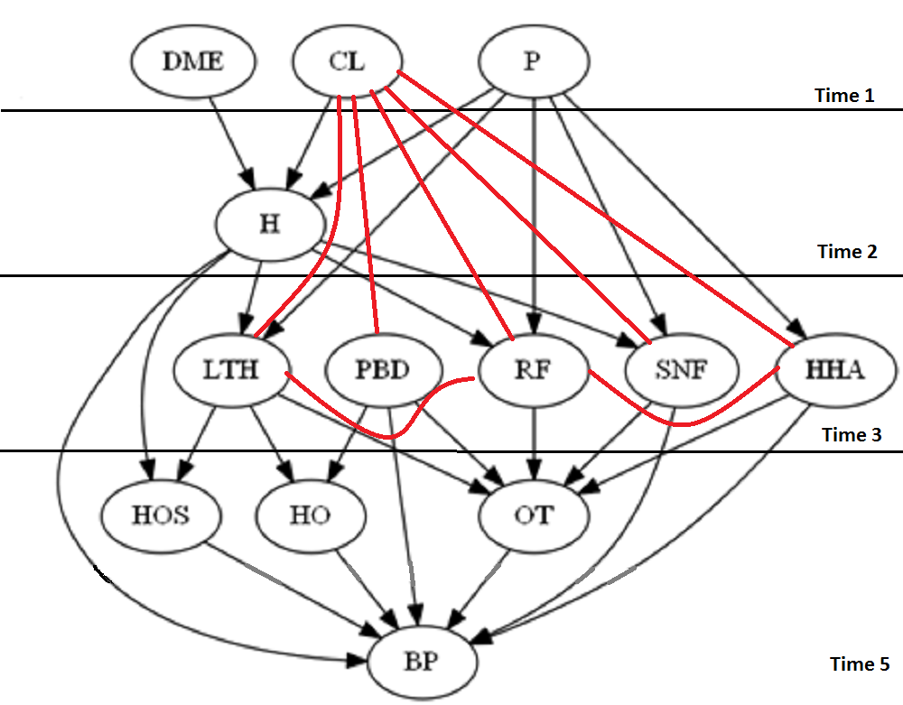

TIME 3 AFTER
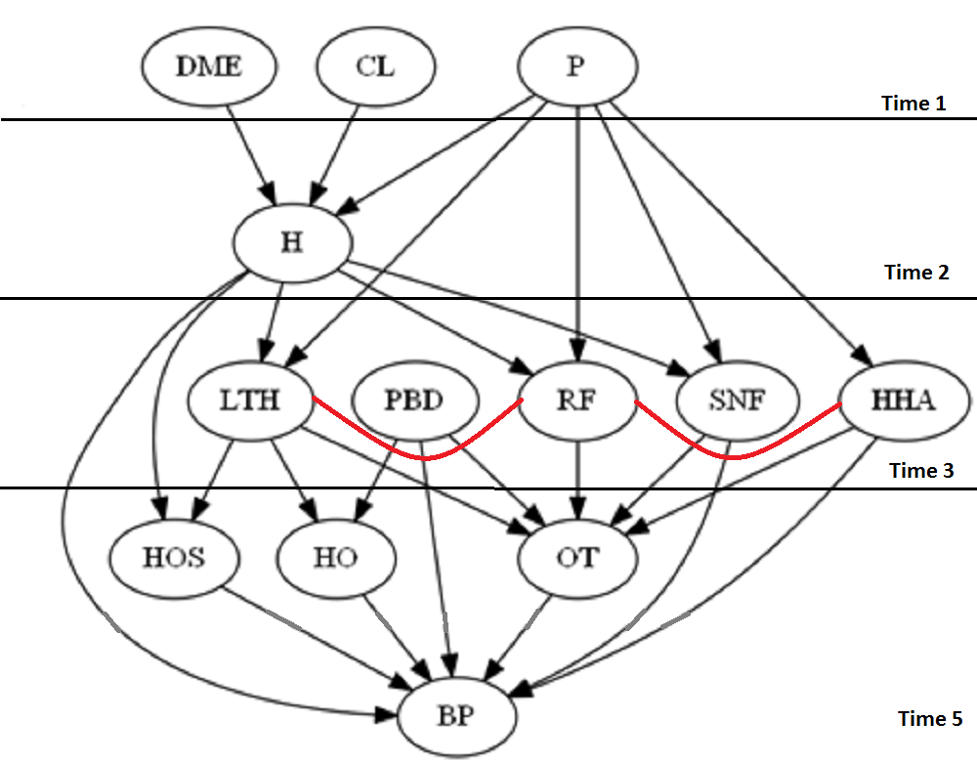
SO ONLY 2 ERRORS AFTER SHRINKING BOTH OF WHICH ARE WITHIN OUR THRESHOLD
TIME 4
q=d[,-12]
t=ddply(q,(1:12),nrow)

u=glm(V1 ~ LTH:RF + HHA:RF + DME + H + P + CL + PBD + SNF + HHA + RF + LTH + DME:H + H:CL + H:P + H:SNF + P:SNF + H:RF + P:RF + P:LTH + H:LTH + P:HHA + (DME:HOS + H:HOS + P:HOS + CL:HOS + PBD:HOS + SNF:HOS + HHA:HOS + RF:HOS + LTH:HOS)+ (DME:HO + H:HO + P:HO + CL:HO + PBD:HO + SNF:HO + HHA:HO + RF:HO + LTH:HO)+ (DME:OT + H:OT + P:OT + CL:OT + PBD:OT + SNF:OT + HHA:OT + RF:OT + LTH:OT) + (HO + HOS + OT)^2, data=t,family=poisson)
Call:
glm(formula = V1 ~ LTH:RF + HHA:RF + DME + H + P + CL + PBD +
SNF + HHA + RF + LTH + DME:H + H:CL + H:P + H:SNF + P:SNF +
H:RF + P:RF + P:LTH + H:LTH + P:HHA + (DME:HOS + H:HOS +
P:HOS + CL:HOS + PBD:HOS + SNF:HOS + HHA:HOS + RF:HOS + LTH:HOS) +
(DME:HO + H:HO + P:HO + CL:HO + PBD:HO + SNF:HO + HHA:HO +
RF:HO + LTH:HO) + (DME:OT + H:OT + P:OT + CL:OT + PBD:OT +
SNF:OT + HHA:OT + RF:OT + LTH:OT) + (HO + HOS + OT)^2, family = poisson,
data = t)

Deviance Residuals:
Min 1Q Median 3Q Max
-2.68939 -0.55141 -0.01088 0.50295 2.81756

Coefficients:
Estimate Std. Error z value Pr(>|z|)
(Intercept) 2.232493 0.097263 22.953 < 2e-16 ***
DME -0.513101 0.084552 -6.068 1.29e-09 ***
H -2.148956 0.112771 -19.056 < 2e-16 ***
P -1.674852 0.109685 -15.270 < 2e-16 ***
CL -0.465894 0.084001 -5.546 2.92e-08 ***
PBD -0.721533 0.090973 -7.931 2.17e-15 ***
SNF -0.812757 0.091053 -8.926 < 2e-16 ***
HHA -0.531430 0.087433 -6.078 1.22e-09 ***
RF -0.577921 0.089595 -6.450 1.12e-10 ***
LTH -1.506102 0.098517 -15.288 < 2e-16 ***
HO -0.417065 0.092660 -4.501 6.76e-06 ***
HOS -0.533275 0.094973 -5.615 1.97e-08 ***
OT -0.518932 0.102317 -5.072 3.94e-07 ***
LTH:RF -0.114560 0.055040 -2.081 0.037396 *
RF:HHA 0.120813 0.047259 2.556 0.010577 *
DME:H 0.620245 0.043454 14.274 < 2e-16 ***
H:CL 0.671137 0.043298 15.500 < 2e-16 ***
H:P 0.297477 0.046239 6.433 1.25e-10 ***
H:SNF 0.681216 0.047518 14.336 < 2e-16 ***
P:SNF 0.721172 0.047069 15.322 < 2e-16 ***
RF:H 0.755684 0.048532 15.571 < 2e-16 ***
RF:P 0.660295 0.049436 13.356 < 2e-16 ***
LTH:P 0.659881 0.049466 13.340 < 2e-16 ***
LTH:H 0.531385 0.049716 10.688 < 2e-16 ***
HHA:P 0.650689 0.043216 15.057 < 2e-16 ***
DME:HOS -0.004980 0.047223 -0.105 0.916015
H:HOS 0.673742 0.051681 13.037 < 2e-16 ***
P:HOS -0.085026 0.051179 -1.661 0.096647 .
CL:HOS 0.018506 0.047206 0.392 0.695037
PBD:HOS -0.170838 0.046651 -3.662 0.000250 ***
SNF:HOS 0.103100 0.052421 1.967 0.049208 *
HHA:HOS 0.007892 0.047465 0.166 0.867940
RF:HOS 0.116929 0.053619 2.181 0.029203 *
LTH:HOS 0.769196 0.051136 15.042 < 2e-16 ***
DME:HO 0.024903 0.045821 0.543 0.586796
H:HO 0.055757 0.051984 1.073 0.283465
P:HO -0.041225 0.049599 -0.831 0.405888
CL:HO -0.030203 0.045659 -0.661 0.508298
PBD:HO 0.701206 0.046995 14.921 < 2e-16 ***
SNF:HO 0.014341 0.051200 0.280 0.779401
HHA:HO 0.024978 0.046913 0.532 0.594422
RF:HO 0.058917 0.052665 1.119 0.263265
LTH:HO 0.691835 0.050328 13.747 < 2e-16 ***
DME:OT -0.078099 0.075921 -1.029 0.303626
H:OT 0.009374 0.094440 0.099 0.920933
P:OT -0.180758 0.089625 -2.017 0.043714 *
CL:OT -0.060612 0.075320 -0.805 0.420979
PBD:OT 0.386255 0.081503 4.739 2.15e-06 ***
SNF:OT 0.840477 0.081063 10.368 < 2e-16 ***
HHA:OT 0.559216 0.076349 7.324 2.40e-13 ***
RF:OT 0.595300 0.080559 7.390 1.47e-13 ***
LTH:OT 0.861010 0.084132 10.234 < 2e-16 ***
HOS:HO 0.148032 0.053463 2.769 0.005625 **
HO:OT 0.310919 0.083866 3.707 0.000209 ***
HOS:OT 0.422191 0.086674 4.871 1.11e-06 ***
---
Signif. codes: 0 ‘***’ 0.001 ‘**’ 0.01 ‘*’ 0.05 ‘.’ 0.1 ‘ ’ 1

(Dispersion parameter for poisson family taken to be 1)

Null deviance: 14762.2 on 2148 degrees of freedom
Residual deviance: 1457.6 on 2094 degrees of freedom
AIC: 7725

Number of Fisher Scoring iterations: 5

So the network now looks like this before shrinking
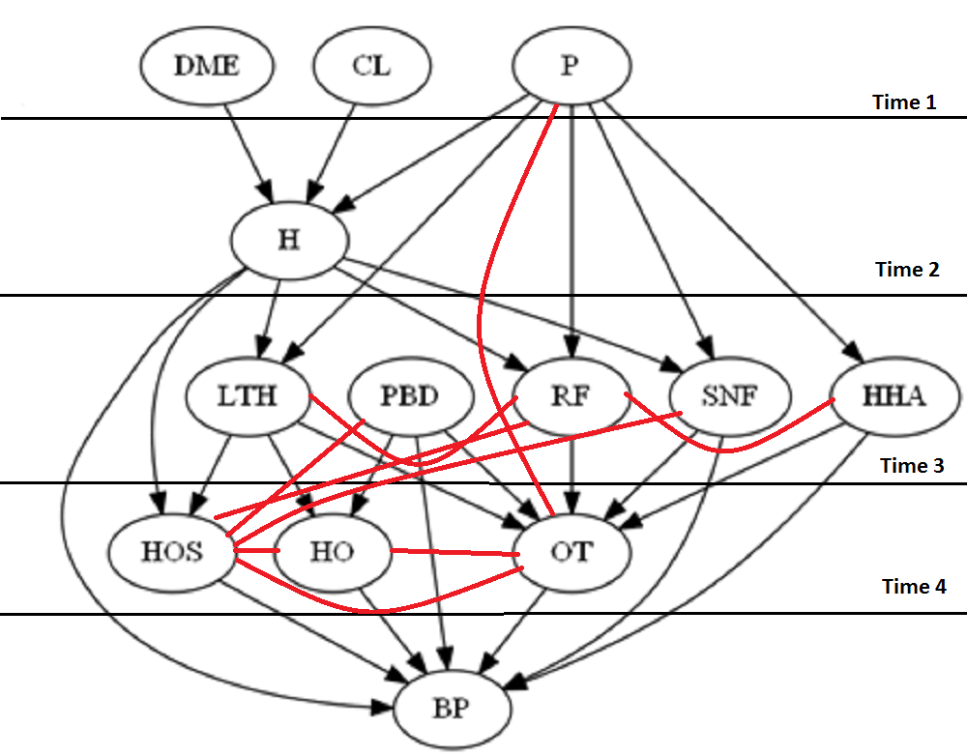

For HO
c=c("H OS ", "OT ", "LTH ", "PBD ", "HO")
q=d[c]
q=as.data.frame(q)
a=ncol(q)
t=ddply(q,(1:a),nrow)
u=glm(V1~.*.,data=t,family=poisson)
summary(u)
Coefficients:
Estimate Std. Error z value Pr(>|z|)
(Intercept) 4.39966 0.07626 57.692 < 2e-16 ***
PBD -1.30517 0.08781 -14.864 < 2e-16 ***
HO -0.15349 0.08152 -1.883 0.059737 .
HOS 0.13062 0.08012 1.630 0.103021
OT 1.09723 0.08074 13.590 < 2e-16 ***
LTH -1.26394 0.08508 -14.856 < 2e-16 ***
PBD:HO 0.92225 0.04759 19.379 < 2e-16 ***
PBD:HOS -0.16901 0.04740 -3.565 0.000363 ***
PBD:OT 0.96269 0.08018 12.007 < 2e-16 ***
PBD:LTH -0.21060 0.04769 -4.416 1.01e-05 ***
HO:HOS 0.06636 0.05209 1.274 0.202715 ---correctly discarded
HO:OT 0.06975 0.07820 0.892 0.372431 ---correctly discarded
HO:LTH 0.84045 0.04989 16.845 < 2e-16 ***
HOS:OT 0.26118 0.07804 3.347 0.000817 ***
HOS:LTH 0.97526 0.04868 20.036 < 2e-16 ***
OT:LTH 1.08513 0.07614 14.251 < 2e-16 ***
---
Signif. codes: 0 ‘***’ 0.001 ‘**’ 0.01 ‘*’ 0.05 ‘.’ 0.1 ‘ ’ 1

(Dispersion parameter for poisson family taken to be 1)

Null deviance: 15314.883 on 31 degrees of freedom
Residual deviance: 18.179 on 16 degrees of freedom
AIC: 264.3

Number of Fisher Scoring iterations: 4

For OT
c=c("P ", "LTH ", "PBD ", "RF ", "SNF ", "HHA ", "HO ", "HOS ", "OT ")
q=d[c]
q=as.data.frame(q)
a=ncol(q)
t=ddply(q,(1:a),nrow)
u=glm(V1~.*.,data=t,family=poisson)
summary(u)
Coefficients:
Estimate Std. Error z value Pr(>|z|)
(Intercept) 2.74546 0.09648 28.456 < 2e-16 ***
P -2.27099 0.10280 -22.090 < 2e-16 ***
HHA -0.67365 0.08852 -7.610 2.74e-14 ***
SNF -0.60996 0.08975 -6.796 1.08e-11 ***
RF -0.28300 0.08803 -3.215 0.001306 **
PBD -1.10638 0.09461 -11.694 < 2e-16 ***
HO -0.21844 0.08992 -2.429 0.015129 *
HOS -0.09381 0.08888 -1.055 0.291211
OT -0.36187 0.10362 -3.492 0.000479 ***
LTH -1.45193 0.09582 -15.153 < 2e-16 ***
P:HHA 0.77791 0.04484 17.348 < 2e-16 ***
P:SNF 0.91825 0.04857 18.908 < 2e-16 ***
P:RF 0.87997 0.04904 17.944 < 2e-16 ***
P:PBD -0.03587 0.04465 -0.803 0.421837
P:HO 0.02365 0.05014 0.472 0.637171
P:HOS 0.01871 0.05008 0.374 0.708720
P:OT -0.07094 0.08471 -0.837 0.402329 ---correctly discarded
P:LTH 0.83187 0.05045 16.490 < 2e-16 ***
HHA:SNF -0.15152 0.04738 -3.198 0.001385 **
HHA:RF 0.11516 0.04705 2.447 0.014385 *
HHA:PBD -0.04709 0.04331 -1.088 0.276813
HHA:HO 0.02251 0.04835 0.466 0.641460
HHA:HOS -0.02923 0.04834 -0.605 0.545423
HHA:OT 0.87137 0.07733 11.268 < 2e-16 ***
HHA:LTH -0.03925 0.04890 -0.803 0.422156
SNF:RF 0.10268 0.04989 2.058 0.039585 *
SNF:PBD -0.11291 0.04660 -2.423 0.015407 *
SNF:HO 0.01759 0.05183 0.339 0.734307
SNF:HOS 0.16465 0.05098 3.229 0.001241 **
SNF:OT 1.04147 0.07750 13.438 < 2e-16 ***
SNF:LTH 0.02252 0.05175 0.435 0.663450
RF:PBD -0.05696 0.04685 -1.216 0.224032
RF:HO -0.02683 0.05231 -0.513 0.608047
RF:HOS 0.18688 0.05120 3.650 0.000262 ***
RF:OT 0.66361 0.07787 8.522 < 2e-16 ***
RF:LTH -0.06399 0.05237 -1.222 0.221724
PBD:HO 0.88877 0.04774 18.616 < 2e-16 ***
PBD:HOS -0.15859 0.04752 -3.337 0.000846 ***
PBD:OT 0.92909 0.08326 11.159 < 2e-16 ***
PBD:LTH -0.18138 0.04852 -3.738 0.000185 ***
HO:HOS 0.06140 0.05222 1.176 0.239647
HO:OT 0.14303 0.08164 1.752 0.079761 . ---correctly discarded
HO:LTH 0.82479 0.05083 16.226 < 2e-16 ***
HOS:OT 0.25710 0.08130 3.162 0.001566 **
HOS:LTH 0.94863 0.04976 19.064 < 2e-16 ***
OT:LTH 0.94845 0.08068 11.756 < 2e-16 ***
---
Signif. codes: 0 ‘***’ 0.001 ‘**’ 0.01 ‘*’ 0.05 ‘.’ 0.1 ‘ ’ 1

(Dispersion parameter for poisson family taken to be 1)

Null deviance: 19514.7 on 456 degrees of freedom
Residual deviance: 313.2 on 411 degrees of freedom
AIC: 2219.8

Number of Fisher Scoring iterations: 4
For PBD
c=c("HOS ", "HO ", "OT ", "PBD ")
q=d[c]
q=as.data.frame(q)
a=ncol(q)
t=ddply(q,(1:a),nrow)
u=glm(V1~.*.,data=t,family=poisson)
summary(u)
Coefficients:
Estimate Std. Error z value Pr(>|z|)
(Intercept) 4.64612 0.07408 62.714 < 2e-16 ***
PBD -1.35059 0.08722 -15.485 < 2e-16 ***
HO 0.10712 0.07880 1.359 0.174007
HOS 0.44591 0.07700 5.791 7.00e-09 ***
OT 1.46082 0.07741 18.870 < 2e-16 ***
PBD:HO 0.88603 0.04674 18.955 < 2e-16 ***
PBD:HOS -0.21186 0.04638 -4.567 4.94e-06 ***
PBD:OT 0.91308 0.07925 11.522 < 2e-16 ***
HO:HOS 0.24821 0.05007 4.958 7.14e-07 ***
HO:OT 0.27500 0.07586 3.625 0.000289 ***
HOS:OT 0.50345 0.07523 6.692 2.20e-11 ***
---
Signif. codes: 0 ‘***’ 0.001 ‘**’ 0.01 ‘*’ 0.05 ‘.’ 0.1 ‘ ’ 1

(Dispersion parameter for poisson family taken to be 1)

Null deviance: 12672.487 on 15 degrees of freedom
Residual deviance: 10.962 on 5 degrees of freedom
AIC: 152.27

Number of Fisher Scoring iterations: 4
For HOS
c=c("HO ", "OT ", "PBD ", "RF ", "SNF ", "LTH ", "H ", "HOS ")
q=d[c]
q=as.data.frame(q)
a=ncol(q)
t=ddply(q,(1:a),nrow)
u=glm(V1~.*.,data=t,family=poisson)
summary(u)
Coefficients:
Estimate Std. Error z value Pr(>|z|)
(Intercept) 3.079320 0.092943 33.131 < 2e-16 ***
H -1.925557 0.095662 -20.129 < 2e-16 ***
SNF -0.693569 0.088040 -7.878 3.33e-15 ***
RF -0.211944 0.086418 -2.453 0.014185 *
PBD -1.183190 0.092675 -12.767 < 2e-16 ***
HO -0.173318 0.088084 -1.968 0.049110 *
HOS -0.179380 0.088531 -2.026 0.042745 *
OT 0.090394 0.098444 0.918 0.358499
LTH -1.468901 0.093413 -15.725 < 2e-16 ***
H:SNF 0.885709 0.047612 18.603 < 2e-16 ***
H:RF 0.926867 0.048024 19.300 < 2e-16 ***
H:PBD 0.010624 0.045578 0.233 0.815683
H:HO 0.046273 0.050663 0.913 0.361061
H:HOS 0.800379 0.049313 16.231 < 2e-16 ***
H:OT 0.008163 0.080793 0.101 0.919524
H:LTH 0.712774 0.049402 14.428 < 2e-16 ***
SNF:RF 0.095298 0.049828 1.913 0.055807 .
SNF:PBD -0.129392 0.046445 -2.786 0.005338 **
SNF:HO 0.013752 0.051639 0.266 0.790006
SNF:HOS 0.007584 0.051565 0.147 0.883071 ---correctly discarded
SNF:OT 1.075088 0.076235 14.102 < 2e-16 ***
SNF:LTH 0.038560 0.051450 0.749 0.453581
RF:PBD -0.074187 0.046845 -1.584 0.113271
RF:HO -0.033175 0.052277 -0.635 0.525683
RF:HOS 0.014791 0.051970 0.285 0.775952 ---correctly discarded
RF:OT 0.680156 0.077136 8.818 < 2e-16 ***
RF:LTH -0.051333 0.052257 -0.982 0.325940
PBD:HO 0.915048 0.047661 19.199 < 2e-16 ***
PBD:HOS -0.167924 0.048188 -3.485 0.000493 ***
PBD:OT 0.975464 0.081830 11.921 < 2e-16 ***
PBD:LTH -0.196837 0.048320 -4.074 4.63e-05 ***
HO:HOS 0.061035 0.052942 1.153 0.248969 ---correctly discarded
HO:OT 0.092350 0.080202 1.151 0.249544
HO:LTH 0.826068 0.050593 16.328 < 2e-16 ***
HOS:OT 0.200768 0.081131 2.475 0.013338 *
HOS:LTH 0.832182 0.049988 16.648 < 2e-16 ***
OT:LTH 0.991814 0.079040 12.548 < 2e-16 ***
---
Signif. codes: 0 ‘***’ 0.001 ‘**’ 0.01 ‘*’ 0.05 ‘.’ 0.1 ‘ ’ 1

(Dispersion parameter for poisson family taken to be 1)

Null deviance: 20661.20 on 247 degrees of freedom
Residual deviance: 193.15 on 211 degrees of freedom
AIC: 1387.5

Number of Fisher Scoring iterations: 4

For LTH
c=c("RF ", "OT " , "H ", "P " , "HOS " , "HO ", "LTH ")
q=d[c]
q=as.data.frame(q)
a=ncol(q)
t=ddply(q,(1:a),nrow)
u=glm(V1~.*.,data=t,family=poisson)
summary(u)
Coefficients:
Estimate Std. Error z value Pr(>|z|)
(Intercept) 3.55685 0.08692 40.922 < 2e-16 ***
P -1.75106 0.09268 -18.893 < 2e-16 ***
H -1.61356 0.09085 -17.761 < 2e-16 ***
RF -0.36773 0.08578 -4.287 1.81e-05 ***
HO 0.14295 0.08337 1.715 0.086392 .
HOS -0.19151 0.08619 -2.222 0.026280 *
OT 0.86507 0.08951 9.665 < 2e-16 ***
LTH -1.67178 0.09275 -18.025 < 2e-16 ***
P:H 0.47722 0.04503 10.598 < 2e-16 ***
P:RF 0.85102 0.04817 17.668 < 2e-16 ***
P:HO 0.02654 0.04755 0.558 0.576664
P:HOS -0.03250 0.04920 -0.660 0.508950
P:OT 0.32914 0.07911 4.161 3.17e-05 ***
P:LTH 0.78057 0.04915 15.882 < 2e-16 ***
H:RF 0.85413 0.04805 17.776 < 2e-16 ***
H:HO 0.03982 0.04902 0.812 0.416628
H:HOS 0.80960 0.04863 16.648 < 2e-16 ***
H:OT 0.19280 0.07773 2.481 0.013119 *
H:LTH 0.63361 0.04926 12.863 < 2e-16 ***
RF:HO -0.05061 0.05203 -0.973 0.330681
RF:HOS 0.02147 0.05277 0.407 0.684056
RF:OT 0.62867 0.07659 8.208 2.25e-16 ***
RF:LTH -0.20100 0.05368 -3.744 0.000181 ***
HO:HOS 0.02301 0.05181 0.444 0.656951
HO:OT 0.27084 0.07675 3.529 0.000418 ***
HO:LTH 0.78322 0.05000 15.664 < 2e-16 ***
HOS:OT 0.15215 0.07917 1.922 0.054634 .
HOS:LTH 0.84992 0.05068 16.771 < 2e-16 ***
OT:LTH 0.92659 0.07790 11.895 < 2e-16 ***
---
Signif. codes: 0 ‘***’ 0.001 ‘**’ 0.01 ‘*’ 0.05 ‘.’ 0.1 ‘ ’ 1

(Dispersion parameter for poisson family taken to be 1)

Null deviance: 19352.185 on 127 degrees of freedom
Residual deviance: 83.042 on 99 degrees of freedom
AIC: 804.56

Number of Fisher Scoring iterations: 4

For RF
c=c("LTH", "H" , "P", "HOS" , "OT" , "RF" ,"HHA")
q=d[c]
q=as.data.frame(q)
a=ncol(q)
t=ddply(q,(1:a),nrow)
u=glm(V1~.*.,data=t,family=poisson)
summary(u)
Coefficients:
Estimate Std. Error z value Pr(>|z|)
(Intercept) 3.93444 0.07914 49.716 < 2e-16 ***
P -2.05500 0.09267 -22.177 < 2e-16 ***
H -1.56364 0.08791 -17.786 < 2e-16 ***
HHA -0.74158 0.08262 -8.976 < 2e-16 ***
RF -0.43742 0.08276 -5.286 1.25e-07 ***
HOS -0.17411 0.08297 -2.098 0.03587 *
OT 0.65431 0.08431 7.761 8.45e-15 ***
LTH -1.16928 0.08649 -13.519 < 2e-16 ***
P:H 0.49346 0.04579 10.776 < 2e-16 ***
P:HHA 0.77104 0.04409 17.489 < 2e-16 ***
P:RF 0.82813 0.04891 16.931 < 2e-16 ***
P:HOS -0.02966 0.04997 -0.593 0.55290
P:OT 0.16966 0.08077 2.101 0.03568 *
P:LTH 0.79036 0.04929 16.035 < 2e-16 ***
H:HHA -0.08957 0.04583 -1.954 0.05067 .
H:RF 0.85634 0.04808 17.811 < 2e-16 ***
H:HOS 0.80948 0.04864 16.643 < 2e-16 ***
H:OT 0.21347 0.07825 2.728 0.00637 **
H:LTH 0.63963 0.04859 13.164 < 2e-16 ***
HHA:RF 0.12553 0.04779 2.627 0.00862 **
HHA:HOS -0.01520 0.04892 -0.311 0.75609 ---correctly discarded
HHA:OT 0.86062 0.07555 11.391 < 2e-16 ***
HHA:LTH -0.03005 0.04858 -0.619 0.53621
RF:HOS 0.02168 0.05279 0.411 0.68132
RF:OT 0.59991 0.07716 7.775 7.57e-15 ***
RF:LTH -0.20856 0.05300 -3.935 8.32e-05 ***
HOS:OT 0.15665 0.07974 1.964 0.04947 *
HOS:LTH 0.85366 0.04994 17.095 < 2e-16 ***
OT:LTH 0.97954 0.07734 12.665 < 2e-16 ***
---
Signif. codes: 0 ‘***’ 0.001 ‘**’ 0.01 ‘*’ 0.05 ‘.’ 0.1 ‘ ’ 1

(Dispersion parameter for poisson family taken to be 1)

Null deviance: 18031.437 on 127 degrees of freedom
Residual deviance: 76.426 on 99 degrees of freedom
AIC: 802.22

Number of Fisher Scoring iterations: 4
So after shrinking we have
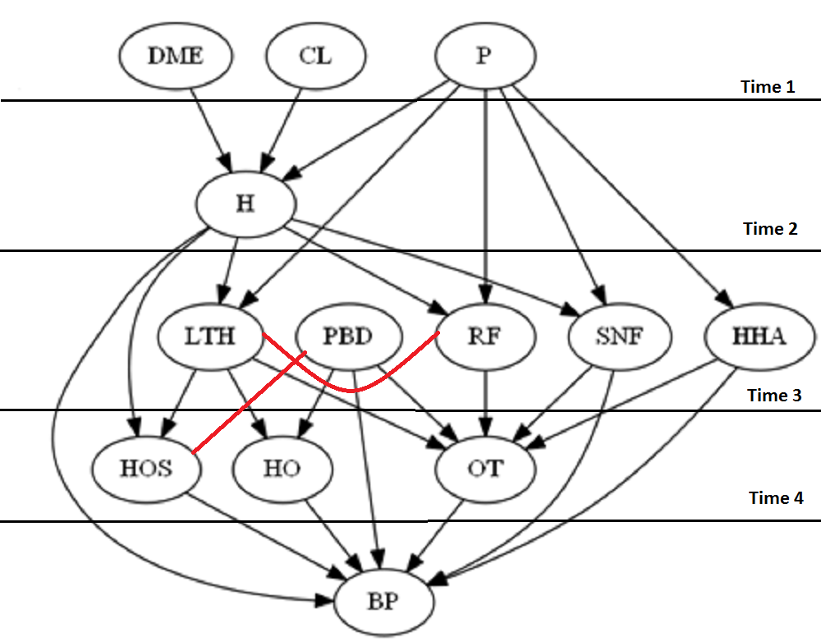

Time 5
t=ddply(d,(1:13),nrow)
glm(formula = V1 ~ PBD:HOS + LTH:RF + H:HOS + LTH:HOS + PBD:HO +
LTH:HO + PBD:OT + SNF:OT + HHA:OT + RF:OT + LTH:OT + DME +
H + P + CL + PBD + SNF + HHA + RF + LTH + HOS + OT + HO +
DME:H + H:CL + H:P + H:SNF + P:SNF + H:RF + P:RF + P:LTH +
H:LTH + P:HHA + (BP:DME + BP:CL + BP:P + BP:H + BP:RF + BP:SNF +
BP:HHA + BP:LTH + BP:PBD + BP:HOS + BP:OT + BP:HO), family = poisson,
data = t)

Call:
glm(formula = V1 ~ PBD:HOS + LTH:RF + H:HOS + LTH:HOS + PBD:HO +
LTH:HO + PBD:OT + SNF:OT + HHA:OT + RF:OT + LTH:OT + DME +
H + P + CL + PBD + SNF + HHA + RF + LTH + HOS + OT + HO +
DME:H + H:CL + H:P + H:SNF + P:SNF + H:RF + P:RF + P:LTH +
H:LTH + P:HHA + (BP:DME + BP:CL + BP:P + BP:H + BP:RF + BP:SNF +
BP:HHA + BP:LTH + BP:PBD + BP:HOS + BP:OT + BP:HO), family = poisson,
data = t)

Deviance Residuals:
Min 1Q Median 3Q Max
-2.8287 -0.5454 0.0229 0.5256 3.4783

Coefficients:
Estimate Std. Error z value Pr(>|z|)
(Intercept) 1.54181 0.07892 19.536 < 2e-16 ***
DME -0.17348 0.10987 -1.579 0.114326
H -2.90499 0.16420 -17.692 < 2e-16 ***
P -1.81297 0.15438 -11.743 < 2e-16 ***
CL -0.15833 0.10571 -1.498 0.134198
PBD -0.75676 0.14873 -5.088 3.61e-07 ***
SNF -1.16981 0.14032 -8.337 < 2e-16 ***
HHA -0.69101 0.13000 -5.315 1.06e-07 ***
RF -0.29137 0.13176 -2.211 0.027013 *
LTH -1.73714 0.15129 -11.482 < 2e-16 ***
HOS -0.40864 0.11183 -3.654 0.000258 ***
OT -0.73614 0.14686 -5.012 5.38e-07 ***
HO -0.59785 0.11654 -5.130 2.90e-07 ***
PBD:HOS -0.13067 0.04526 -2.887 0.003885 **
LTH:RF -0.09028 0.05335 -1.692 0.090578 . ---discarded correctly
HOS:H 0.71178 0.04768 14.928 < 2e-16 ***
HOS:LTH 0.78151 0.04899 15.953 < 2e-16 ***
PBD:HO 0.67984 0.04663 14.581 < 2e-16 ***
LTH:HO 0.69873 0.04736 14.754 < 2e-16 ***
PBD:OT 0.44398 0.07856 5.651 1.59e-08 ***
OT:SNF 0.76960 0.07624 10.095 < 2e-16 ***
OT:HHA 0.50748 0.07440 6.821 9.07e-12 ***
RF:OT 0.58890 0.07560 7.789 6.75e-15 ***
LTH:OT 0.91737 0.07604 12.064 < 2e-16 ***
H:DME 0.59438 0.04279 13.890 < 2e-16 ***
H:CL 0.65048 0.04266 15.250 < 2e-16 ***
H:P 0.25650 0.04580 5.600 2.14e-08 ***
H:SNF 0.67940 0.04636 14.655 < 2e-16 ***
SNF:P 0.68577 0.04695 14.605 < 2e-16 ***
RF:H 0.77201 0.04801 16.082 < 2e-16 ***
RF:P 0.67343 0.04874 13.818 < 2e-16 ***
LTH:P 0.61402 0.04802 12.787 < 2e-16 ***
LTH:H 0.53221 0.04898 10.867 < 2e-16 ***
HHA:P 0.64446 0.04221 15.267 < 2e-16 ***
DME:BP -0.38333 0.11170 -3.432 0.000599 ***
CL:BP -0.36039 0.10767 -3.347 0.000816 ***
P:BP -0.04578 0.14463 -0.317 0.751614
H:BP 0.82734 0.14904 5.551 2.84e-08 ***
RF:BP -0.12635 0.12405 -1.019 0.308424
SNF:BP 0.53934 0.12533 4.303 1.68e-05 ***
HHA:BP 0.33846 0.11670 2.900 0.003729 **
LTH:BP 0.16348 0.13558 1.206 0.227909
PBD:BP -0.01914 0.12689 -0.151 0.880125
HOS:BP 0.45281 0.11102 4.078 4.53e-05 ***
OT:BP 0.60336 0.14260 4.231 2.33e-05 ***
HO:BP 0.67706 0.11473 5.902 3.60e-09 ***
---
Signif. codes: 0 ‘***’ 0.001 ‘**’ 0.01 ‘*’ 0.05 ‘.’ 0.1 ‘ ’ 1

(Dispersion parameter for poisson family taken to be 1)

Null deviance: 15570.6 on 2399 degrees of freedom
Residual deviance: 1671.3 on 2354 degrees of freedom
AIC: 8371.1

Number of Fisher Scoring iterations: 5
So now the network at Time 5 looks like this BEFORE cleaning up
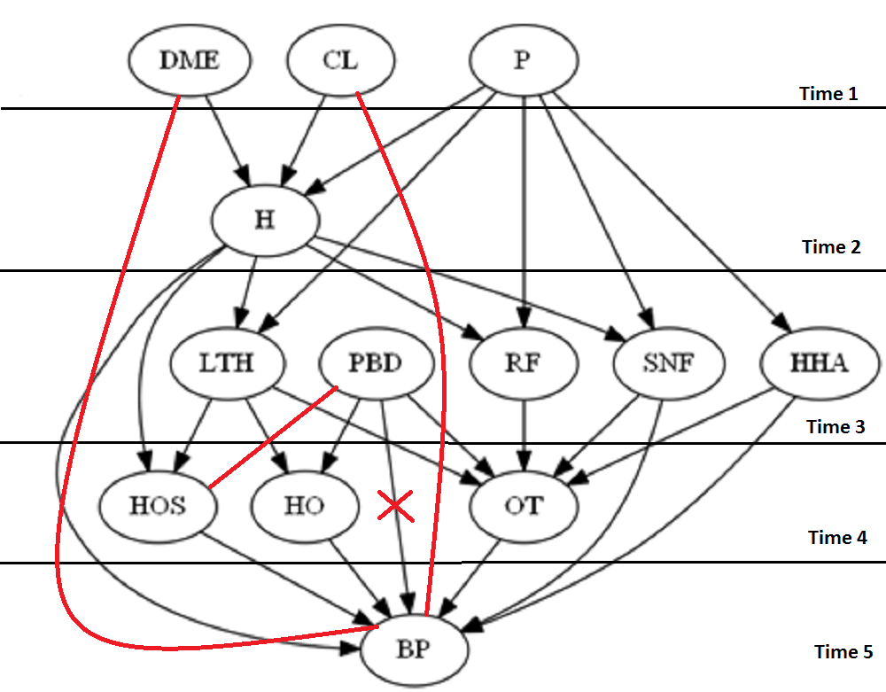

For HOS
c=c("H ", "LTH ", "PBD ", "BP ", "HOS ")
q=d[c]
q=as.data.frame(q)
a=ncol(q)
t=ddply(q,(1:a),nrow)
u=glm(V1~.*.,data=t,family=poisson)
summary(u)
Coefficients:
Estimate Std. Error z value Pr(>|z|)
(Intercept) 4.27216 0.09126 46.813 < 2e-16 ***
H -1.83366 0.12192 -15.040 < 2e-16 ***
PBD -0.99159 0.11847 -8.370 < 2e-16 ***
HOS -0.38943 0.10787 -3.610 0.000306 ***
BP 1.56141 0.09644 16.190 < 2e-16 ***
LTH -0.65115 0.10806 -6.026 1.68e-09 ***
H:PBD -0.04242 0.04295 -0.988 0.323313
H:HOS 0.79063 0.04756 16.624 < 2e-16 ***
H:BP 1.27047 0.11779 10.786 < 2e-16 ***
H:LTH 0.72412 0.04648 15.581 < 2e-16 ***
PBD:HOS -0.15989 0.04703 -3.399 0.000675 ***---incorrectly kept in
PBD:BP 1.14112 0.11767 9.697 < 2e-16 ***
PBD:LTH 0.01406 0.04582 0.307 0.758884
HOS:BP 0.46173 0.10880 4.244 2.20e-05 ***
HOS:LTH 0.85197 0.04872 17.488 < 2e-16 ***
BP:LTH 0.53011 0.10780 4.918 8.76e-07 ***

For BP
c=c("DME ", "CL, ", "HOS ", "HO ", "OT ", "H ", "SNF ", "HHA ", "BP ")
q=d[c]
q=as.data.frame(q)
a=ncol(q)
t=ddply(q,(1:a),nrow)
u=glm(V1~.*.,data=t,family=poisson)
summary(u)
Coefficients:
Estimate Std. Error z value Pr(>|z|)
(Intercept) 2.421671 0.131070 18.476 < 2e-16 ***
CL -0.462963 0.121641 -3.806 0.000141 ***
DME -0.590974 0.122825 -4.812 1.50e-06 ***
H -2.490359 0.152155 -16.367 < 2e-16 ***
HHA -1.108705 0.127365 -8.705 < 2e-16 ***
SNF -1.283500 0.132405 -9.694 < 2e-16 ***
HO -0.609622 0.121868 -5.002 5.66e-07 ***
HOS -0.425890 0.123344 -3.453 0.000555 ***
OT -0.495310 0.136276 -3.635 0.000278 ***
BP -0.053589 0.140756 -0.381 0.703409
CL:DME -0.083616 0.041766 -2.002 0.045284 *
CL:H 0.792883 0.045095 17.583 < 2e-16 ***
CL:HHA 0.022590 0.042302 0.534 0.593341
CL:SNF -0.019174 0.046246 -0.415 0.678427
CL:HO -0.022521 0.045856 -0.491 0.623330
CL:HOS 0.024993 0.047189 0.530 0.596368
CL:OT 0.082463 0.076078 1.084 0.278401
CL:BP -0.207524 0.109359 -1.898 0.057743 . -----correctly discarded
DME:H 0.728044 0.045349 16.054 < 2e-16 ***
DME:HHA 0.040059 0.042340 0.946 0.344080
DME:SNF 0.008946 0.046306 0.193 0.846812
DME:HO 0.065492 0.045975 1.425 0.154297
DME:HOS 0.005151 0.047253 0.109 0.913190
DME:OT 0.053789 0.076233 0.706 0.480446
DME:BP -0.181561 0.109493 -1.658 0.097279 . ---correctly discarded
H:HHA 0.024606 0.045882 0.536 0.591764
H:SNF 0.851788 0.048045 17.729 < 2e-16 ***
H:HO 0.086931 0.049622 1.752 0.079799 .
H:HOS 0.879054 0.049102 17.903 < 2e-16 ***
H:OT 0.134896 0.082268 1.640 0.101066
H:BP 0.901694 0.129627 6.956 3.50e-12 ***
HHA:SNF -0.025093 0.046730 -0.537 0.591287
HHA:HO -0.029536 0.046519 -0.635 0.525487
HHA:HOS -0.010015 0.047603 -0.210 0.833366
HHA:OT 0.856763 0.075284 11.380 < 2e-16 ***
HHA:BP 0.784218 0.112052 6.999 2.58e-12 ***
SNF:HO -0.063592 0.050718 -1.254 0.209909
SNF:HOS 0.021826 0.050991 0.428 0.668624
SNF:OT 0.992177 0.076816 12.916 < 2e-16 ***
SNF:BP 0.810685 0.115477 7.020 2.21e-12 ***
HO:HOS 0.143821 0.050760 2.833 0.004606 **
HO:OT 0.401704 0.078423 5.122 3.02e-07 ***
HO:BP 1.109841 0.107337 10.340 < 2e-16 ***
HOS:OT 0.354804 0.079838 4.444 8.83e-06 ***
HOS:BP 0.475612 0.111065 4.282 1.85e-05 ***
OT:BP 1.213738 0.131676 9.218 < 2e-16 ***
---
Signif. codes: 0 ‘***’ 0.001 ‘**’ 0.01 ‘*’ 0.05 ‘.’ 0.1 ‘ ’ 1

(Dispersion parameter for poisson family taken to be 1)

Null deviance: 23674.94 on 406 degrees of freedom
Residual deviance: 284.11 on 361 degrees of freedom
AIC: 1917.9

Number of Fisher Scoring iterations: 5

So after cleaning up time 5 looks like this
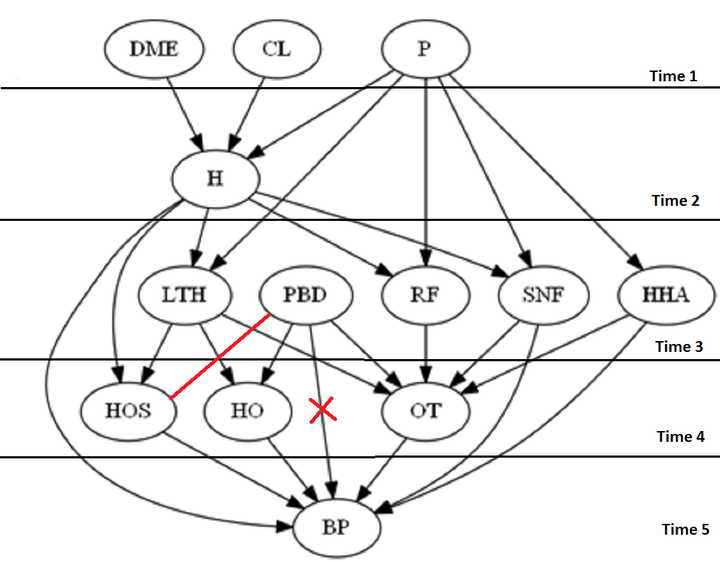
Note: The relation between HOS:PBD is -0.15 which is well within our threshold.

