UJWALA POLEPEDDI
TEACH ONE- STRATIFIED COVARIATE BALANCING
QUESTION 2:

The following data provide the survival among stomach cancer patients. The data provides 35 common comorbidities for patients who have or don't have stomach cancer.
- Using SQL, group the diagnoses into commonly occurring strata.
- Within each strata, calculate the odds of mortality from cancer.
- Calculate the common odds ratio across strata.
- Conduct sensitivity analysis for the calculated common odds ratio. Sensitivity analysis is the process of changing one variable and re-examining the conclusions. Drop one of the 35 comorbidities from the analysis and repeat the entire analysis and check that 65% of cases are matched to controls. The percent of cases that are matched is called overlap. It is defined as:
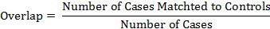
In most problems, one wants to maximize the overlap to be around at least 80%, so that findings can be generalized to the original cases.
Report how the un-confounded and confounded odds of mortality from stomach cancer are different from each other? Data► Using Synthetic Controls► Using Parents in Markov Blanket►
First group the diagnosis into commonly occurring strata

SELECT ([Column 0])as ID
,cast([Cancer] as int)as CA
,[I305 1]
,[I309 81]
,[I311 ]
,[IE849 7]
,[I150 9]
,[I276 1]
,[I276 8]
,[I530 81]
,[I263 9]
,[I276 51]
,[IV15 82]
,[I511 9]
,[I401 9]
,[I787 20]
,[I564 00]
,[I272 4]
,[I280 9]
,[I285 9]
,[I496 ]
,[I458 9]
,[I486 ]
,[IV58 61]
,[I197 7]
,[I578 9]
,[I584 9]
,[IV66 7]
,[I244 9]
,[I414 01]
,[I599 0]
,[I414 00]
,[I585 9]
,[I600 00]
,[I428 0]
,[I427 31]
,[I403 90]
,cast([Dead] as int) as Dead
into stoamch_cancer1 FROM [Stratified_covariate].[dbo].[StomachCancer]-----(100000 rows affected)

Select ID,CA,[I305 1]+[I309 81]+[I311 ]+[IE849 7]+[I150 9]+[I276 1] +[I276 8] +[I530 81]+[I263 9]
+[I276 51]+[IV15 82]+[I511 9]+[I401 9]+[I787 20]+[I564 00]+[I272 4]+[I280 9]+[I285 9]
+[I496 ]+[I458 9]+[I486 ]+[IV58 61]+[I197 7]+[I578 9]+[I584 9]+[IV66 7]+[I414 01]
+[I599 0] +[I414 00] +[I585 9]+[I600 00] +[I428 0]+[I403 90] as strata,Dead
Into #temp1
FROM stoamch_cancer1

select * from #temp1
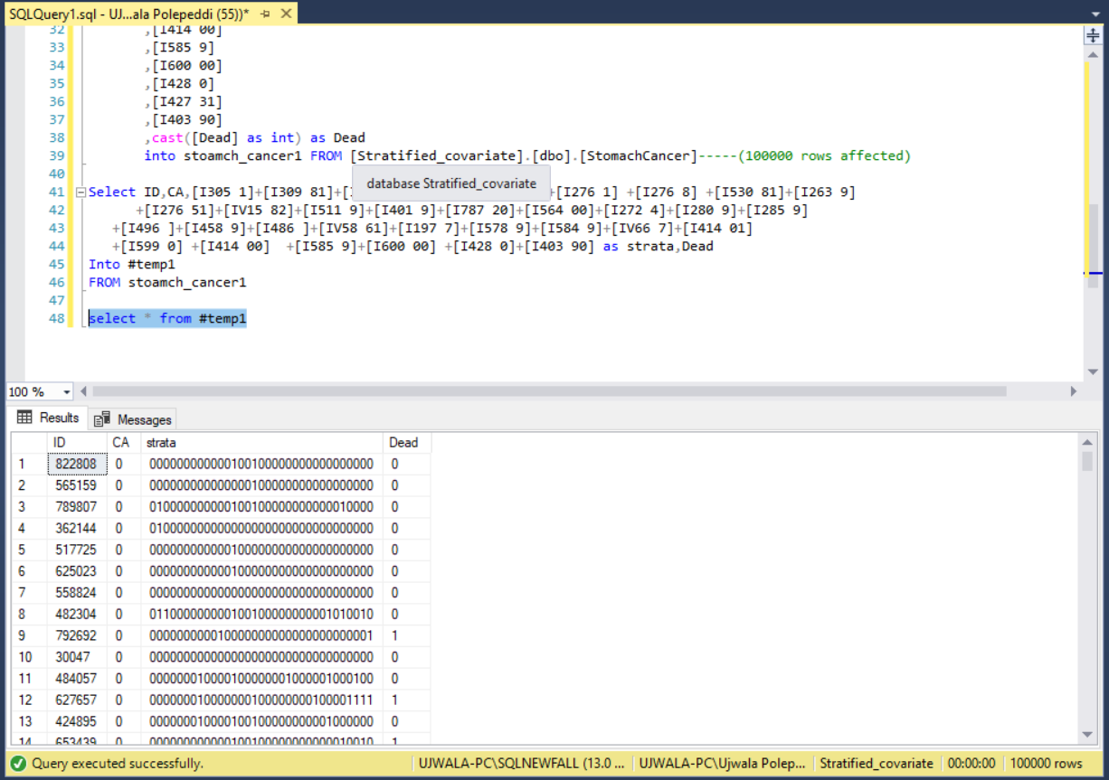

--CASES
---drop table #cases
SELECT COUNT(distinct [ID]) AS nCases -- Number of residents unable to eat
, Sum(IIF([Dead] = 1, 1., 0.)) AS a
, SUM(IIF([Dead] = 0, 1., 0.)) AS b
, strata
INTO #Cases -- Save in temporary file called Cases
FROM #temp1
WHERE [CA] = 1 -- Select only residents who were unable to eat
GROUP BY strata -------(176 rows affected)

--CONTROLS
--drop table #controls
SELECT COUNT(distinct [ID]) AS nControls -- Number of residents unable to eat
, Sum(IIF([Dead] = 1, 1., 0.)) AS c
, SUM(IIF([Dead] = 0, 1., 0.)) AS d
, strata
INTO #Controls -- Save in temporary file called Cases
FROM #temp1
WHERE [CA] = 0 -- Select only residents who were unable to eat
GROUP BY strata-------(23823 rows affected)

SELECT #cases.*,ncontrols,c,d
FROM #Cases inner join #Controls
ON #cases.strata=#Controls.strata
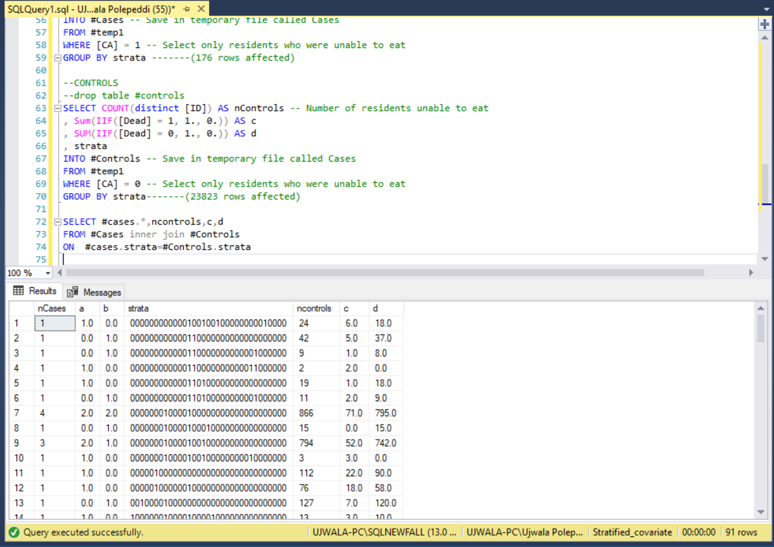

Within each strata, calculate the odds of mortality from cancer

-----CALCULATING ODDS RATIO
select sum(a*d/(a+b+c+d))/sum(b*c/(a+b+c+d)) As [Common Odds Ratio]
FROM #Cases inner join #Controls
ON #cases.strata=#Controls.strata
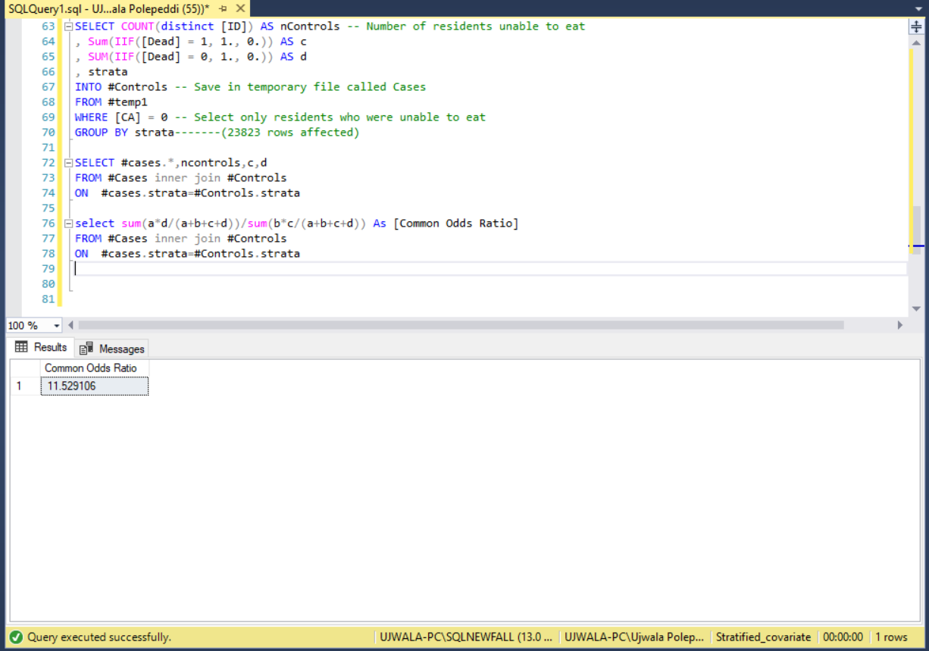
select
(a+1)/(b+1) as Odds, *
from #Cases
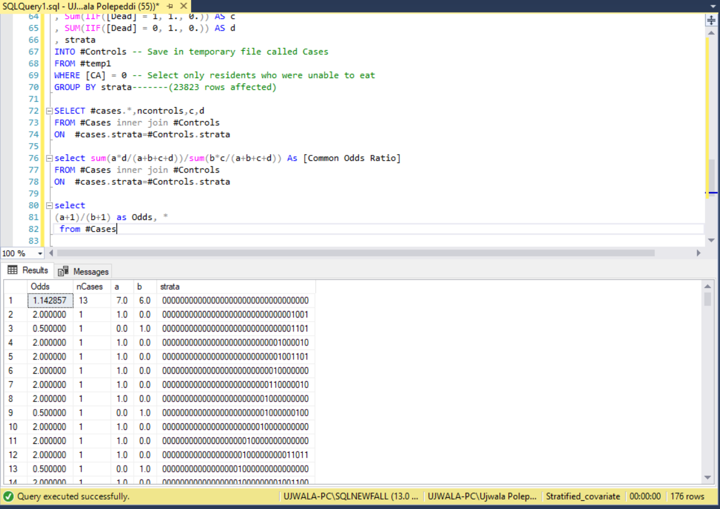

Calculate the common odds ratio across strata.
Declare @TotalCases Float
Set @TotalCases = (Select Count ([Dead]) from #temp1 Where [CA] =1)

SELECT sum(cast((a*d)/(a+b+c+d)as float))/sum(cast((b*c)/(a+b+c+d)as float)) As [Common Odds]
,sum (cast((a+b)/(c+d)as float)) As WeightControl
,sum(Cast(a+b As Float))/ @TotalCases As Overlap

INTO #Match
FROM #Cases inner join #Controls on
#Cases.strata =#Controls.strata

select * from #Match
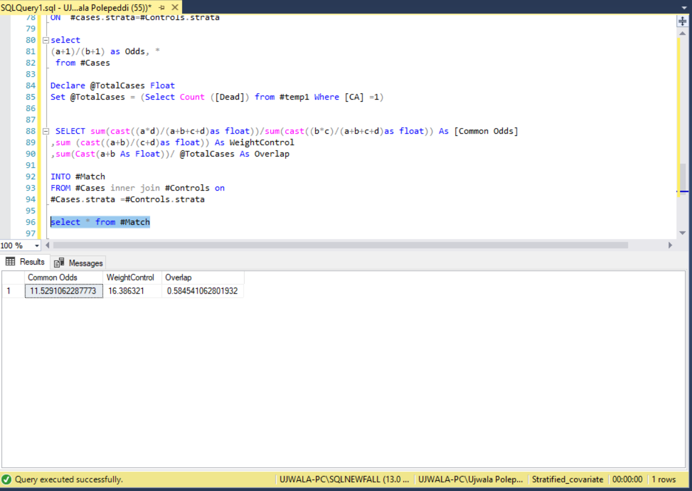

Conduct sensitivity analysis for the calculated common odds ratio.
Sensitivity analysis is the process of changing one variable and re-examining the conclusions.

LOADING AND RUNNING THE DATA IN R TO FIND SIGNIFICANT VARIABLES
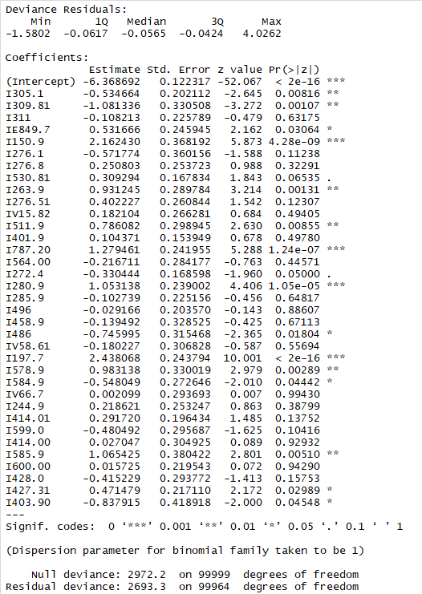
Taking into consideration the significant variables and dropping the rest.
Re-run the SQL code for calculating the common odds ratio and percentage overlap.
Drop table #Cases
SELECT COUNT(distinct ID) AS nCases
, Sum(IIF([Dead] = 1, 1., 0.)) AS a
, SUM(IIF([Dead] = 0, 1., 0.)) AS b
,[I305 1], [I309 81]
, [IE849 7], [I150 9], [I530 81], [I263 9]
, [I787 20], [I272 4], [I280 9], [I486 ]
, [I578 9], [I584 9]
, [I585 9], [I427 31], [I403 90]
INTO #Cases
FROM stoamch_cancer1
WHERE [CA] = 1
GROUP BY [I305 1], [I309 81]
, [IE849 7], [I150 9], [I530 81], [I263 9]
, [I787 20], [I272 4], [I280 9], [I486 ]
, [I578 9], [I584 9]
, [I585 9], [I427 31], [I403 90]-------(95 rows affected)

--- Grouping Controls that have NO Cancer by the conditions & seperating dead to column A & B
Drop table #Controls
SELECT COUNT(distinct [ID]) AS nControls
, Sum(IIF([Dead] = 1, 1., 0.)) AS c
, SUM(IIF([Dead] = 0, 1., 0.)) AS d
, [I305 1], [I309 81]
, [IE849 7], [I150 9], [I530 81], [I263 9]
, [I787 20], [I272 4], [I280 9], [I486 ]
, [I578 9], [I584 9]
, [I585 9], [I427 31], [I403 90]
INTO #Controls
FROM stoamch_cancer1
WHERE [CA] = 0
GROUP BY [I305 1], [I309 81]
, [IE849 7], [I150 9], [I530 81], [I263 9]
, [I787 20], [I272 4], [I280 9], [I486 ]
, [I578 9], [I584 9]
, [I585 9], [I427 31], [I403 90] --(2493 rows affected)

-- Calculating the Common Odd Ratio

SELECT sum(a*d/(a+b+c+d))/sum(b*c/(a+b+c+d)) As [Common Odds Ratio]
into #OddsRatio
FROM #Cases inner join #Controls
ON #Cases.[I305 1] =#Controls.[I305 1]
and #Cases.[I309 81] = #Controls.[I309 81]
and #Cases.[IE849 7]= #Controls.[IE849 7]
and #Cases.[I150 9]= #Controls.[I150 9]
and #Cases.[I530 81]= #Controls.[I530 81]
and #Cases.[I263 9]= #Controls.[I263 9]
and #Cases.[I787 20]= #Controls.[I787 20]
and #Cases.[I272 4]= #Controls.[I272 4]
and #Cases.[I280 9]= #Controls.[I280 9]
and #Cases.[I486 ]= #Controls.[I486 ]
and #Cases.[I578 9]= #Controls.[I578 9]
and #Cases.[I584 9]= #Controls.[I584 9]
and #Cases.[I585 9]= #Controls.[I585 9]
and #Cases.[I427 31]= #Controls.[I427 31]
and #Cases.[I403 90]= #Controls.[I403 90]

select * from #OddsRatio
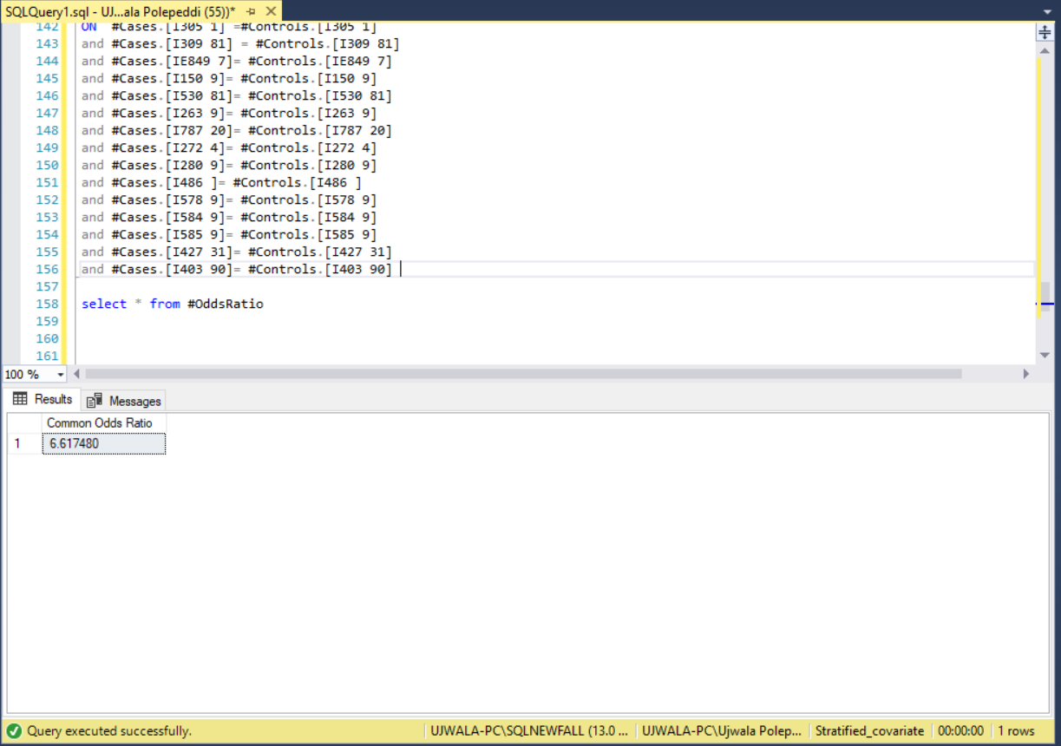
-- Matching Cases with controls
drop table #Match
select a ,b ,c ,d into #Match
from #Cases join #Controls
ON #Cases.[I305 1] =#Controls.[I305 1]
and #Cases.[I309 81] = #Controls.[I309 81]
and #Cases.[IE849 7]= #Controls.[IE849 7]
and #Cases.[I150 9]= #Controls.[I150 9]
and #Cases.[I530 81]= #Controls.[I530 81]
and #Cases.[I263 9]= #Controls.[I263 9]
and #Cases.[I787 20]= #Controls.[I787 20]
and #Cases.[I272 4]= #Controls.[I272 4]
and #Cases.[I280 9]= #Controls.[I280 9]
and #Cases.[I486 ]= #Controls.[I486 ]
and #Cases.[I578 9]= #Controls.[I578 9]
and #Cases.[I584 9]= #Controls.[I584 9]
and #Cases.[I585 9]= #Controls.[I585 9]
and #Cases.[I427 31]= #Controls.[I427 31]
and #Cases.[I403 90]= #Controls.[I403 90] --(88 rows affected)

The sum of the controls and cases 73804.0

select * from #Match

--Calculating the overalp
Declare @TotalCases Float
SET @totalCases = (SELECT Sum(nCases) FROM #Cases)
SELECT ROUND(SUM(a+b)*100/@TotalCases,2) as [Percent Overlap]
FROM #Match
