Question 1

A hospital has recently determined that there has been an increase in errors in medications dispensed to patients. A database that is a registry for medication errors is created and utilized by hospital administrators in tracking mistakes in medication dispension. Medication errors can be a result of misdiagnosis by the doctor; misreading of the doctor’s prescription (illegible, mistake in interpreting doctor’s rx, etc); mistake in dispensing by authorized medical official; or mistake in dispensing by the pharmacist. This database is to be used to determine the root cause of these errors.

This registry will contain data that can influence decisions. One decision that can be influenced is to determine how staffing may assist a particular pharmacy in reducing the amount of medication dispension errors. Another decision that is being weighed is if the hospital should implement an electronic prescription tool for doctors to write and submit their prescriptions electronically.

Question2

Use Case Summary: Registry of Medication Errors: Number of Available Pharmacy personnel

Overview: The purpose of this use case is to determine if a particular pharmacy needs to have additional staff delegated to its pharmacy to reduce the amount of errors that are occurring due to rushed workload.

Primary Actor:
Data entry clerk

Secondary Actor:
Hospital Administrator (responsible party for making decisions on staffing levels)

Starting Point
The primary actor accesses the registry of medication errors to enter information when an occurrence of medication error dispension has occurred.

Ending Point
The data entry clerk submits the information into the medication error database (ie,she fills out the form and after all necessary fields are filled out, clicks the “Submit” button on the form).

Information Exchanges
The data entry clerk provides information regarding the code of the medication dispension error that has occurred, name of prescribing doctor, name of dispensing pharmacist, patient’s name, time, date, location, the responsible party’s statement, number of available pharmacy on staff at time of dispension and patient diagnosis. S/he also includes an attachment of the staff schedule at time that error occurred. This information is then submitted (saved) in the registry. A pre-determined hospital administrator receives an email that a medication error has occurred so s/he can query the database to review the error.

Measurable Results:
A new medication record is created and the hospital administrator is notified of the event via email. The hospital administrator makes a determination based on the information gathered in the incident report and recorded in the database.

GRAPHIC REPRESENTATION OF ABOVE USE CASE


Submission of incident of medication error info aassessment
ABC Hospital -Medication Errors Registry
Data Entry Clerk Hospital Administrator

Determine if pharmacist was at fault

Determine if pharmacy was adequately staffed services

Use Case Summary 2

Use Case: Medication Error Registry: Determination of Pharmacy Peer review

Overview:
The purpose of this use case is to determine if pharmacists need to have their dispension reviewed for accuracy by a peer prior to dispension.

Primary Actor
Hospital Administrator

Secondary Actor
Director of Pharmacy

Starting Point
The hospital administrator electronically inputs his/her assessment of the number and reason of medication errors a particular pharmacy has encountered. S/he indicates her assessment if she wants to implement peer review at the subject pharmacy before dispension of prescriptions

Ending Point
The hospital administrator submits his/her assessment in the system. An email is generated to the Director of Pharmacy

Information Exchanges
The hospital administrator retrieves the error incident profile electronically and indicates his/her assessment of whether a peer review should take place prior to dispension at the subject pharmacy. After submission in the system, an email with this recommendation is forwarded to the Director of Pharmacy for final approval.

Measurable Results
The Hospital Administrator’s recommendation is forwarded to the Director of Pharmacy for existing error incident reports. The Director of Pharmacy then makes the final determination if peer review should occur or not.

GRAPHIC REPRESENTATION OF ABOVE USE CASE

Hospital Administrator’s Assessment & Recommendation
ABC Hospital – Medication Errors Registry
Hospital Director of Pharmacy
Administrator

Determine if peer review should be implemented

USE CASE SUMMARY 3

Use Case: Medication Error Registry: Determination of Doctor script illegibility

Overview:
The purpose of this use case is to determine how many medication dispension errors occur because doctors’ prescriptions are illegible.

Primary Actor
Data entry clerk

Secondary Actor
Hospital Administrator

Starting Point
The data entry clerk enters all written incident reports of medication errors received in the Medication Error Registry.

Ending Point:
The data entry clerk submits the information electronically regarding to the hospital administrator for review.

Information Exchanges
The data entry clerk electronically enters the information, data and circumstances recorded on paper. The new records are saved in the database.

Measurable Results
New records are created in the medication error registry when medication errors occur. The hospital administrator is notified daily of the new submissions that were entered from the previous day and assesses the cause of error.

GRAPHIC REPRESENTATION OF ABOVE USE CASE

ABC Hospital- Medication Error Registry
Data Entry Clerk Hospital Administrator
Submission of Medication Error Report (s)

Query and run report on medication errors

Assess cause of medication error and if due to doctor script illegibility

Use Case Summary 4: Medication Error Registry:

Overview: The purpose of this use case is to compare amount of medication dispension errors for doctors who submit prescriptions electronically to pharmacies versus those who write out the prescriptions. This is used to help in determining if the medical staff responsible for writing prescriptions should start submitting their prescriptions electronically.

Primary Actor:
Hospital Administrator

Secondary Actor:
Hospital Director of Medicine

Starting Point
The hospital administrator runs report on medication errors. Two reports are run, one showing electronic script submission and one showing manual script submission.

Ending Point
The hospital administrator finishes running the report and saves the report in the medication error registry.

Information Exchanges
The hospital administrator performs the appropriate queries and saves the report. The report is emailed to the Director of Medicine at the hospital.

Measurable Results:
A new report is created and the Director of Medicine is notified of the event via email. The Director of Medicine makes a determination based on the results of the report if the medical staff should start prescribing medication using electronic means.

GRAPHIC REPRESENTATION OF ABOVE USE CASE

Query, save and submission of Report
ABC Hospital – Medication Errors Registry
Hospital Director of Medicine.
Administrator

Determination of mandatory use of electronic script use by med staff

Question 3 – Master List of Attributes

PatientID
PatientFirstName
PatientMiddleName
PatientLastName
PatientAddress
SocialSecurityNum
Diagnosis
MedicationPrescribed
MedicationDirection
ClinicianID
ClinicianFirstName
ClinicianLastName
DEA #
DrugDispenser
DrugIDNum
DrugName
DrugManufacturer
DrugSideEffects
DrugInteractions
DrugStorage
DrugPrecautions
DrugDosage
OtherMed
PharmacyID
PharmacistID
RxNum
DrugDispensed
AmountDispensed
DateTimeDispensed
NumberofStaffAvail
ErrorCode
StatementOfResponsibleParty
MedicationDoubleChecked
PeerReview
PrescriptionSubmitElectronic
StaffMember *
DateDiagnosis *
DateRx *

* See Question 5

Question 4

Below is the database with 6 tables listed below:
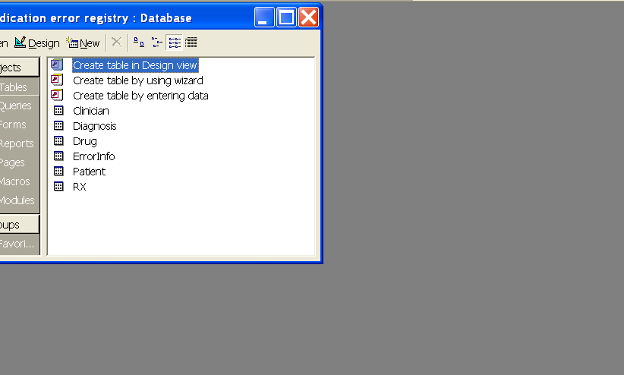

The Clinician Table contains information on the Clinician (ie, Doctor’s) Information:

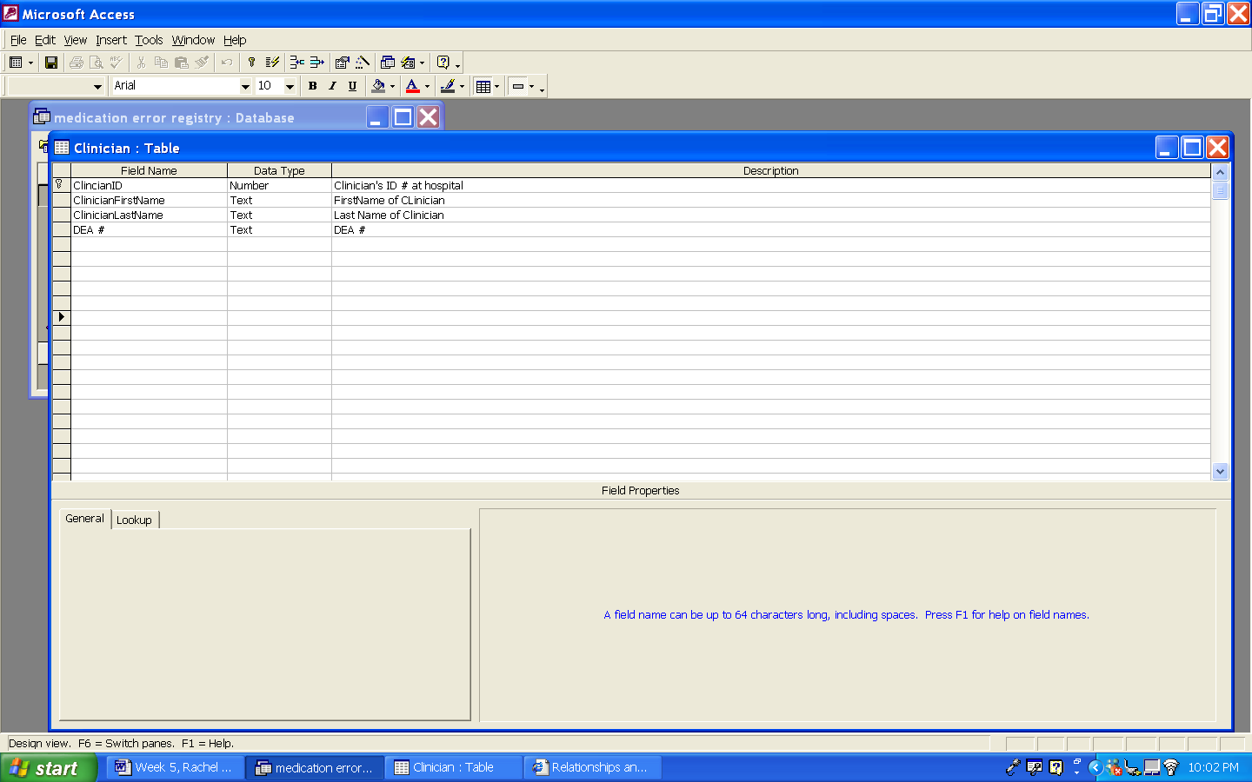

The Diagnosis Table provides information on the Patient’s Diagnosis and what Drugs were prescribed:

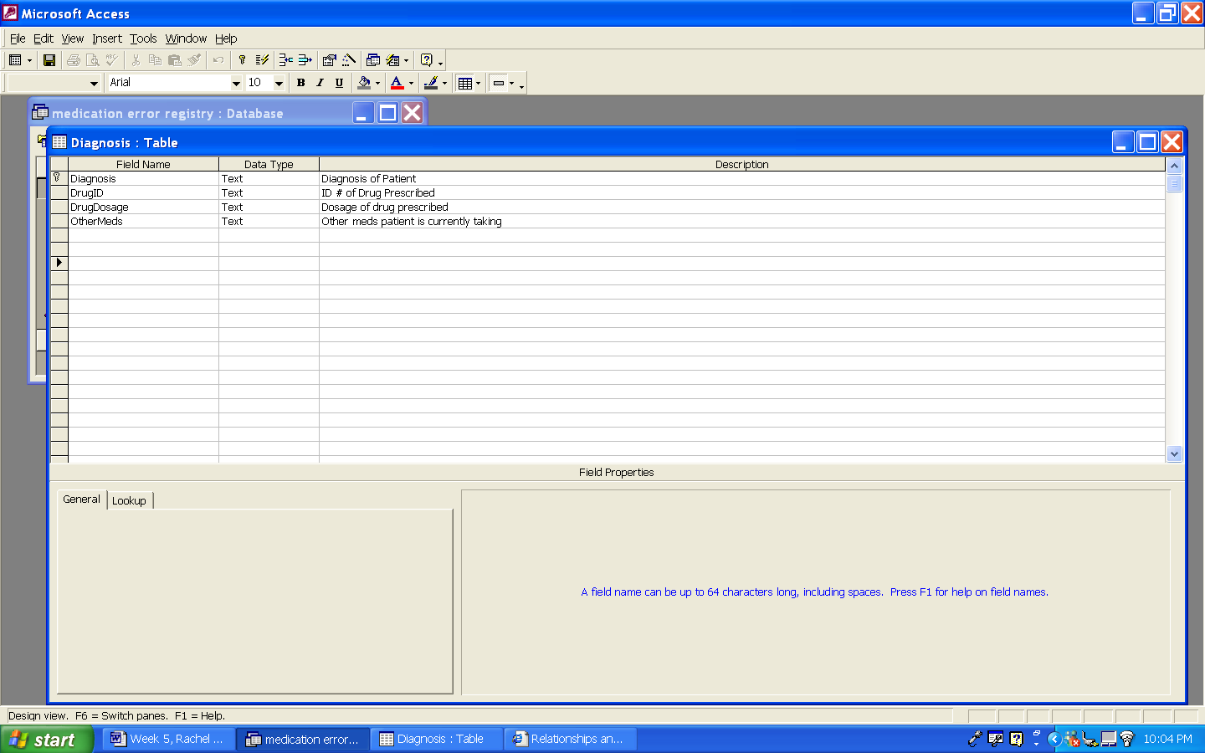

The Drug Table provides information on the Drug and its’ properties:
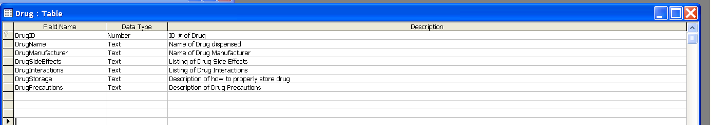

The Error Info Table provides details on the medication error and some events (and possible causes) leading up to it:
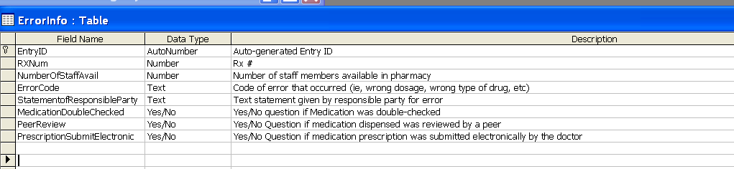

The Patient Table contains demographic info on the patient:

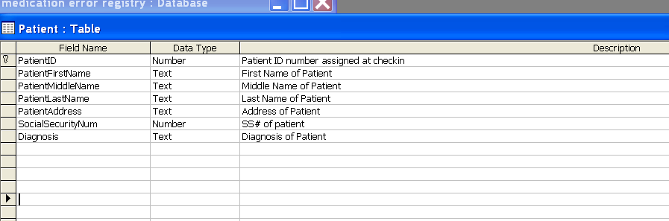

The Rx Table provides information on the specific prescription and what was dispensed:

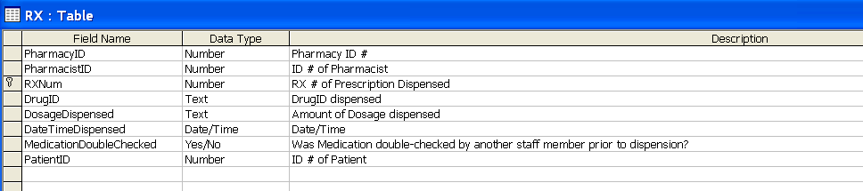

Question 5:

Only 2 tables in Question 4 did not have 5 attributes, the Clinician Table and the Diagnosis Table. These 2 tables have been revised and included below. The addition to the Master List of attributes are marked in Question 3 with an asterisk.

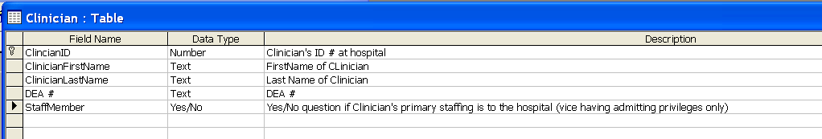

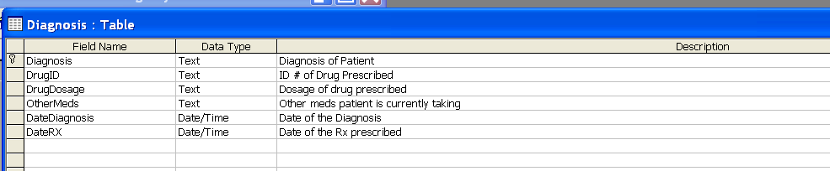

Question 6:

I’ve shown 2 different relationships:

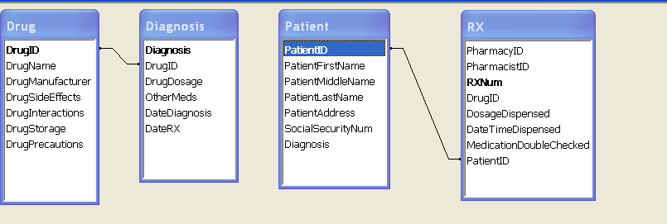

The first is between the Drug and Diagnosis Tables. There is a one-to-many-relationship. A drug can only be prescribed for a particular diagnosis but a diagnosis can have many drugs prescribed for it.

The second relationship I’ve depicted is between the Patient and Rx tables. This is a one-to-many relationship. A patient can have many Rx but an Rx can only be assigned to one patient.

Question 7 and Question 8:

Check for Hierarchies: It did not appear to me that there were any hierarchies among the entities.

However, I added the “ClinicianID” field to the Patient Table and the Rx Table. I’ve also revised the ER diagram:

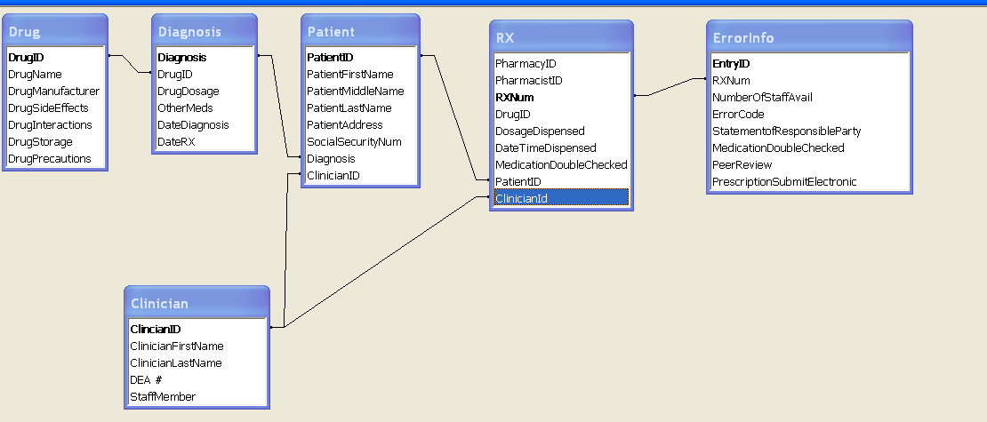

Question 9:

Entity | Primary Key | Foreign Key
Drug | DrugID | DrugID in Diagnosis Table
Diagnosis | Diagnosis | Diagnosis in Patient Table
Patient | PatientID | PatientID in Rx Table
Rx | RxNum | RxNum in ErrorInfo Table
ErrorInfo | EntryID | None
Clinician | ClinicianID | ClinicianID in Patient Table and Rx Table

Question 10 and 11:

The screen shot in Question 9 shows the table for each entity and the attributes in the table. The primary key is designated by the attribute in bold and the remaining fields are in regular font.

Question 12:

Following are screen shots of 3 rows of data for each table:

Clinician Table:

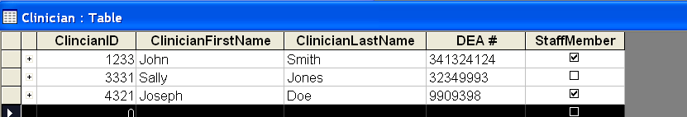

Diagnosis Table:

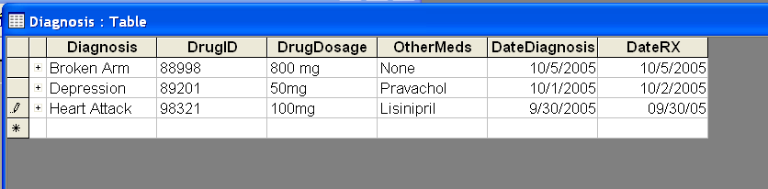

Drug Table:

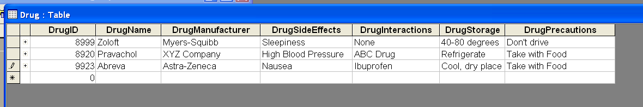

Error Info Table:

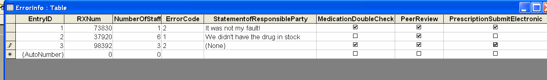

Patient Table:

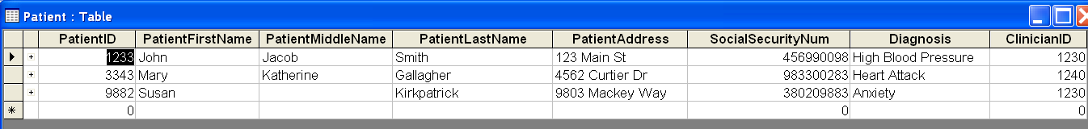

Rx Table:



