-- **************** This Routine Calculates Likelihood Ratios ***************
USE HAP725 -- The name of your database is likely to be different
/*-- Create new tables from DxAge_x tables and use CAST to change data types
/* These commands are made into comments so that they do not accidentally re-run
DROP TABLE #temp
SELECT * INTO #temp FROM [dbo].[DxAge_1] -- 4233546 rows
INSERT INTO #temp SELECT * FROM [dbo].[DxAge_2] -- 5223128 rows
INSERT INTO #temp SELECT * FROM [dbo].[DxAge_3] -- 4179754 rows
INSERT INTO #temp SELECT * FROM [dbo].[DxAge_4] -- 3807014 rows
DROP TABLE dbo.final
SELECT CAST([id] as int) as id
, [icd9]
, CASE AgeAtDx
WHEN 'NULL' THEN null
ELSE CAST(AgeAtDx as float) END as AgeAtDx
, CASE AgeAtFirstDM
WHEN 'NULL' THEN null
ELSE CAST(AgeAtFirstDM as float) END as [AgeAtFirstDM]
, CASE AgeAtDeath
WHEN 'NULL' THEN null
ELSE CAST(AgeAtDeath as float) END as [AgeAtDeath]
INTO dbo.final
FROM #temp
*/
SELECT Count(*) FROM dbo.final --(17,443,442 rows)
-- Identify zombies
DROP TABLE #Z
SELECT DISTINCT Id
INTO #Z
FROM dbo.final
WHERE AgeAtDeath<AgeAtDx -- Death before Dx
GROUP BY ID
SELECT TOP 5 * FROM #Z ORDER BY id DESC

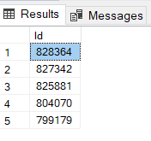
-- 168 unique patients with wrong date of death
-- Exclude zombies from final table
DROP TABLE #data
SELECT a.*
INTO #data
FROM dbo.final a left join #Z b ON a.id=b.id
WHERE b.id is null
SELECT TOP 3 * FROM #data order by ID
-- (17,432,694 row(s) affected)
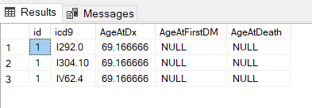

-- Remove patients with more than 365 diagnosis in a year and diagnosis with age being wrong
DROP TABLE #Data2
SELECT DISTINCT ID
INTO #Data2
FROM #Data
GROUP BY ID, Cast(AgeAtDx as Int)
HAVING Count(Icd9) >365
SELECT TOP 10 * FROM #Data2
-- (56 row(s) affected)

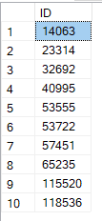

DROP TABLE #Data3
SELECT a.*
INTO #Data3
FROM #Data a left join #Data2 b on a.id=b.id
WHERE b.id is null and AgeAtDx is not null AND AgeAtDx >0
-- removing also problems with age at diagnosis
SELECT TOP 3 * FROM #Data3 WHERE AGeAtDx>0
-- 17,432,694 is reduced to 17,379,713 reduced to 17,379,218
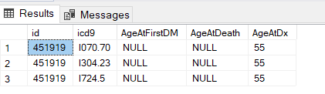

-- Select training and validation set
SELECT *
INTO dbo.training
FROM #Data3
WHERE Rand(ID) <=.8
SELECT TOP 5 * FROM dbo.training WHERE ID=467828
-- (13,760,073 row(s) affected) ---- (13759944 rows affected)

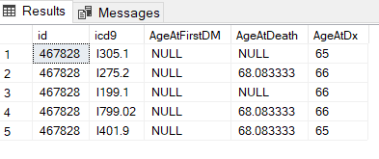

-- Find unique IDs in training set
DROP TABLE #trainID
SELECT DISTINCT ID
INTO #trainID
FROM dbo.training
-- (657,885 row(s) affected) --- (657883 rows affected)
-- Create Validation set
SELECT a.*
INTO dbo.vSet
FROM #Data3 a left join #trainID b ON a.id=b.id
WHERE b.id is null
-- (3619145 row(s) affected)
-- Calculate # dead and # alive in training set
DROP TABLE #cnt1
select ID, CASE WHEN Max(ageatdeath)>0 THEN 1 ELSE 0 END AS Dead
, CASE WHEN Max(ageatdeath)>0 THEN 0 ELSE 1 END AS Alive
, CASE WHEN Max(AgeAtDeath) IS NULL THEN 1 ELSE 0 END AS Alive2
INTO #cnt1
FROM dbo.training
GROUP BY ID
SELECT TOP 3 * FROM #cnt1

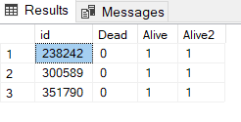
-- (657885 row(s) affected)
DROP TABLE #cnt2
SELECT SUM(Alive) AS PtsAlive, Sum(Dead) AS PtsDead
INTO #Cnt2
FROM #cnt1
SELECT * FROM #Cnt2
/* Unique patients alive or Dead*/

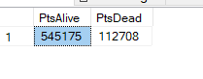
-- ******** Calculate Likelihood Ratio *********
-- Select patients who died 6 month after diagnosis
DROP TABLE #DeadwDx
SELECT ICD9, count(distinct ID) as PtsDead6
INTO #DeadwDx
FROM dbo.training
WHERE AgeatDeath-AgeatDx<=.5 -- This is 6 months in age measured in years
GROUP BY ICD9
SELECT TOP 5 * FROM #DeadwDx

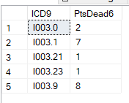
-- (6400 row(s) affected)---6297 rows
-- Select diagnosis where patient did not die or did not die within 6 months
DROP TABLE #AlivewDx
SELECT ICD9, count(distinct ID) as PtsAlive6
INTO #AlivewDx
FROM dbo.training
WHERE AgeatDeath-AgeatDx>.5 or AgeAtDeath is null -- Not dead in 6 months or not dead
GROUP BY ICD9
SELECT TOP 5 * FROM #AlivewDx ORDER BY ICD9

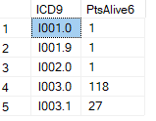

--(10439 row(s) affected)
-- Combine the tables for dead and alive patients
Drop Table #Dx
SELECT CASE a.Icd9 WHEN null THEN b.icd9 ELSE a.icd9 END as icd9
, PtsDead6
, PtsAlive6
INTO #Dx
FROM #alivewDx a FULL OUTER JOIN #DeadwDx b
ON a.icd9=b.icd9 --Full join keeps record even if not in either table
SELECT TOP 5 * FROM #Dx

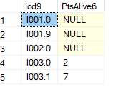

-- (10480 row(s) affected) 10480 rows affected
-- Calculate Likelihood Ratios
-- Set LR to maximum when all in DX are dead
-- Set LR to minimum when all in Dx are alive
SELECT Icd9
, PtsDead6
, PtsAlive6
, PtsDead
, PtsAlive
, CASE
WHEN PtsAlive6 is null THEN PtsDead6+1
WHEN PtsAlive6=0 THEN PtsDead6+1
WHEN PtsDead6 is null THEN 1/(PtsAlive6 +1)
WHEN PtsDead6= 0 THEN 1/(PtsAlive6 +1)
ELSE
(cast(PtsDead6 as float)/Cast(PtsDead as float))/(Cast(PtsAlive6 as Float)/Cast(PtsAlive As Float)) END AS LR
-- % of Dx among dead divided by % of Dx among alive patients
INTO dbo.LR
FROM #Dx cross join #Cnt2
SELECT top 10 * FROM dbo.LR ORDER BY LR desc

--(10480 row(s) affected)

