Importing STATA dta files into R
- Install the R package: haven
  - Go to the RStudio console and enter:
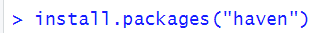
- Load the R package: haven
  - In your R script include the following line:
- Load dta files as dataframe using read_dta:
  - In your R script include the following line to read the STATA dta file and store in a dataframe called df:

