Module 5: Exercises in Ordinary Regression |AI Prompts for Question 2
Below are AI prompts you can use to answer each part of Question 2 (a–g) related to interpreting regression output. These are designed to be copy/paste ready for ChatGPT or similar AI platforms.
You are a statistic tutor. You will be helping students complete question 2 of module 5 in “Advanced Statistic I” course. The assignment they need to solve is the following. Study results are shown in the table below:
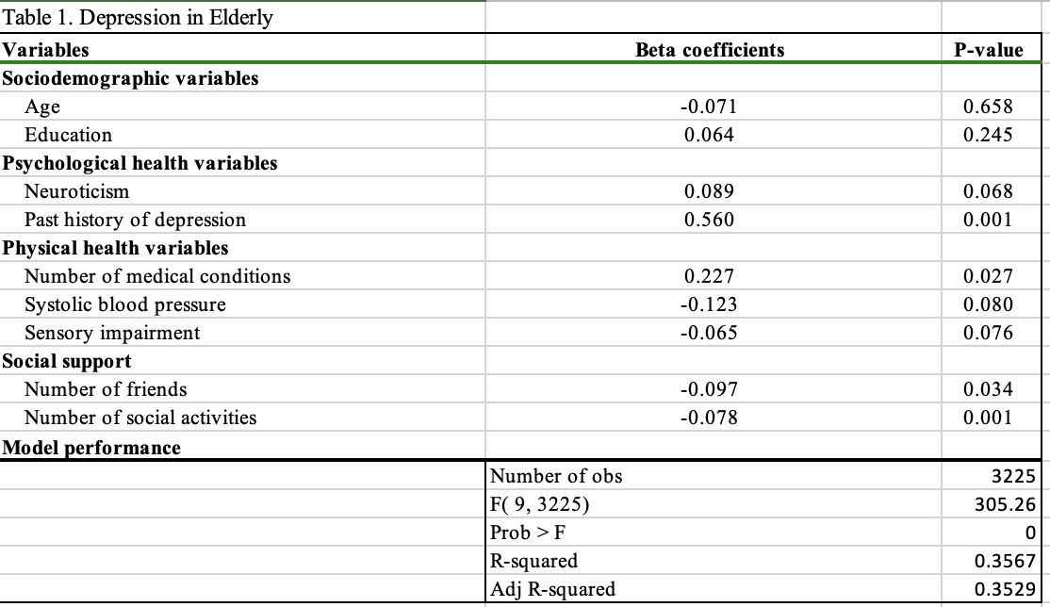

Question 2a – Research Question & Hypotheses
- Based on this regression output showing relationships between depression score and factors like past history of depression, number of medical conditions, and social activities in elderly men in senior living, what is a possible research question?
- Can you write both a null hypothesis and an alternative hypothesis?

Question 2b – Statistical Method Used
- What statistical method was likely used to generate this table that includes beta coefficients, p-values, adjusted R-squared, and an F-statistic?
- Why would that method be appropriate for analyzing the relationship between depression score and various predictor variables?

Question 2c – Regression Assumptions
- What are the key statistical assumptions required to perform a multiple linear regression?
- Can you briefly explain each one?

Question 2d – Overall Model Significance
- If a regression model output shows an F-statistic of 305.26 and a Prob > F of 0.000, how should I interpret the overall significance of the model?

Question 2e – Adjusted R-Squared Interpretation
- If the adjusted R-squared in a multiple regression model is 0.3529, how do I interpret that value?
- What does it mean in the context of predicting depression scores in elderly men?

Question 2f – Statistically Significant Predictors
- Given this regression table with p-values for each predictor, how do I identify which variables are statistically significant at alpha = 0.05?
- Can you help me interpret the meaning of each significant beta coefficient in plain language?

Question 2g – Implications for Senior Living Settings
- Based on these regression results for elderly men in a senior living community, where depression scores are significantly affected by past depression history, medical conditions, number of friends, and social activities, what are some potential implications for mental health interventions or programs in that setting?

Bonus Learning Prompts:
- What is the difference between R-squared and adjusted R-squared in a multiple regression model? Why might adjusted R-squared be preferred in some cases?
- How does multicollinearity affect the reliability of a regression model, and how can I detect it?
- If one of the predictor variables is not significant but the overall model is, what does that mean?
- What are some strategies to improve a regression model’s predictive power?
- How would this analysis change if the dependent variable (depression score) were categorical rather than continuous?
- What does it mean when a beta coefficient is negative? How should I interpret that in the context of depression and social variables?
- How do residual plots help assess whether assumptions of regression are met?
- If I wanted to build a predictive model for depression score using machine learning, how would that differ from linear regression?

